The examination and drawing of blood cells observed in blood smears STUDENT

Introduction
Making, fixing, staining and examining a blood smear is an excellent way to gain confidence and competence with microscopy as well as a useful insight into the cellular composition of blood. Blood is packed with cells – mostly erythrocytes but also leucocytes. Erythrocytes are only ̴7 µm in diameter. Observations about their characteristic shape and great abundance can be made with a light microscope. Leucocytes are bigger and much more variable in appearance. They are very difficult to see in an unstained preparation.

Aims
- To prepare and examine a blood smear.

Intended class time
- 1 hour

Equipment
- Light microscope with x10 and x40 objective lenses and an eyepiece graticule
- Stage micrometer
- Microscope slides
- 70% ethanol
- Buffered water
- Leishman’s Stain
- Mammalian blood
- Disposal pot containing 1% sodium hypochlorite (bleach)
- Glass rod

Method
Note: you are provided with new, clean microscope slides. This is important for good results. Handle the slides by the edges to avoid contaminating the surface.
- Gently shake your sample of blood to re-suspend the cells.
- Dip the glass rod into the blood and place a drop of blood about a quarter of the way along a microscope slide. Put the rod into the disposal pot so the contaminated end is immersed in the hypochlorite.
- Hold a second slide at an angle of about 45˚. Push it backwards until it just touches the drop of blood and then pull it forwards towards the far end of the slide, dragging a smear of blood behind it. It is important that the second slide makes the briefest possible contact with the drop of blood, otherwise too much will be collected and far too many cells will spread on the slide. Most of the drop should remain at the origin.
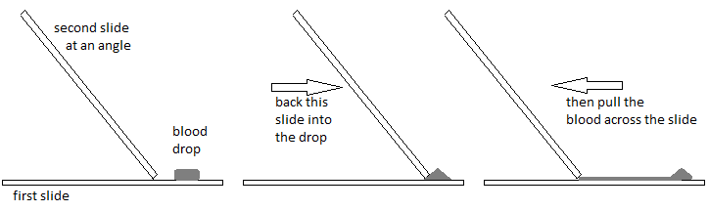

- Put the slide used to smear the blood into the disposal pot.
- Leave the smear to air-dry on the bench. This will stick the cells to the slide but only if it is fully dried.
- While the smear is drying, use the stage micrometer to calibrate the eyepiece graticule with the x40 objective. Make a note of this calibration – you will refer to it later when viewing cells at high power.
- Pour ethanol onto the dry smear and leave for 2 minutes before pouring off. (This fixes and dehydrates the cells.)
- Put 5 drops of Leishman’s stain on the smear and leave for 1 minute.
- Add 5 drops of the buffered water and leave for 5 minutes.
- Wash the slide in buffered water until it looks pale pink, gently blot dry with filter paper and place a cover slip over the smear (at the end where it is thinnest).
- Examine your preparation under the microscope. Use the x10 objective to focus the microscope and identify the right part of the smear.
- Next use the x40 objective to make high power drawings to show the appearance of the different cells.
Add labels, annotations and a scale bar to each drawing.
Here is a list of things to things to look out for, including the appearance of cells when stained with Leishman’s stain:
- Erythrocytes (red blood cells) – red
- Thrombocytes (platelets) – purple grains (so small they will be difficult to see even at high power)
- Lymphocytes – very dark nuclei (purple or dark blue) and light blue cytoplasm
- Neutrophils – dark purple nuclei, pale pink cytoplasm
- Eosinophils – blue nuclei, pale pink cytoplasm, red granules within the cytoplasm (these cells are rare and you will probably not see any examples in your sample)
- Basophils – dark blue nuclei, very dark granules in the cytoplasm (these cells are rare and you will probably not see any examples in your sample)
If you identify and draw erythrocytes, neutrophils and lymphocytes you have done well. If you find something you think might be an eosinophil or a basophil, you have a rare find – get your teacher and other students to have a look.
- Calculate the diameter of a typical erythrocyte from your slide.
- When you have finished dispose of the slide in the disposal pot and wash your hands.

Extension questions to consider while carrying out practical work

- Could you use a sample of your own blood for this practical? What precautions would you need to take if you did?
- Make an estimate of the concentration of erythrocytes in this sample of blood. What facts do you need to produce this estimate? How accurately can you gauge each of these things? What do you judge to be the uncertainty in this estimate? How would you go about making a more accurate measurement and what additional apparatus would you need?
- Using your calculation of the diameter of a typical erythrocyte, and assuming these cells are spherical, what is the volume of a typical erythrocyte? Given what you know about the shape of erythrocytes do you think this is likely to be an over-estimate or an under-estimate?
- What are the functions of the various different cell types you have identified in the sample?
To submit
For this piece of work to count towards Practical Activity Group 1 of the Practical Endorsement, you need to have evidence showing your high power drawings complete with labels, annotations and scale bars. You also need to have considered the above questions as the answers will aid you in preparation for your written examinations.

