Using diffraction from a CD as a means to determine wavelength
Introduction
In this experiment you will be estimating the relative wavelengths of colours in visible light by observing the diffraction pattern from the tracks on a CD or DVD and by taking simple measurements of distances with magnitudes in the order of cm and m.
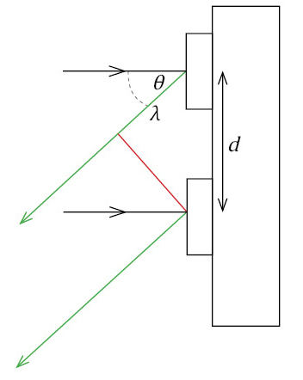
You are expected to be familiar with the formula λ = d sinθ relating the wavelength to the angle of diffraction. (This investigation is only concerned with the first diffraction pattern so the n of the standard formula is 1.)

θ is the angle of the observed diffraction
d is the separation of the tracks producing the diffraction pattern.

Aim
- To observe and use a diffraction pattern to estimate the ratio of wavelengths

Intended class time
- 45 to 60 minutes

Equipment
- lamp
- CD or DVD
- metre rule

Health and safety
- Do not look directly at the lamp for long periods.
- The lamp may get hot.
Procedure
This investigation requires the ability to hold the CD at an appropriate distance from the eye, and at an appropriate angle to the lamp to get a refracted pattern of concentric coloured rings. Take some time to familiarise yourself with this pattern to make the measurement process as valid as practically possible..
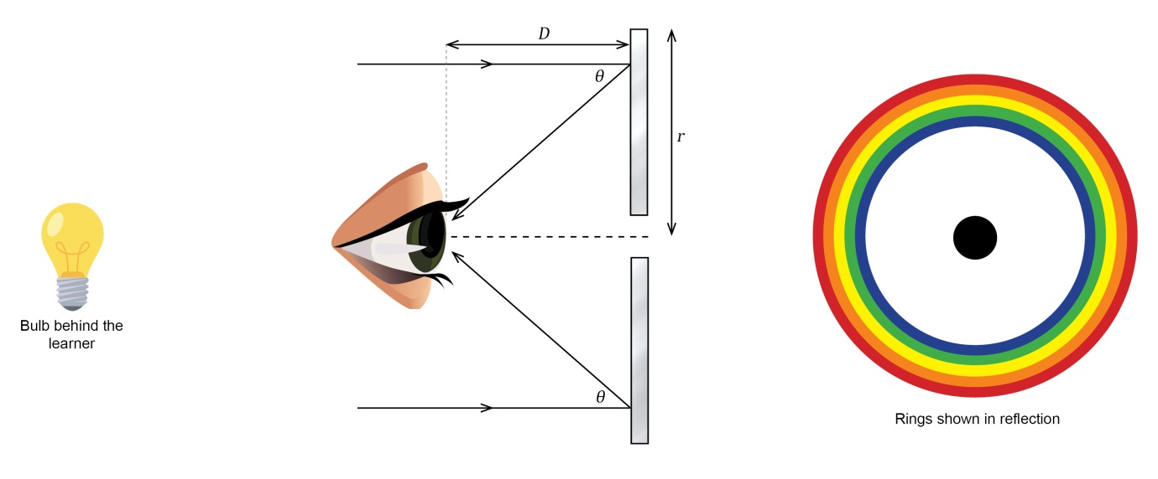
By moving the CD relative to your eye you can find a position where the red circle is on the diameter of the CD.
The two measurements you will take are:
D, the distance from the eye to the CD
r, the diameter of the CD
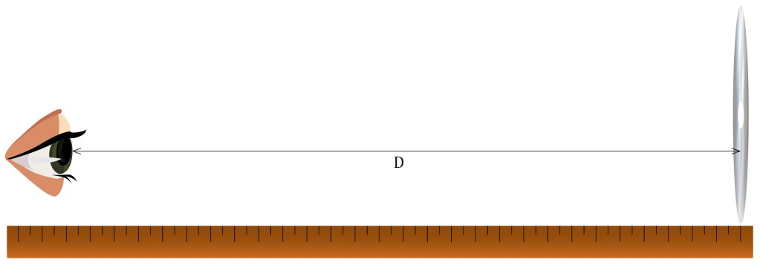

Using these you are able to determine the angle θ for the diffraction of red light.
The experiment can be repeated for other colours and the ratio of wavelengths determined using the formula provided and values calculated for θ.

Evaluation
- Compare your ratios with those for accepted values.
- Which of the colours has the least uncertainty in measurements?
Extension Opportunities
Using accepted values for the wavelength of the different colour LEDs determine, either mathematically or graphically, a value for d the separation of the tracks on the CD or DVD being used.

Recording
As evidence for the Practical Endorsement you should have the measurements of your practical activity clearly recorded. All work should be clearly dated.
In addition, in preparation for the assessment of practical work in the written examination, you should have used the data collected to calculate ratios for the differing wavelengths, explaining clearly how you have used the data in the calculation and showing all working.
You should identify the relative uncertainties in the measurements and could also determine a value for the separation between the adjacent tracks on a CD.

