Determining the speed of sound in air using a resonance tube
Introduction
In this experiment you will be determining the speed of sound in air by using the resonance of a tube.
You are expected to be familiar with the formula v=fλ relating the velocity of a wave to its frequency and wavelength.
You are also expected to have studied the differing patterns of resonance in open and closed tubes, relating to resonance at different harmonics.
Aims
- To determine the speed of sound
- To consider uncertainty
Intended class time
- 45 to 60 minutes
Equipment
- signal generator
- loudspeaker
- tube (tall measuring cylinder)
- stand, clamp and boss to support metre rule
- metre rule
- oscilloscope
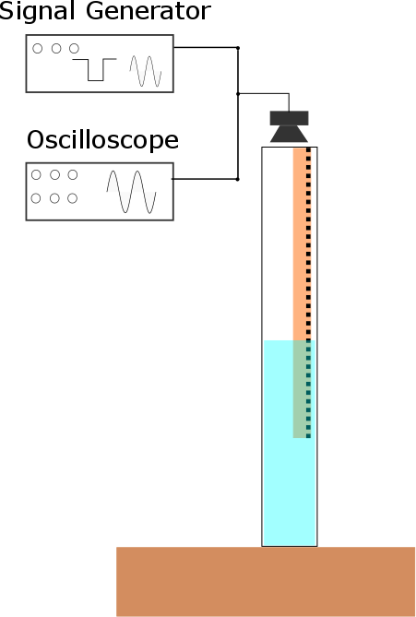
Procedure
- Set up the apparatus as shown.
- Fill the tube with water up to approximately three quarters of its height.
- Take measurements to determine the distance from the top of the tube to the surface of the water.
- Position the speaker above the tube and adjust the frequency until the level of sound increases indicating resonance.
- Use the oscilloscope to determine the frequency of the signal.
- Keeping the signal at the same frequency, reduce the water level until a new resonant point is identified.
- Take measurements to determine the distance from the top of the tube to the surface of the water.
- Repeat the experiment to obtain additional readings, continuing to maintain the same frequency.
- Use this data to determine the wavelength of the sound wave.
- Using your calculated wavelength and measured frequency, determine the speed of sound in air.

Obtaining results
- Explain what steps you took to increase the accuracy of your measurements of distance related to the tube.
Evaluation

- Estimate the uncertainty in the measurements made.
- Estimate the resulting uncertainty for the speed which you have determined.
- Compare your result with an accepted value and identify if your value is within the uncertainty of the experiment.
Extension Opportunties
- There is an additional effect at the end of the tube which would introduce a systematic error into any readings. What steps do you need to take to allow for this?

Recording
As evidence for the Practical Endorsement you should have evidence of your measurements. All work should be clearly dated.
In addition, in preparation for the assessment of practical work in the written examinations and to help you develop your understanding, you should:
- have used the data collected to calculate a value for the wavelength, explaining clearly how you have used the data in the calculation and showing all working.
- discuss the uncertainty and ways to reduce this.
- consider questions 11 to 15 and write a reasoned response to each point.

