Investigating circuits with more than one source of e.m.f.
Introduction
In this practical activity you will be measuring the potential difference and current for each component in a circuit and using this to substantiate Kirchhoff’s first and second laws. You should already be aware of the difference between e.m.f. and potential difference and have an understanding of internal resistance and how to determine this.
Aim
- To draw circuit diagrams and make circuits from circuit diagrams.
- To measure values within the circuit
- To observe whether Kirchhoff’s laws are substantiated, within experimental uncertainty
Intended class time
- 45 to 60 minutes
Equipment (per group)
- 3 D standard cells in holders (not high power or high capacity cells)
- voltmeter
- ammeter
- multimeter, reading in milliamps
- various resistors in the range 10Ω to 100Ω.
Health and safety
- Safe use of electrical circuits
Procedure
- Determine the e.m.f. and internal resistance of one cell.
- Determine the emf of three cells in series.

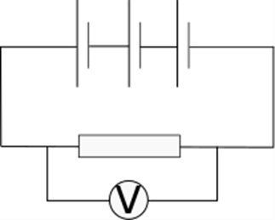

- What do you predict the internal resistance of this arrangement of cells will be?
- Determine if your prediction is correct.
- Rearrange the cells as follows and predict the e.m.f. and internal resistance of this combination.

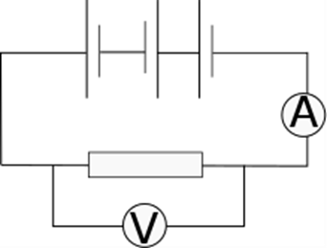

- Determine whether your prediction was correct.
- Arrange a circuit as follows with two cells in series, but without the single cell in the centre, measure V and I for each component and comment as to whether Kirchhoff’s laws are upheld.
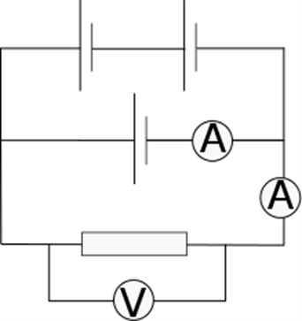

- Add the third cell as shown and repeat the measurements including those for the new cell.
- Comment on your observations.
- Draw your own circuit including resistors in series and parallel and a source of e.m.f. and demonstrate if your measurements support Kirchhoff’s laws.
Extension Opportunities
Consider whether your readings support Kirchhoff precisely or within a calculated uncertainty.
Comment on how the uncertainty in the experiment could be reduced.

Recording
As evidence for the Practical Endorsement you should have the data collected from your group in a clear and logical format. All work should be clearly dated.
In addition, in preparation for the assessment of practical work in the written examinations and to help you develop your understanding, you should have noted your measurements in a table or as annotations to the circuit diagrams. You should have drawn conclusions from the measurements taken.

