Investigating Electrical Characteristics
Introduction
In this experiment you will be determining the current – voltage characteristic of an electrical component.

Aim
- To set up the circuit correctly
- To obtain an appropriate set of data
- To plot the characteristic
Intended class time
- 45 to 60 minutes
Equipment (per group)
- power supply (max 12V)
- rheostat/potentiometer
- ammeter
- voltmeter
- leads
- test component (resistor as shown in circuit diagram, filament lamp, diode, LED)
Health and safety
Ensure the safe use of electrical circuits at all times. Work within the limits of voltage and current provided by your teacher. Do not short the cells.

Procedure
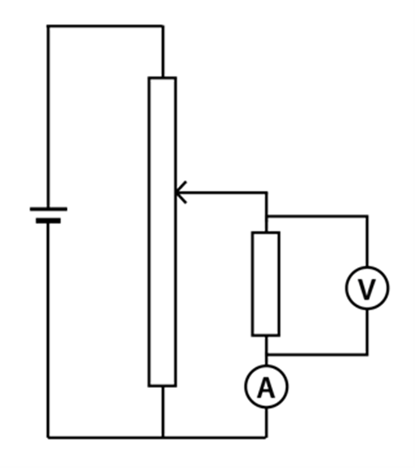
- To measure the characteristic curve for a component you must change the voltage and measure the current, this should include reversing the polarity of the supply to obtain readings for negative voltage.
- Find the maximum and minimum values of voltage that give appropriate readings of current, and then select the steps needed to give the required number of values.
- Measure the current as the voltage is changed across the component.
- Draw the current – voltage curves for your component.
- Calculate the resistance of the component at any point.
- Describe the characteristic of the component with relation to potential difference, current and resistance.
- If there is time, complete a characteristic for both a resistor and diode.

Recording
As evidence for the Practical Endorsement you should have the data collected from your group in a clear and logical format. All work should be clearly dated.

In addition, in preparation for the assessment of practical work in the written examinations and to help develop your understanding of physics, you should have plotted a graph and described this characteristic.

