Investigating the properties of a plastic bag
Introduction
In this experiment you will be investigating the properties of the material used to make a carrier bag.
You are expected to be familiar with the concept of the application of a force leading to the extension of an elastic material in tension and the further concepts of stress and strain.
You will be plotting a graph to show the effect of increasing load.
The observations you make may allow you to make some judgements on the material and how it is used.
Aim
- To determine the relationship between force and extension or stress and strain
- To use these observations to describe the materials behaviour
Intended class time
- 45 to 60 minutes
Equipment
- samples of plastic bag cut both in line with the normal load and at ninety degrees to that
- 100g masses on holder
- calipers or vernier measurement system
- metre rule
- stand
- boss and clamp
- material clamps

Health and Safety
Care should be taken such that when the material finally breaks the masses land safely without damaging equipment or endangering people.
[Make sure the masses are less than 10cm above the desk, and that there is a soft protective material for them to land on after the material breaks.]

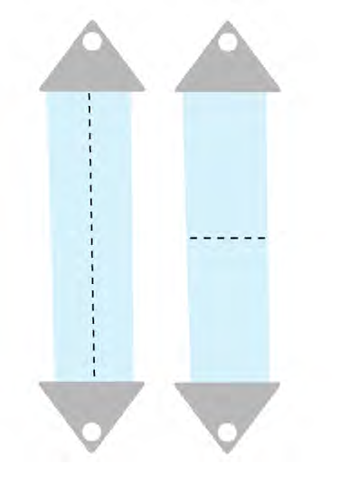
sample 1 sample 2

Procedure
- Measure the original length, L, of the sample.
- Load the spring with 100g and determine the extension, x.
- Add an additional 100g mass and determine the new extension from L.
- Continue to load the material 100g at a time, noting its behaviour after the addition of each mass.
- Plot a graph of load against extension.
- Try to explain what is happening to the material as it changes.
- Repeat the experiment with sample 2.
- Explain your observations in terms of the structure of the material.
Recording
As evidence for the Practical Endorsement you should have the data collected from your group in a clear and logical format. All work should be clearly dated.
In addition, in preparation for the assessment of practical work in the written examinations and to help you develop your understanding, you should have used the data collected to plot graphs and noted your detailed observations. As an extension you may have explained the behaviour of the material using appropriate technical terminology.

