Investigating Terminal Velocity
Method 1
In this experiment, you will measure the terminal velocity of a ball bearing as it falls through a viscous liquid with the possibility of using this value to determine the viscosity as an extension task.
Aim
- To determine terminal velocity for an object falling through a viscous liquid
Intended class time
- 90 to 120 minutes
Equipment (per group)
- measuring cylinder
- beaker containing viscous liquid
- access to a balance and micrometer screw gauge
- tube filled with viscous liquid
- elastic bands or other method of marking distances along tube
- steel ball bearings
- magnet
- metre rule
- stopwatch
- paper towels
Health and safety
Beware of falling objects.

Procedure
- Measure the mass of an empty measuring cylinder. Pour some of the viscous liquid into the measuring cylinder. Record the volume of liquid and the new mass of the measuring cylinder.
- Determine the density of the liquid.
- Measure and record the mass (m) and diameter (d) of the ball bearings.
- Carefully drop a ball bearing into the centre of the liquid and watch it fall as shown in Fig. 1.
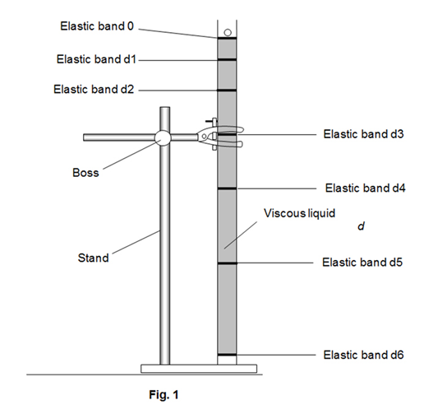
- Think about where the elastic bands should be placed to identify the distance travelled in equal time periods as the ball falls through the liquid.
- As the ball drops, mark the positions of the ball at fixed time intervals using elastic bands. The magnet can be used to take a ball bearing out of the tube to repeat your measurements and refine the position of the bands.

- For each time period measure the distance travelled between consecutive elastic bands, record the time period and use this time to calculate the average velocity of the ball.
- Plot a graph of velocity, v, on the y-axis and cumulative time from the release of the ball, t, on the x-axis and draw a smooth curve.
- Identify the time at which the ball reached its terminal velocity.
- Use your graph to determine the best value of terminal velocity.
- Identify the range of values for terminal velocity and calculate the maximum percentage variation from your best value.
12. a) Draw a sequence of diagrams to represent the forces acting on the ball bearing at three different positions showing how they change.
b) Discuss what you would expect to happen with smaller or larger ball bearings, giving scientific explanations to support your reasoning.
Recording
As evidence for the Practical Endorsement you should have the data collected from your group in a clear and logical format. All work should be clearly dated.

In addition, to support the assessment of practical skills in the written examination and to help you develop your understanding, you have used the data collected to plot a graph to determine the terminal velocity of the ball.

Extension to reinforce Area under velocity/time graph represents Displacement
Determining the area under the velocity/time graph should give a result equal to the depth of the viscous liquid.
Be very careful to note the units used in measurement and the scales on each axis to make sure that your answer is in the correct units.
Extension to determine the viscosity of the liquid
Determine a value for the viscosity of the liquid using the equation
43
η = (mg - r³gρ)
6πrv
Where:
- η = viscosity of liquid | - r = radius of the ball bearing
- m = mass of the ball bearing | - ρ = density of the liquid
- g = acceleration of free fall | - ν = terminal velocity

Evaluating your result
- Comment on the reliability of your value for viscosity by considering your results and possible variations in timings.
- Estimate the error in timing. Estimate the error in your diameter measurements.
- Combine the errors of all measurements to estimate the percentage error in viscosity.

Method 2
In this experiment, you will determine the terminal velocity of a bun-case as it falls through the air.
Aim
- To determine terminal velocity for an object falling through the air
Intended class time
- 60 minutes
Equipment (per group)
- bun-case
- access to a balance
- vernier calipers or calipers
- metre rule x 2
- stopwatch
Health and safety
Beware of falling objects.
Procedure
- Record the mass of the bun-case.
- Measure with a recorded uncertainty the dimensions of the bun-case and draw a scale diagram of it.
- Drop the bun-case from approximately 1m above the ground and observe its fall.
- Plan a method to time the fall of the bun-case as accurately as possible.
- Time the descent of the bun-case from 1m and then in increments up to a maximum of 2m to give sufficient data for analysis.
- Plot a graph of time against height of drop.
- Plot a graph of average speed against height of drop.
- Use these graphs to estimate the terminal velocity and give your reasoning.

Recording
As evidence for the Practical Endorsement you should have the data collected from your group in a clear and logical format. All work should be clearly dated.

In addition, to support the assessment of practical skills in the written examination and to help you develop your understanding, you have used the data collected to plot graphs to determine the terminal velocity of the bun-case.

