BWS A’ Level Physics

Year 12 Independent Study Forces and Motion Booklet B

Write all your answers in the spaces provided and use additional sheets where necessary.

This booklet is available for download on the website but may be updated so check you have an up to date copy.

A **C** by a certain activity indicates this is compulsory and must be completed ready for the next week as your lessons may depend on your ability to follow certain techniques or content.

Finally this booklet **must** be available for inspection at all times in your file.

Grade boundaries throughout for consolidation work are:

* A 80%
* B 70%
* C 60%
* D 50%
* E 40%
* U <40%



|  |  |  |  |  |  |  |
| --- | --- | --- | --- | --- | --- | --- |
| Week | Topic | **Prep / Consolidation** | Practice | | | Target Areas for improvement |
| Complete | Practice Mark and Grade | Corrected |
| 8 | Forces and F = ma |  |  | /31 Grade: |  |  |
| 9 | Drag and Terminal Velocity |  |  | / 32 Grade: |  |  |
| 10 | Moments and Centre of Gravity |  |  | / 38 Grade: |  |  |
| 11 | Equilibrium of forces and Moments |  |  | / 37 Grade: |  |  |
| 12 | Density and Pressure |  |  | / 32 Grade: |  |  |
| 13 | Progress Test B |  |  |  |  |  |

**8. Force and F = ma**

**Independent Study tasks this week:**

|  |  |
| --- | --- |
| **Notes:** | **Completed ✓** |
| Make revision notes/cards on the different types of forces, free body diagrams and F=ma |  |
| **Independent Study Learning Preparation task:**  Watch clips and create notes requested in powerpoint Q:\Physics\Year 12 Mechanics\9. Drag and Terminal Velocity\Drag Preparation.pptx | **C** |
| **Isaac Physics**  Read concept page on Newton’s 2nd law and F=ma <https://isaacphysics.org/concepts/cp_newtonii> (only go up to level 2 section) |  |
| **Independent Study Practice Questions:**  complete all the questions in the spaces provided | **C** |

**1** Define:

**(a)** *Acceleration*

………………………………………………………………………………………………………………………

………………………………………………………………………………………………………………………

………………………………………………………………………………………………………………………

**[1]**

**(b)** The *newton*

………………………………………………………………………………………………………………………

………………………………………………………………………………………………………………………

………………………………………………………………………………………………………………………

**[1]**

**(c)** A mass of 2.0 kg has a net force of 4.0 N acting on. Calculate its acceleration.

……………………………………

**[2]**

**2**  An aircraft of mass 560 000 kg reaches a take of speed of 270 kmh-1. The length of the runway is 3.0 km.

**(a)** Calculate the average acceleration of the aircraft.

ms-2……………….

**[3]**

**(b)** Calculate the time taken to reach speed of 270 kmh-1.

………………………..s

**[1]**

**(c)** Calculate the net force acting on the aircraft.

…………………………………..

**[3]**

**3**  A tractor is used to pull a heavy log of mass 600 kg. The cable connecting the tractor to the log is inclined at 15 degrees above the horizontal. There is a constant frictional force of 1500 N acting between the log and the ground.

**(a)** The log accelerates at 0.20 ms-2. Calculate the net force acting on the log.

…………………….N

**[2]**

**(b)** Calculate the tension in the cable.

…………………….N

**[3]**

**4** Fig. 5.1 shows a person standing in a stationary lift.

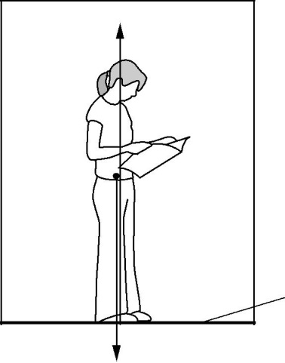

R

590N

Fig 5.1

Lift floor

There are only two forces acting on the person. The weight of the person is 590 N. The vertical contact force acting on the person from the floor of the lift is *R*.

**(a)** Show that the mass of the person is 60 kg.

**[1]**

1. The lift starts from rest. It has a constant upward acceleration of 0.50 m s–2. Calculate the magnitude of the contact force *R*.

*R* = ...................................................... N**[2]**

1. After a short period of acceleration, the lift travels upwards at a constant velocity. Explain why the force *R* is equal to the weight of the person when the lift travels at a constant velocity.

............................................................................................................................................

............................................................................................................................................

............................................................................................................................................ **[1]**

1. State and explain how the force *R* changes at the instant the lift starts to decelerate.

............................................................................................................................................

............................................................................................................................................

............................................................................................................................................

............................................................................................................................................ **[2]**

**5.** Fig. 5 shows a car travelling up a slope at a constant speed.

slope 18 m s–1

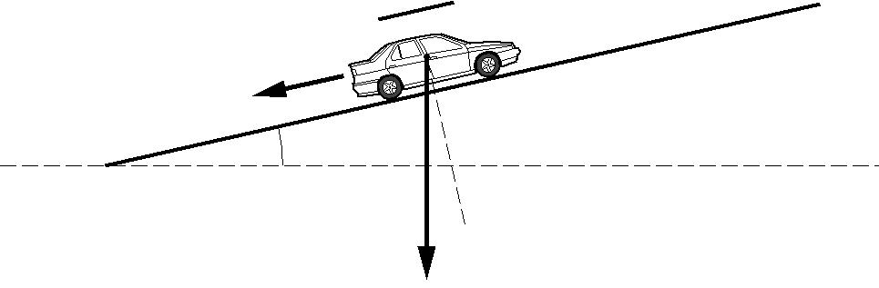

300 N

 7.0

7.0

9000 N

**Fig. 5**

The angle between the slope and the horizontal is 7.0°. The weight of the car is 9000 N. The car travels up the slope at a constant speed of 18 ms–1. A resistive force of 300 N acts on the car down the slope.

1. What is the net force acting on the car? Explain your answer.

...........................................................................................................................................

...........................................................................................................................................

.................................................................................................................................... **[2]**

1. Calculate the component of the weight of the car acting down the slope.

component of weight = ..................................................... N **[2]**

**(iii)** The driver parks the car on the hill but the handbrake is faulty and can only provide a constant resistive force of 800 N.

Calculate the acceleration of the car down the slope as it begins to roll.

…………………………ms-2

**[5]**

**9. Drag and Friction**

**Independent Study tasks this week:**

|  |  |
| --- | --- |
| **Notes:** | **Completed ✓** |
| Make revision notes/cards on Drag and Friction including details about the experiment to measure terminal velocity of the ball bearing in glycerol. |  |
| **Independent Study Learning task:**  Complete the ‘Terminal velocity of a paper case’ question at the end of this section on paper. Ready to hand in for marking. | **C** |
| **Isaac Physics**  Equations of motion – 1D - freefall gameboard |  |
| **Independent Study Practice Questions:**  complete all the questions in the spaces provided | **C** |

**1** **(a)** A skydiver jumps from a stationary hot-air balloon several kilometres above the ground.

In terms of acceleration and forces, explain the motion of the skydiver

**immediately** after jumping

...........................................................................................................................................

...........................................................................................................................................

...........................................................................................................................................

..........................................................................................................................................

...........................................................................................................................................

...........................................................................................................................................

at a time **before** terminal velocity is reached

...........................................................................................................................................

...........................................................................................................................................

...........................................................................................................................................

...........................................................................................................................................

...........................................................................................................................................

**At** terminal velocity.

...........................................................................................................................................

...........................................................................................................................................

...........................................................................................................................................

...........................................................................................................................................

…………....................................................................................................................................**[6]**

1. In the final stage of the fall, the skydiver is falling through air at a constant speed. The skydiver’s kinetic energy does not change even though there is a decrease in the gravitational potential energy. State what happens to this loss of gravitational potential energy.

..........................................................................................................................................

………...........................................................................................................................................**[1]**

**(c)** Fig. 1 shows a sketch graph of the variation of the velocity*v*of the skydiver with time*t*.

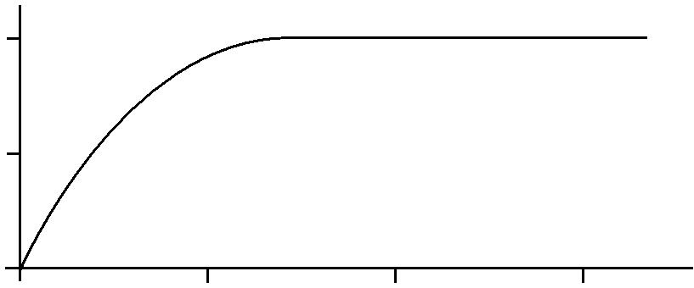

*v* / m s–1

50

25

**Fig. 1**

0

0 10 20 30

t/s

**1** Suggest the changes to the graph of Fig. 1, if any, for a more massive (heavier) skydiver of the same shape.

...................................................................................................................................................

...................................................................................................................................................

...................................................................................................................................................

.............................................................................................................................................. **[2]**

**2** The terminal velocity of a raindrop falling vertically through air is 4.0 ms–1.

* 1. In terms of the forces acting on the raindrop, explain why it is at terminal velocity.

...........................................................................................................................................

...........................................................................................................................................

.................................................................................................................................... **[2]**

1. Fig. 2 shows a velocity vector diagram for the falling raindrop in a horizontal crosswind of speed 1.5 m s–1.

raindrop

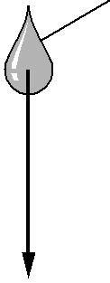

1.5 m s–1

4.0 m s–1

**Fig. 2**

1. On Fig.2, draw an arrow on the raindrop to show the **direction** in which it will travel.
2. Calculate the magnitude of the resultant velocity of the raindrop. Use the space below for your working.

resultant velocity = ............................................... m s–1 **[3]**

**3** **(a)** According to Aristotle (384 – 322 B.C.)

‘heavier objects fall faster than lighter ones’.

Explain how one experiment carried out by Galileo (1564 – 1642) overturned Aristotle’s ideas of motion.

...................................................................................................................................................

...................................................................................................................................................

...................................................................................................................................................

...................................................................................................................................................

...................................................................................................................................................

............................................................................................................................................ **[3]**

**(b)** In order to find ‘*g’*, the *Galileo Society* decides to drop a basketball from a high tower, 125m above the ground. They record the time taken as 5.53 s. Calculate the value of *g* obtained with this data.

……………………………………………ms-2

**[3]**

(c) Disappointed with their answer they repeat the experiment with a very heavy ball of similar size to the basketball and obtain a value for acceleration of free fall as 9.69 ms-2. Explain why the new value is closer to the accepted value of 9.81 ms-2.

…………………………………………………………………………………………………

…………………………………………………………………………………………………

…………………………………………………………………………………………………

…………………………………………………………………………………………………

………….……………………………………………………………………………………**[2]**

1. **(a)** State two factors that affect the magnitude of the drag force acting on an object fallingthrough air.

1. ………………………………………………………………………………………

2. ………………………………………………………………………………………**[2]**

**(b)** Fig. 4 shows a skydiver of total mass 75 kg falling vertically towards the ground.

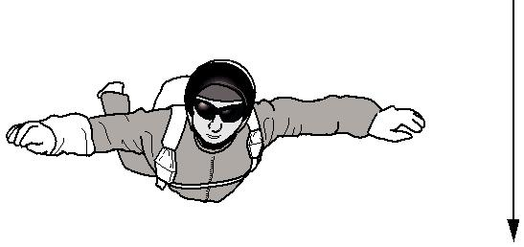

direction of fall

**Fig. 4**

The air resistance, or drag force, *D* in newtons (N) acting on the skydiver falling through the air is given by the equation

*D* = 0.3*v* 2

where *v* is the speed in m s–1 of the skydiver.

1. On Fig. 4.1, draw arrows to represent the weight (labelled *W* ) and drag force (labelled

*D* ). **[1]**

1. Calculate the weight of the skydiver.

weight = ........................................................ N **[1]**

1. At a particular instant, the speed of the skydiver is 20 ms–1. Calculate the instantaneous acceleration of the skydiver.

acceleration = ......................................... ms–2 **[3]**

1. State the relationship between the forces *W* and *D* when the skydiver reaches terminal velocity.

.........................................................................................................................................

...................................................................................................................................... …**[1]**

1. Determine the terminal velocity of the skydiver.

terminal velocity = ................................... ms–1 **[2]**

[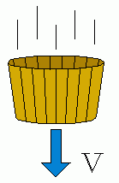](https://www.lhup.edu/~dsimanek/scenario/labman1/viscous.htm)**Terminal velocity of paper cases.**

When a paper cake case is dropped it reaches a terminal velocity. It is believed that the speed is related to the effective surface area. More specifically it is believed that the speed is proportional to the square of the effective diameter. Design an experiment to test this hypothesis. You may assume that normal lab equipment would be available.

In your answer you should indicate

* What equipment you require
* What measurements you will take.
* How you will use the equipment and use these measurements
* Any safety precautions
* Measures to reduce uncertainty
* How you can verify the hypothesis

**10. Moments and Torque**

**Independent Study tasks this week:**

|  |  |
| --- | --- |
| **Notes:** | **Completed ✓** |
| Make revision notes/cards on Moments and Torque |  |
| **Independent Study Learning task:**  Read pages 58 and 59 and make notes on the worked examples for the simple see-saw and loaded bridge. | **C** |
| **Isaac Physics**  Moments gameboard |  |
| **Independent Study Practice Questions:**  complete all the questions in the spaces provided | **C** |

1. The diagram shows a wheel freely pivoted at its centre. Two forces are applied to the wheel as shown. Calculate the turning moment of each force and identify whether the wheel will remain at rest, and if not, in which direction it will rotate.

0.5m

0.8m

12N

8N

Moment of 12N Force =

Moment of 8N Force =

Wheel turns Yes/No

Direction …………………………………………

**[3]**

2. A lever of length 100cm is pivoted at one end. A weight of 20N is suspended 40cm from the pivot and an upward force at the opposite end just keeps the lever balanced.

a. Draw a diagram to represent the arrangement

**[2]**

b. Calculate the magnitude of the upward force.

**[3]**

3. A metre rule is pivoted at its centre. A weight of 1N is suspended at the 30cm mark while a 2N weight is suspended at the 90cm mark.

a. Draw a diagram to represent the situation

**[2]**

b. Show via calculation and explain why the system is not balanced

**[2]**

c. Where must an upwards force of 3N be applied in order to restore the balance?

**[3]**

|  |  |  |
| --- | --- | --- |
| 4 |  | **(a)** Define*moment of a force*. |

|  |  |  |
| --- | --- | --- |
|  |  | ........................................................................................................................................... |
|  |  | .................................................................................................................................... **[2]** |

**(b)** Fig. 1 shows three forces acting on a rod.

30 N

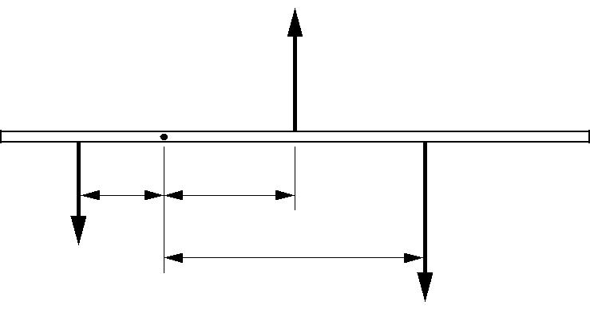

**X**

0.20 m 0.30 m

10 N

0.60 m

20 N

**Fig. 1**

By taking moments about point **X**, show that the rod is not in equilibrium when acted upon by these forces.

….......................................................................................................................................................

.…..…. ...................................................................................................................................... …….

**[3]**

**5**

**(a)** State the two conditions that apply when an object is in equilibrium.

1. ...............................................................................................................................................

2. .......................................................................................................................................... **[2]**

**(b)** Fig. 2.1 is a diagram of a human arm lifting an object.

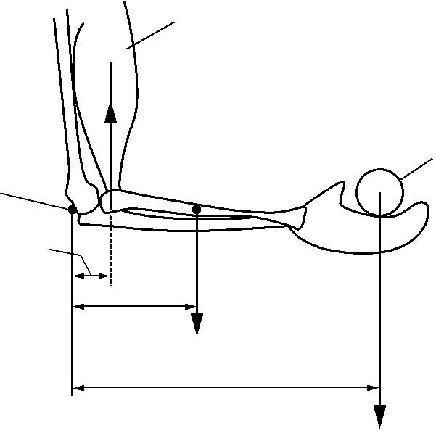

biceps muscle

*F*

object

elbow joint 0.040 m

0.150 m

18 N

0.460 m

30 N

**Fig. 2.1**

The lower arm is horizontal and its centre of gravity is 0.150 m from the elbow joint. The weight of the lower arm is 18 N. The biceps muscle exerts a vertical force *F* on the arm. The horizontal distance between the elbow joint and the point of attachment of the muscle to the lower arm bone is 0.040 m. The weight of the object held in the hand is 30 N and its centre of gravity is 0.460 m from the elbow joint. The arm is in equilibrium.

1. Define *centre of gravity.*

...........................................................................................................................................

...................................................................................................................................... **[1]**

1. Calculate the total clockwise moment about the elbow joint.

total clockwise moment = .................................................. N m **[2]**

1. As the lower arm is moved away from the body, the force *F* exerted by the biceps muscles acts at an angle *θ* to the vertical as shown in Fig.2.2.

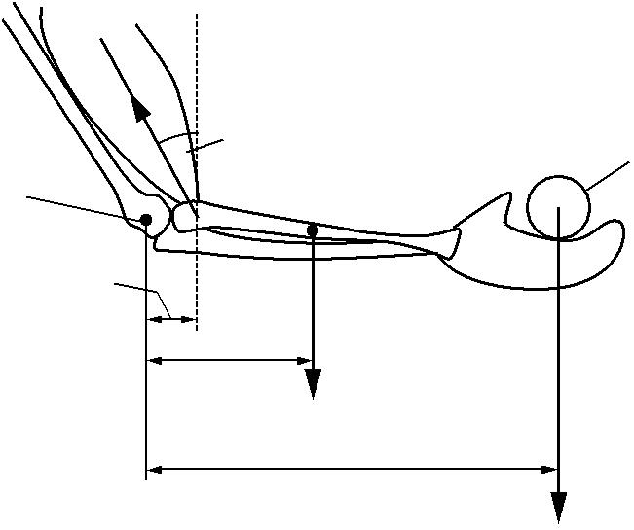

*F*

*θ*

elbow joint

0.040 m

object

0.150 m

18 N

0.460 m

30 N

**Fig. 2.2**

The lower arm remains horizontal and in equilibrium. Describe and explain what happens to each of the following quantities as the angle *θ* is increased

1. the anticlockwise moment about the elbow joint

....................................................................................................................................

....................................................................................................................................

1. the magnitude of the force *F*.

....................................................................................................................................

....................................................................................................................................

....................................................................................................................................

............................................................................................................................... **[3]**

**6 (a)** Define the following terms:

* 1. *couple*

............................................................................................................................

..................................................................................................................................**[1]**

1. *torque of a couple*.

*In your answer, you should use appropriate technical terms, spelled correctly.*

............................................................................................................................

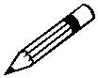

..................................................................................................................................**[1]**

**(b)** Fig. 4.1 shows a satellite in space moving from left to right.

**A** satellite

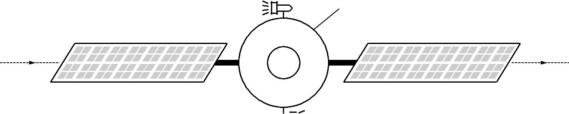

**B** 

**Fig. 4.1**

The satellite has two small rockets **A** and **B** mounted at opposite ends of a diameter. When fired, each rocket motor provides the **same** constant force, but in **opposite** directions.

Describe the change in the motion of the satellite when

1. both rocket motors are fired

............................................................................................................................

............................................................................................................................

.................................................................................................................................**[2]**

1. only rocket motor **A** is fired.

............................................................................................................................

............................................................................................................................

………………………………………………………………………………………**[2]**

**7** Fig. 4 shows a kitchen cupboard securely mounted to a vertical wall. The cupboard rests on a support at **A**.

screw

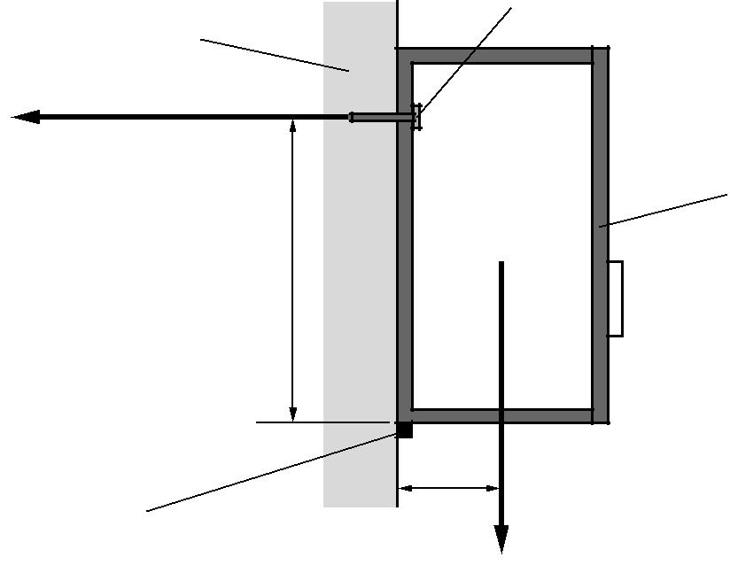

wall

*F*

cupboard

|  |  |
| --- | --- |
|  | 75 cm |
|  | **A** |
| support | 12 cm |
|  | 200 N |

**Fig. 4**

The total weight of the cupboard and its contents is 200 N. The line of action of its weight is at a distance of 12 cm from **A**. The screw securing the cupboard to the wall is at a vertical distance of 75 cm from **A**.

1. State the principle of moments.

*In your answer, you should use appropriate technical terms, spelled correctly.*

.........................................................................................................................................

.........................................................................................................................................



.......................................................................................................................................... **[2]**

1. The direction of the force *F* provided by the screw on the cupboard is horizontal as shown in Fig. 5.2. Take moments about **A**. Determine the value of *F*.

*F* = .......................................................N**[3]**

**11. Equilibrium of Forces and Moments**

**Independent Study tasks this week:**

|  |  |
| --- | --- |
| **Notes:** | **Completed ✓** |
| Make revision notes/cards on Moments and Torque |  |
| **Independent Study Preparation task:**  Read pages 65- 69 and make notes on density and pressure (solids and liquids) | **C** |
| **Isaac Physics**  Forces in equilibrium gameboard |  |
| **Independent Study Practice Questions:**  complete all the questions in the spaces provided | **C** |

**1.** The diagram shows a 250 kg iron ball being used on a demolition site. The ball is suspended from a cable at point A, and is pulled into the position shown by a rope that is kept horizontal. The tension in the rope is 1200 N.

(a) In the position shown the ball is in equilibrium.

(i) What balances the force of the rope on the ball?

(ii) What balances the weight of the ball?

(2)

(b) Determine

(i) the magnitude of the vertical component of the tension in the cable,

(ii) the magnitude of the horizontal component of the tension in the cable,

(iii) the magnitude of the tension in the cable,

(iv) the angle the cable makes to the vertical.

(6)

(Total 8 marks)

**2.** An athlete is analysing his shot putting technique so as to improve his performance. He finds that the optimum performance is achieved when the angle which his leg makes with the ground is 57° immediately before releasing the shot. The maximum force he can exert on the ground is 650 N at an angle of 57° to the ground.

(a) Draw and label arrows on the diagram to represent

(i) *T*, the force the foot exerts on the ground,

(ii) *N*, the normal reaction of the ground on the foot,

(iii) *F*, the frictional force of the ground on the foot.

(3)

(b) Calculate the magnitude of

(i) the frictional force *F*,

(ii) the normal reaction of the ground *N*.

(2)

(Total 5 marks)

**4.** (a) State the condition necessary for the equilibrium of three coplanar forces acting at a point.

(1)

(b) The diagram shows a crane hook in equilibrium under the action of a vertical force of 16.5 kN in the crane cable and tension forces *T*1 and *T*2 in the sling.

Find the tension forces *T*1 and *T*2 acting in the sling. You may **either** calculate these forces **or** find them by scale drawing. In either case you should show your method clearly.

*T*1 = ...................................

*T*2 = ...................................

(4)

(Total 5 marks)

**5.** The diagram shows the forces acting on a stationary kite. The force *F* is the force that the air exerts on the kite.



(a) Show on the diagram how force *F* can be resolved into horizontal and vertical components.

(2)

(b) The magnitude of the tension, *T*, is 25 N.  
Calculate

(i) the horizontal component of the tension,

1. the vertical component of the tension.

(2)

(c) (i) Calculate the magnitude of the vertical component of *F* when the weight of the kite is 2.5 N.

1. State the magnitude of the horizontal component of *F*.
2. Hence calculate the magnitude of *F*.

(4)

(Total 8 marks)

6. A bar is pivoted at the point ) and weights of 4N and ‘W’ are suspended from its ends. If the system balances calculate the value of ‘W’ and also the reaction at the pivot.

0

W

60cm

150cm

4N

Value of W

Reaction at pivot 0

**[4]**

7. A plank of length 6m is supported at two points A and B and the three forces shown act on the plank. Using moments, calculate the reaction forces at A and B and double check your answer using the requirements for a system to be in equilibrium.

A

10N

1m

2m

8N

B

2m

4N

Reaction force at A

Reaction force at B

Verification of answer

**[7]**

**12. Density and Pressure**

**Independent Study tasks this week:**

|  |  |
| --- | --- |
| **Notes:** | **Completed ✓** |
| Make revision notes/cards on Density and Pressure |  |
| **Independent Study Preparation task:**  Research and write an experiment plan to measure the height of Bishopgate using a barometer. |  |
| **Isaac Physics**  Equations of motion in 2D gameboard |  |
| **Independent Study Practice Questions:**  complete all the questions in the spaces provided | **C** |

**1 (a)** Define *density*.

……………………………………………………………………………………………………………

……………………………………………………………………………………………………………

**[1]**

**(b)** Define *pressure*.

……………………………………………………………………………………………………………

……………………………………………………………………………………………………………

**[2]**

**(c)** A rectangular metal block of dimension 0.30 by 0.30 by 0.50m is placed on the ground. The density of the metal is 5500 kgm-3. Calculate the minimum pressure that the metal block exerts on the ground.

…………………………………….

**[4]**

**2**  A swimming pool has a base of area 100 m2 and is filled with water to a uniform depth of 1.50m. The density of the water is 1000 kgm-3. Calculate:

**(a)** The mass of water in the pool.

………………………….kg

**[2]**

**(b)** The pressure exerted on the base of the swimming pool.

………….…………………………….

**[3]**

**3** A cylinder with base of area A is filled to a depth h with liquid of density ρ.

**(a) (i)** Show that the mass of liquid in the container is ρAh.

**[2]**

**(ii)** Show that the pressure exerted on the base of the cylinder is ρgh.

**[2]**

**(b)** Calculate the pressure exerted by 10m depth of sea water. The density of sea water is 1050 kgm-3.

…………………………………………………

**[3]**

**4**  During a commercial airliner flight, pressure inside the cabin is typically 0.90 of standard atmospheric pressure while outside it is 0.25 of standard atmospheric pressure.

Calculate the net force exerted on a square window of side 20 cm. Atmospheric pressure is 1.01 x 105 Pa.

………………………………………..N

**[4]**

5.

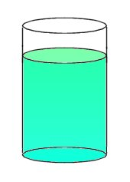

Density 

Height h

Area A

The diagram shows some liquid in a cylindrical container.

(a) (i) State the formula for the pressure at the bottom of this container, due to the liquid.

[1]

(ii) Show how this formula can be derived from the definition of pressure as Force / Area.

[3]

(iii) In which direction does this pressure act?

[1]

7. (b) A submarine is at a depth of 500m in seawater of density 1040kgm-3 .If the pressure

inside the submarine is atmospheric (1.01 × 105 Pa), calculate the resultant force on a

section of the hull of area 20m2. Take g = *9.81ms-2*

[4]

Total 9 marks

**13. Progress Test B**

**Independent Study tasks this week:**

|  |  |
| --- | --- |
| **Notes:** | **Completed ✓** |
| Read document ‘Revision – What does it look like?’ Q:\Physics\Year 12 Mechanics\Revision resources\Revision what does it look like.docx  Prepare revision resources for all Mechanics topics to date and complete practice questions to revise for a topic test. | **C** |
| **Independent Study task:**  Revision questions to help consolidation and practice :  Q:\Physics\Year 12 Mechanics\Revision resources\2 Mechanics B resources\Past Paper questions Revision Mechanics Dec.docx | **C** |
| **Isaac Physics**  Complete previous questions not attempted as revision |  |
| **Independent Study Practice Questions:**  Further questions can be found in the Mechanics past papers  Q:\Physics\AS Exam papers\Mechanics |  |
| **Test Analysis**  When you have your marked test, correct any errors fully and note target areas for improvement on the front of this booklet. | **C** |