BWS A’ Level Physics

Year 12 Independent Study Forces and Motion Booklet A

Write all your answers in the spaces provided and use additional sheets where necessary.

This booklet is available for download on the website but may be updated so check you have an up to date copy.

A **C** by a certain activity indicates this is compulsory and must be completed ready for the next week as your lessons may depend on your ability to follow certain techniques or content.

Finally this booklet **must** be available for inspection at all times in your file.

Grade boundaries throughout for consolidation work are:

* A 80%
* B 70%
* C 60%
* D 50%
* E 40%
* U <40%

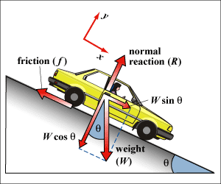

|  |  |  |  |  |  |  |
| --- | --- | --- | --- | --- | --- | --- |
| Week | Topic | **Prep / Consolidation** | Practice | | | Target Areas for improvement |
| Complete | Practice Mark and Grade | Corrected |
| 1 | Base units and the SI system |  |  | /30 Grade: |  |  |
| 2 | Vectors |  |  | / 33 Grade: |  |  |
| 3 | Velocity, displacement & acceleration |  |  | / 30 Grade: |  |  |
| 4 | Equations of linear motion (“SUVAT”) |  |  | / 36 Grade: |  |  |
| 5 | PAG Experiment to determine g and uncertainties |  |  | / 36 Grade: |  |  |
| 6 | Projectiles and Freefall 1 |  |  | /40 Grade: |  |  |
| 7 | Progress Test A |  |  |  |  |  |

1. **Base Units and the SI System**

**Independent Study tasks this week:**

|  |  |
| --- | --- |
| **Notes:** | **Completed ✓** |
| Make revision notes/cards on the SI base units, prefixes and derived units, learn prefixes and practice using (p9 text book) |  |
| **Independent Study Learning Preparation task:**  Read sections 2.3 – 2.6 p 12 – 19 and make a list of scalar and vector quantities |  |
| **Isaac Physics**  Create an account at <https://isaacphysics.org/login> using your school email address  Link to teacher via code provided to you & complete questions A1 |  |
| **Independent Study Practice Questions:**  complete all the questions in the spaces provided |  |

**1** Match up the physical quantities to the relevant base unit by drawing straight lines from quantity to unit.

Temperature Ampere

Mass Second

Amount of substance Metre

Electric current Kilogram

Time Kelvin

Length mole

**[3]**

**2** Work out the derived unit for:

Area ………………………

Volume…………………..

Density……………………

Speed……………………..

Acceleration……………… **[5]**

**3 (a) (i)** Show that the *newton* is equivalent to kgms-2

**[2]**

**(ii)** Show that the *pascal* is equivalent to kgm-1s-2.

**[2]**

**(b) (i)** Given that Work done = Force x distance moved in direction of the force, find the derived unit for the *joule.*

joule is equivalent to …………………**[2]**

**(ii)** Break the *watt* down into base units.

watt is equivalent to…………………….………………..**[2]**

**4** Show that the following famous equations are homogenous:

**(a)** E = mc2

Where E is energy, m is mass and c is speed of light.

**[2]**

**(b)** Ek = ½ mv2

Where Ek is energy, m is mass and v is speed.

**[2]**

**(c)** v = fλ

Where v is speed, f is frequency and λ is wavelength. (Hint: Frequency is reciprocal of time period.)

**[2]**

**5** Decide whether the following equations are homogenous or not. An equation cannot be correct physics if it is not homogenous. You must show some logical reasoning to be awarded any marks.

**(a) $P=\frac{ρ c}{3}$** Where P is pressure, c is speed and ρ is density.

Yes/no………………….**[2]**

**(b)** P = Fv where P is power, F is force and v is speed.

Yes/no……………….**[2]**

**(c)** s =ut + ½ at2 where s is distance, a is acceleration, u is speed and t is time.

Yes/no………………….**[2]**

**(d)** v2 = 2as2 where v is velocity, a is acceleration and s is distance.

Yes/no………………….**[2]**

1. **Vectors**

**Independent Study tasks this week:**

|  |  |
| --- | --- |
| **Independent Study Review Task:** | **Completed ✓** |
| Make revision notes/cards on Vectorsand complete TAP 201-4 –Flying in a side wind questions (Q:drive) |  |
| **Independent Study Preparation task:**  Read sections 3.1 – 3.4 p22 – 30 and complete motion preparation sheet to bring to lesson(Q;drive)the ‘Introduction to kinematics LJK’ powerpoint might help too. |  |
| **Isaac Physics**  Read the concept guide on Ohms Law |  |
| **Independent Study Practice Questions:**  complete all the questions in the spaces provided |  |

1. **(a)** State **one** difference between a scalar quantity and a vector quantity.

...................................................................................................................................................

.............................................................................................................................................. **[1]**

**(b)** Fig. 1.1 shows two sets of quantities listed as ‘scalars’ and ‘vectors’ by a student.

|  |  |  |
| --- | --- | --- |
| acceleration |  | displacement |
| pressure |  | energy |
| stress |  | power |
| time |  | velocity |
| volume |  | weight |
|  |  |  |
| **scalars** |  | **vectors** |
|  | **Fig. 1.1** | |

1. State the one quantity that has been incorrectly listed as a scalar.

...................................................................................................................................... **[1]**

1. State two quantities that have been incorrectly listed as vectors.

1. ..................................................................

2. .................................................................. **[1]**

1. State two quantities listed as scalars that have the same unit. List them below. Add the unit

1. ..................................................................

2. ..................................................................

unit: ..............................................................

[**2]**

**(c)** Circle the correct value for the prefix tera (T) in the list below.

106 109 1012 1015

**(d)** Rearrange the following prefixes in the order of smallest to largest. **[1]**

m c p k M

.............................................................................................................................................. **[1]**

1. **(a)** State a similarity and a difference between*distance*and*displacement*.
   1. similarity: ...........................................................................................................................

...................................................................................................................................... **[1]**

**(ii)** difference: ..........................................................................................................................

...................................................................................................................................... **[1]**

**(b)** Fig. 2 shows two airports **A** and **C**.

north

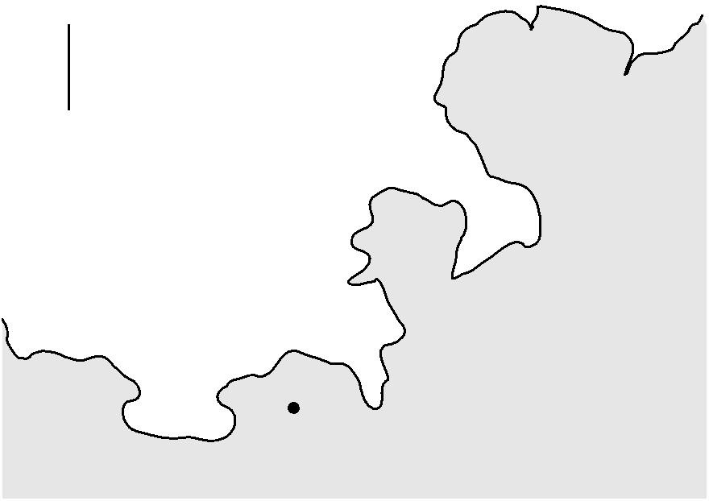

**B**  **C**

sea

land

**A**

**not to scale**

**Fig. 2**

An aircraft flies due north from **A** for a distance of 360 km (3.6 × 105 m) to point **B**.

Its average speed between **A** and **B** is 170 m s–1. At **B** the aircraft is forced to change course and flies due east for a distance of 100 km to arrive at **C**.

1. Calculate the time of the journey from **A** to **B**.

time = ....................................................... s **[1]**

1. Draw a labelled displacement vector triangle below. Use it to determine the magnitude of the displacement in km of the aircraft at **C** from **A**.

displacement = .................................................... km **[3]**

**3. (a)** Fig. 3.1 shows the velocity vector for a particle moving at an angle of 31° to the horizontal.

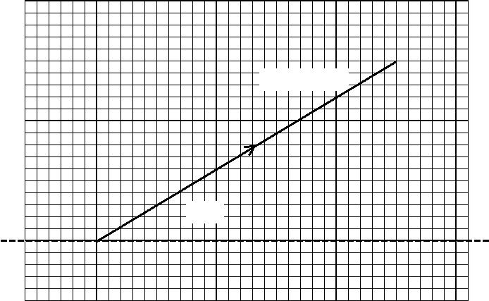

8ms-1

31o

**Fig. 3.1**

1. On Fig. 4.1, show the horizontal (*x*-direction) and vertical (*y*-direction) components of the

velocity. **[2]**

1. Calculate the horizontal (*x*-direction) component of the velocity.

velocity = ................................................ m s–1 **[1]**

**(c)** Fig. 3.2 shows a ship **S** being pulled by two tug-boats.

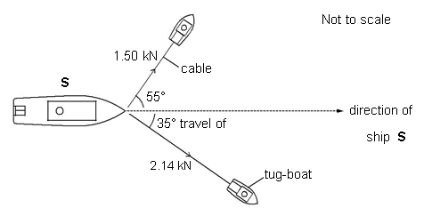

The ship is travelling at a constant velocity. The tensions in the cables and the angles made by these cables to the direction in which the ship travels are shown in Fig. 3.2.

1. Draw a vector triangle and determine the resultant force provided by the two cables.

resultant force = .................................................... kN **[3]**

1. State the value of the drag force acting on the ship **S**. Explain your answer.

...........................................................................................................................................

...........................................................................................................................................

.......................................................................................................................................... .**[2]**

1. **(a)** Complete the table of Fig. 4 by stating the value or name of each of the remaining threeprefixes.

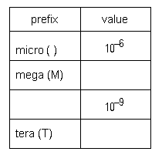

**Fig. 4.**

**[3]**

**(b)** Circle all the scalar quantities in the list below.

**density** **weight** **velocity** **volume** **acceleration**

**[1]**

1. The distance between the Sun and the Earth is 1.5 x 10 11 m. Calculate the time in minutes for light to travel from the Sun to the Earth. c = 3.0 x 10 8 ms-1.

time = ..................................................min **[2]**

**5** Fig. 5.1 shows the forces acting on a stage light of weight 120 N held stationary by two separate cables.

 ceiling

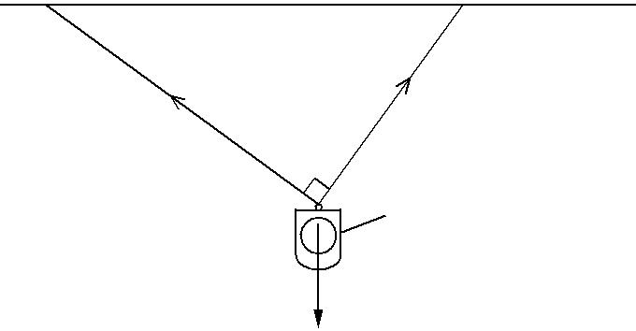

cable  cable

*T*

70 N

90°

stage light

120 N

**Fig. 5.1**

The angle between the two cables is 90°. One cable has tension 70 N and the other has tension *T*.

1. State the magnitude and the direction of the **resultant** of the tensions in the two cables. magnitude .........................................................................................................................

direction ........................................................................................................................ **[2]**

1. Sketch a labelled vector triangle for the forces acting on the stage light. Hence, determine the magnitude of the tension *T*.

*T* =..............................................................N**[4]**

1. **Velocity, displacement & acceleration**

**Independent Study tasks this week:**

|  |  |
| --- | --- |
| **Notes:** | **Completed ✓** |
| Make revision notes/cards on s-t, v-t graphs, gradients, areas etc, and definitions s, v, a |  |
| **Independent Study Learning task:**  Research how average speed cameras and hand held/fixed position speed cameras work to identify speed of a vehicle. |  |
| **Isaac Physics**  Complete questions A3 Standard Form and Prefixes |  |
| **Independent Study Practice Questions:**  complete all the questions in the spaces provided |  |

1. Fig. 1 shows a graph of velocity against time for an object travelling in a straight line.

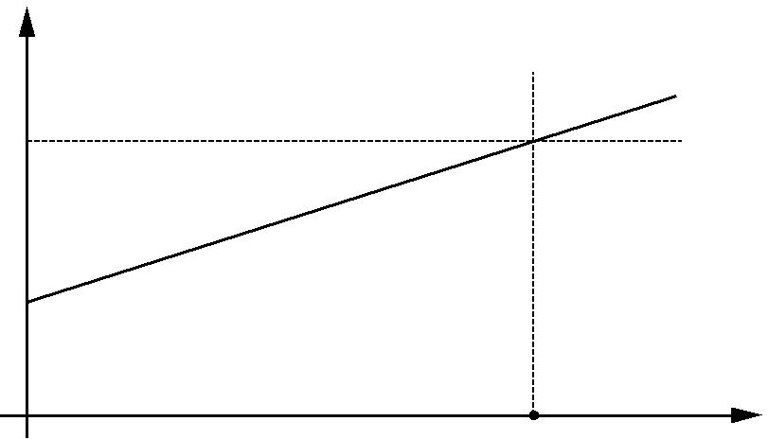

velocity

*v* 

*u* 

0

|  |  |  |  |
| --- | --- | --- | --- |
| 0 | *t* | time |  |
|  |  |  |

**Fig. 1**

The object has a constant acceleration *a*. In a time *t* its velocity increases from *u* to *v*.

1. Describe how the graph of Fig. 1 can be used to determine
   1. the acceleration *a* of the object

*In your answer, you should use appropriate technical terms, spelled correctly.*

….........................................................................................................................

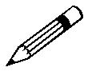

..................................................................................................................................

**[1]**

1. the displacement *s* of the object.

...........................................................................................................................

............................................................................................................................

**[1]**

**b)** Define*acceleration*.

....................................................................................................................................

.................................................................................................................................... **[1]**

**(c)** A super-tanker cruising at an initial velocity of 6.0 m s–1 takes 40 minutes to come to a stop. The super-tanker has a constant deceleration.

1. Calculate the magnitude of the deceleration.

deceleration...............................................ms–2

**[3]**

1. Calculate the distance travelled in the 40 minutes it takes the tanker to stop.

distance..................................................m **[2]**

1. On Fig. 1.1, sketch a graph to show the variation of distance *x* travelled by the super-tanker with time *t* as it decelerates to a stop.

*x* / km

10

5

0

|  |  |  |
| --- | --- | --- |
| 0 | 20 | 40 |
|  |  | *t* / mins |
|  | **Fig. 1.1** | **[2]** |

1. (a) Define*velocity*.

....................................................................................................................................

....................................................................................................................................**[1]**

1. A heavy ball is dropped from a high tower and reaches a velocity of 29.4 ms-1 in a time of 3 s before hitting the ground. Calculate the acceleration of the ball.

Acceleration……………………………**[2]**

**(c)** Calculate the height from which the ball was dropped.

Height…………………… …**[3]**

1. **(i)** In the space belowsketch a graph of the height fallen (y) against the time (x). Label key data.

**[4]**

1. Describe how you would find the velocity at t = 2.0 s using your graph.

…………………………………………………………………………………………

…………………………………………………………………………………………

…………………………………………………………………………………………

…………………………………………………………………………………………

**[2]**

1. Light travels at 3.0 x 10 8 ms-1 and takes 8.33 minutes to reach the Earth from the Sun.
2. Calculate the distance from the Earth to the Sun

Distance…………………**[2]**

1. Light from the nearest star to the Sun takes approximately 4 years to reach it. How far away is this star from the Sun?

Distance …...……….………**[2]**

1. The furthest observable objects from the Earth are approximately 14 billion light years away from us.
2. Calculate the distance light travels in one year, the ‘light year.’

……………………m **[2]**

1. Calculate the volume of the observable universe.

……………………..m3 **[2]**

1. **Equations of Linear Motion (“SUVAT”)**

**Independent Study tasks this week:**

|  |  |
| --- | --- |
| **Notes:** | **Completed ✓** |
| Make revision notes/cards on SUVAT and learn equations and techniques for using |  |
| **Independent Study Preparation task:**  Read PAG 1 ready to complete Q:\Physics\AS-A2 BWS PAG activities\PAG 1 Dynamics\BWS Physics_Student_Sheet_1.1_Acceleration_of_Free_Fall_v1.2.docx | **C** |
| **Isaac Physics**  Complete questions A4 Converting units |  |
| **Independent Study Practice Questions:**  complete all the questions in the spaces provided | **C** |

**1 (a)** Starting with the equations v = u + at and s = ½ (u +v)t, derive the equation v2 = u2 + 2as.

**[3]**

**(b)** Use the equations v = u + at and s = ½ (u +v)t to prove that s = ut + ½ at2.

**[3]**

**2** A train starts from rest and accelerates at 0.50 ms-2 for a time of 2 minutes.

**(a)(i)** Calculate the distance travelled.

…………………………………m

**[2]**

**(ii)** Calculate the velocity obtained.

……………………………….m/s **[2]**

**(iii)** The train now has to perform and emergency stop, braking and stopping in a distance of 1.5 km. Calculate the deceleration of the train.

Deceleration………………………… m/s2

**[2]**

**3**  Fig.1 below shows the variation of braking distance with speed *v* of a car.

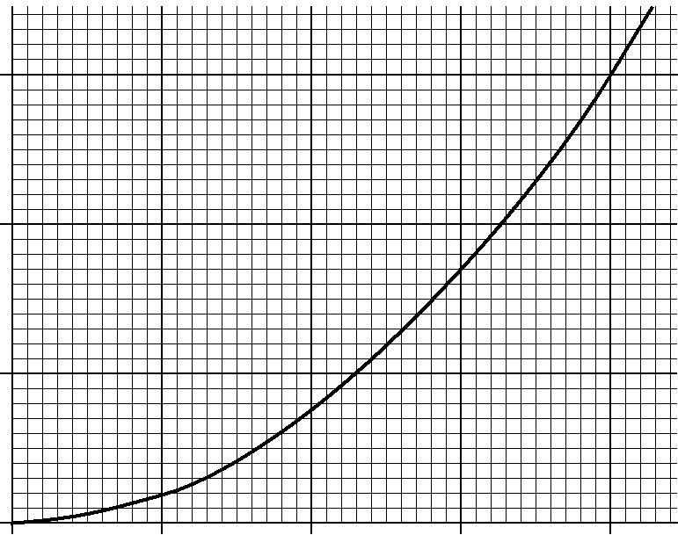

30

braking distance / m

20

10

|  |  |  |  |  |
| --- | --- | --- | --- | --- |
| 0 |  |  |  |  |
| 0 | 5 | 10 | 15 | 20 |

*v* / m s–1

**Fig. 1**

**(i)** The car is travelling on a level straight road at a speed of 20 m s–1. The reaction time of the driver is 0.50 s.

**1** Calculate the thinking distance.

thinking distance = .................................................. m

**[1]**

**2** Hence, determine the stopping distance of the car.

stopping distance = ........................................................... m

**[3]**

1. In Fig. 1, the braking distance is directly proportional to the square of the speed. Determine the braking distance of the car when travelling at a speed of 32 m s–1.

…………………m

**[3]**

**4**  A driver travelling in a car on a straight and level road sees an obstacle in the road ahead and applies the brakes until the car stops. The initial speed of the car is 20 m s–1. The reaction time of the driver is 0.50 s.

Fig. 2. shows the velocity against time graph for the car.

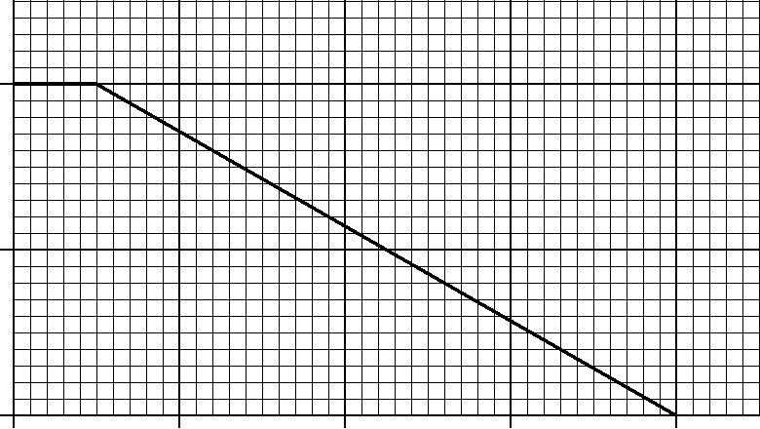

|  |  |  |  |  |
| --- | --- | --- | --- | --- |
| 20 |  |  |  |  |
| velocity / m s–1 |  |  |  |  |
| 10 |  |  |  |  |
| 0 |  |  |  |  |
| 0 | 1.0 | 2.0 | 3.0 | 4.0 |
|  |  | time / s |  |  |

**Fig. 2**

1. Define *thinking distance*.

............................................................................................................................................

...................................................................................................................................... **[1]**

**(b)** What does the area under a velocity against time graph represent?

...................................................................................................................................... **[1]**

1. Use your answer to **(b)** and Fig. 2 to determine the overall stopping distance

Overall stopping distance...................................................m **[3]**

**5** A rock is dropped from the edge of a vertical cliff, 30 m above the sandy beach below. The rock accelerates at 9.81 ms-2.

**(a)** Calculate the impact speed of the rock.

Impact speed ……………m/s

**[2]**

**(b)** Calculate the time taken to hit the sandy beach below.

Time ……………………...s

**[2]**

**(c)** The rock decelerates rapidly upon impact, coming to rest in a distance of 5.0 cm. Calculate the deceleration of the rock on impact with the sand.

Deceleration………………………………….. **[4]**

**6** A ball approaches a tennis racquet with a velocity of 21ms-1. The tennis racquet gives it an average acceleration of 3000ms-2 for 0.020 s in the opposite direction to its initial velocity.

**(a)** What is the velocity of the ball after leaving the racquet?

…………………………….ms-1

**[2]**

**(b)** Over what distance is the racquet in contact with the ball?

…………………………………m

**[2]**

1. **Experiment to determine g and uncertainty calculations**

**Independent Study tasks this week:**

|  |  |
| --- | --- |
| **Notes:** | **Completed ✓** |
| Using text book p 37-39 Make revision notes on the three methods to measure g experimentally:  Electromagnet and trap door, light gates and taking pictures. | **C** |
| **Independent Study Practical task:**  Complete the ‘Determining g by plotting a graph’ section work on p 39 including the graph and calculation questions. |  |
| **Isaac Physics**  Complete questions B1 components of a Vector |  |
| **Independent Study Practice Questions:**  Complete the questions in the spaces provided showing all working | **C** |

**1** In order to estimate the acceleration *g* of free fall, a student drops a large stone from a tall building. The height of the building is known to be 32 m. Using a stopwatch, the time taken for the stone to fall to the ground is 2.8 s.

* 1. Use this information to determine the acceleration of free fall.

acceleration = ................................................. m s–2

**[2]**

1. One possible reason why your answer to **(c)(i)** is smaller than the accepted value of

9.81ms-2 is the reaction time of the student. State another possible reason why the answer is smaller than 9.81 ms–2.

....................................................................................................................................

..…...….............................................................................................................................. **[1]**

**2**  An electromagnet and trapdoor arrangement can be used to find *g*, the acceleration of freefall.

A steel ball is held at rest by an electromagnet. When the electromagnet is switched off, the electronic timer is started and the ball falls. The timer is stopped when the ball opens the trapdoor. The distance between the bottom of the ball and the top of the trapdoor is 0.600 m. The timer records a time of fall of 0.356 s.

1. Show that the value for the acceleration *g* of free fall obtained from this data is 9.47 ms-2.

**[2]**

1. State **one** reason why the experimental value in **(i)** is less than 9.81 ms–2.

.........................................................................................................................................

.........................................................................................................................................

.........................................................................................................................................

**[1]**

1. On Fig. 2.2 sketch a graph to show the variation of the vertical distance *s* fallen by the ball with time *t*.

**[1]**



s/m

0.6

0.3

0.0

0.0

0.365

t/s

**Fig. 2.2**

**3 (a)** A student wishes to measure the acceleration of freefall *g* by dropping a heavy metal ball into a sandpit from various heights. Describe how g may be obtained. Include:

* The measurements taken.
* The instruments used.
* The graph plotted.
* How g is obtained.
* An explanation as to why *g* is only an estimate.

………………………………………………………………………………………………………………………………………………………………..

………………………………………………………………………………………………………………………………………………………………..

………………………………………………………………………………………………………………………………………………………………..

………………………………………………………………………………………………………………………………………………………………..

………………………………………………………………………………………………………………………………………………………………..

………………………………………………………………………………………………………………………………………………………………..

………………………………………………………………………………………………………………………………………………………………..

………………………………………………………………………………………………………………………………………………………………..

………………………………………………………………………………………………………………………………………………………………..

………………………………………………………………………………………………………………………………………………………………..

………………………………………………………………………………………………………………………………………………………………..

………………………………………………………………………………………………………………………………………………………………..

………………………………………………………………………………………………………………………………………………………………..

………………………………………………………………………………………………………………………………………………………………..

………………………………………………………………………………………………………………………………………………………………..

………………………………………………………………………………………………………………………………………………………………..

………………………………………………………………………………………………………………………………………………………………..

………………………………………………………………………………………………………………………………………………………………..

………………………………………………………………………………………………………………………………………………………………..

………………………………………………………………………………………………………………………………………………………………..

…………………………………………………………………………………………………………………………………………………………….**[5]**

**(b)** A particular piece of data shows drop height, s = 2.00 m and the time t = 0.69 s. The student estimates the uncertainty in time, Δt = 0.10 s.

Show that the percentage uncertainty in t is 14%.

**[1]**

**(c)** What is the percentage uncertainty in t2?

………………………………………….%

**[1]**

**(d)** Using the equation s = ½ gt2, show the value of g obtained with this data would be 8.4 ms-2.

**[2]**

**(e)** Given that the percentage uncertainty in s is 2%, estimate the total percentage uncertainty in the student’s value of g. Hint: Add individual errors.

………………………………….%

**[3]**

**(f)** Calculate the percentage difference between the student’s value of 8.4 ms-2 and the accepted value of 9.8 ms-2.

………………………%

**[2]**

**(g)** Explain why the student’s value for g cannot be considered accurate.

……………………………………………………………………………………………………………………………………………………………………

……………………………………………………………………………………………………………………………………………………………………

……………………………………………………………………………………………………………………………………………………………… **[2]**

**4** A juggler throws a ball vertically upward at speed of 5.0 ms-1.

(a) Calculate the time taken for the ball to reach maximum height.

……………..s

**[2]**

(b) State the total time of flight.

……………….s

**[1]**

(c) Calculate the maximum height reached.

………………………m **[2]**

**Uncertainty Calculations**

1. What is the percentage uncertainty in a length of 76mm measured with a metre ruler that has a millimetre scale?

[1]

1. What is the percentage uncertainty for these values for the time of a pendulum swing?

0.63s, 0.65s, 0.62s, 0.65s, 0.61s, 0.62s

[1]

1. If a human’s reaction time is 0.2s, what percentage would this be of each pendulum swing for Qu2?

[1]

1. Suggest a method to reduce the percentage uncertainty due to reaction time when using a manual stopclock to measure the time for a pendulum swing and explain why it reduces the uncertainty.

[1]

1. A compound variable is calculated using the formula: $y=\frac{ab}{c^{3}}$. What is the percentage uncertainty in y if the percentage uncertainty in a is 3%, b is 6% and c is 2%?

[1]

1. Two students compare the width of their hand spans by spreading their fingers as wide as they can. The two measurements are 22.7 ±0.1cm and 23.2±0.1cm. What is the percentage uncertainty in the difference in their hand spans?

[1]

1. The diameter of a solid sphere is measured with Vernier callipers to be 4.73 ±0.01cm and its mass is measured to be 429.20 ± 0.01g.
   1. Calculate the density of the sphere in kgm-3.

[1]

* 1. Calculate the percentage uncertainty in the density.

[1]

1. **Projectiles and Freefall 1**

**Independent Study tasks this week:**

|  |  |
| --- | --- |
| **Notes:** | **Completed ✓** |
| Make revision notes/cards on projectiles |  |
| **Independent Study Preparation task:**  Read PAG 1 ready to complete Q:\Physics\AS-A2 BWS PAG activities\PAG 1 Dynamics\BWS Physics_Student_Sheet_1.1_Acceleration_of_Free_Fall_v1.2.docx | **C** |
| **Isaac Physics**  Complete questions B3 Uniform Accelerated Motion in One dimension |  |
| **Independent Study Practice Questions:**  complete all the questions in the spaces provided | **C** |

**1.**  A small block of wood is held at a horizontal distance of 1.2 m from a metal ball. The metal ball is fired horizontally towards the block at a speed of 8.0 m s–1. At the same instant the ball is fired, the block is released and it falls vertically under gravity.

Fig. 3 shows the paths of the metal ball and the block. The ball collides with the block. Air resistance is negligible.

* 1. m

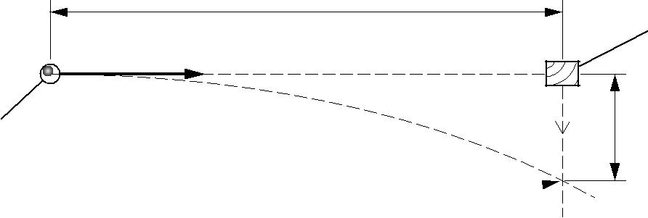wood block

8.0 m s–1

|  |  |
| --- | --- |
| metal ball | *h* |



**Fig. 3**

Ball and block collide here

**(a)** Show that the time between firing the ball and it colliding with the block is 0.15 s.

**[1]**

1. Calculate the vertical distance *h* fallen by the wooden block when it collides with the metal ball.

*h* = ............................................ m

**[2]**

1. Briefly explain why the metal ball will always collide with the wood block, even if the speed of the ball or the horizontal distance is changed.

.............................................................................................................................................

.............................................................................................................................................

............................................................................................................................................

**[1]**

1. Fig. 2 shows the path of a metal ball fired at a velocity of 24 ms–1 at an angle of 30° to the horizontal.

|  |  |  |  |  |
| --- | --- | --- | --- | --- |
| 24 m s–1 | | path of ball |  |  |
|  | **B** |  |  |
|  | |  |  |  |
| *h* |  |  |  |  |
| 30° |  |  |  |  |
|  |  |  |  |  |
| **A** | | **C** | horizontal |  |
|  |  |  |  |
|  |  |  | ground |  |

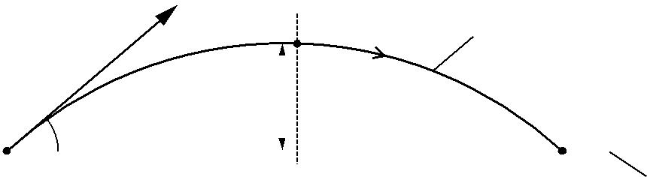

**Fig. 2**

Air resistance has negligible effect on the motion of the metal ball. The ball is fired from point **A** and it reaches its maximum height at point **B**. The mass of the ball is 450 g.

**(a)** State the direction of the acceleration of the ball during its flight.

.......................................................................................................................................**[1]**

**(b)** Calculate the horizontal and vertical components of the velocity of the ball at **A**.

horizontal velocity ................................ m s–1

vertical velocity ..................................... m s–1

**[2]**

1. Explain why the gravitational potential energy gained by the ball as it moves from **A** to **B** is not equal to its initial kinetic energy at **A**.

...................................................................................................................................................

...................................................................................................................................................

.............................................................................................................................................. **[1]**

**(d)** Calculate the maximum height h.

………………………m

**[2]**

**3**  A cannon ball is fired at 45 degrees to the horizontal at speed 60 ms-1.

**(a)** Calculate the time of flight of the cannon ball.

…………………….s

**[3]**

**(b)** Calculate the maximum height reached by the cannon ball.

…………………….m

**[2]**

**(c)** Calculate the horizontal range of the cannon ball.

……………………….m

**[2]**

**4**  A football is kicked at 20 ms-1 at an angle of 30 degrees to the horizontal.

**(a)** Calculate the vertical and horizontal components of the velocity, uv and uh.

uv………………..

uh ………………..

**[3]**

**(b)** Calculate the time of flight for the football.

……………………..s

**[2]**

**(c)** Calculate the horizontal range of the football.

………………………..m

**[2]**

**(d)** Show that the football has identical range if instead kicked at 60 degrees to the horizontal with the same speed.

**[5]**

**5.** As part of Hollywood movie *Avengers Loiter*, a car is make a jump across a gap as shown below. The car lands 45m horizontally from the launch point as shown.



(a) State the magnitude of the car’s vertical and horizontal acceleration.

Horizontal……………….

Vertical………………….

**[2]**

(b) Calculate the car’s time of flight.

………………………..s

**[2]**

1. Calculate the horizontal speed of the car

**[2]**

1. Calculate the vertical velocity on impact.

…….…………m/s

**[2]**

(e) Calculate the impact speed of the car.

………………….ms-1

**[3]**

**7. Progress Test A**

**Independent Study tasks this week:**

|  |  |
| --- | --- |
| **Notes:** | **Completed ✓** |
| Read document ‘Revision – What does it look like?’ Q:\Physics\Year 12 Mechanics\Revision resources\Revision what does it look like.docx  Prepare revision resources for all Mechanics topics to date and complete practice questions to revise for a topic test. | **C** |
| **Independent Study task:**  Revision questions to help consolidation and practice :  Q:\Physics\Year 12 Mechanics\Revision resources\1 Mechanics A resources | **C** |
| **Isaac Physics**  Complete questions B4 Trajectories |  |
| **Independent Study Practice Questions:**  Further questions can be found in the Mechanics past papers  Q:\Physics\AS Exam papers\Mechanics |  |
| **Test Analysis**  When you have your marked test, correct any errors fully and note target areas for improvement on the front of this booklet. | **C** |