BWS A’ Level Physics

Year 12 Independent Study Booklet

DC Electricity I



Write all your answers in the spaces provided and use additional sheets where necessary.

This booklet is available for download on the website but may be updated so check you have an up to date copy.

COMPULSORY by a certain activity indicates this task must be completed ready for the time stated as your lessons that week may depend on your ability to complete certain techniques or know certain content.

Finally this booklet **must** be available for inspection at all times in your file.

Grade boundaries throughout for consolidation work are:

* A 80%
* B 70%
* C 60%
* D 50%
* E 40%
* U <40%

|  |  |  |  |  |  |  |
| --- | --- | --- | --- | --- | --- | --- |
| Week | Topic | **Prep / Consolidation** | Practice | | | Target Areas for improvement |
| Complete | Practice Mark and Grade | Corrected |
| 1 | Current & Kirchhoff’s 1st Law |  |  | / 30 Grade: |  |  |
| 2 | Drift Velocity |  |  | / 48 Grade: |  |  |
| 3 | p.d |  |  | / 47 Grade: |  |  |
| 4 | Resistance |  |  | / 32 Grade: |  |  |
| 5 | IV Characteristics I |  |  | / 22 Grade: |  |  |
| 6 | IV Characteristics II |  |  | / 38 Grade: |  |  |

1. **Current and Kirchhoff’s First Law**

Independent Study tasks this week:

|  |  |
| --- | --- |
| **Notes / Revision Preparation:** | **Completed ✓** |
| Make flash cards of the circuit symbols you do not remember from GCSE. |  |
| **Independent Study Learning Preparation task:**  Research how an ammeter works and write an A4 page (including diagram) on how one functions. You are advised to look at an analogue ammeter first and consider how the same function can be completed digitally. Your work must include a diagram and a clear statement of your references. | **\*compulsory** |
| **Isaac Physics**  (see task in Mechanics work booklet) |  |
| **Independent Study Practice Questions:**  Complete all the questions in the spaces provided | **\*compulsory** |

1. Complete the table below identifying the circuit component in each case.

|  |  |  |  |
| --- | --- | --- | --- |
| 1 |  | 6 |  |
| 2 |  | 7 |  |
| 3 |  | 8 |  |
| 4 |  | 9 |  |
| 5 |  | 10 |  |

**[10]**

1. The current in a certain wire is 0.35 A. Calculate the charge passing a point in the wire:
   1. In 10 s
   2. In 10 min.

**[2]**

1. Calculate the average current in a wire through which a charge of 15 C passes in:
   1. 5 s
   2. 100 s.

**[3]**

1. Calculate the number of electrons passing a point in the wire in 1 minute when the current is:
   1. 1 μA
   2. 5.0 A

**[3]**

1. What current flows when a total electric charge of 150 C passes in in 30 s? How many electrons pass this point in this time?

**[2]**

1. Calculate the charge passing through a torch bulb in 5 minutes when the bulb carries a steady current of 0.3 A.

**[1]**

1. Calculate the number of electrons hitting a TV tube each second when the beam current is 1 mA.

**[2]**

1. The electron beam in a cathode ray tube travels a distance of 0.5 m in a vacuum. If the speed of the electrons is 8.0 × 107 ms-1 and the beam current is 2mA, calculate the number of electrons in the beam at any one instant.

**[3]**

1. In an electrolysis experiment, a steady current of 0.40 A is passed for 20 minutes through a cell containing copper sulphate solution. Copper ions from the solution are attracted to the cathode and neutralized by gaining two electrons per ion. Each copper atom leaving the anode goes in to solution as a copper ion by releasing two electrons. Calculate:
   1. The total charge passed.
   2. The number of copper atoms deposited on the cathode.
   3. The mass of copper deposited on the cathode. [Mass of Cu atom: 1.1 × 10-25 kg]

**[4]**

**Charge and I = nAve**

|  |  |
| --- | --- |
| **Notes / Revision Preparation:** | **Completed ✓** |
| Read pages 131 – 134 and make notes explaining the differences between conductors, insulators and semi-conductors |  |
| **Independent Study Learning Preparation task:**  Find out what a transistor is and why semi-conductor material needs to be used to create them. You may find the YouTube channel Veritasium helpful. |  |
| **Isaac Physics**  Complete the questions on “Drift Velocity”  <https://isaacphysics.org/questions/drift_velocity?board=917bf496-471b-4f6f-bde4-ed665b93edce> |  |
| **Independent Study Practice Questions:**  Complete all the questions in the spaces provided | **\*compulsory** |

**1** **(a)** A 12 V 36 W lamp is lit to normal brightness using a 12 V car battery of negligible internal resistance. The lamp is switched on for one hour. For the time of 1 hour, calculate

**(i)** the energy supplied by the battery

energy = ………………………..J **[3]**

**(ii)** the charge passing through the lamp

charge = …………………….unit……….**[3]**

**(iii)** the total number of electrons passing through the lamp.

number of electrons = ………………………… **[2]**

**(b)** The wires connecting the 36 W lamp to the 12 V battery are made of copper. They have a cross-sectional area of 1.1 x 10-7 m2. The current in the wire is 3.0 A. The number *n* of free electrons per m3 for copper is 8.0 x 1028 m-3.

**(i)** Describe what is meant by the term *mean* *drift* *velocity* of the electrons in the wire.

………………………………………………………………………………………………

………………………………………………………………………………………………

………………………………………………………………………………………………

………………………………………………………………………………………………

**[2]**

**(ii)** Calculate the mean drift velocity *v* of the electrons in this wire.

*v* = …………………………..m s–1 **[3]**

**2** **(a)** A trickle charger is used to fully charge a car battery. The current that flows is 5.0 A for a time of 24 hours. Calculate the total charge transferred.

…………………………………………. **[3]**

**(b)** When the car’s engine is started, the current is 100 A and this flows for a time of 4.0 s. Calculate the charge transferred.

…………………………………………………………..

**[2]**

**(c)** The car’s engine can be started until the battery falls to 95% of its full charge. Estimate the number of times the engine can be started at 100A for 4.0 s without further recharging taking place.

…..…………………………………………………..

**[3]**

**(d)** Given that the potential difference across the battery is 10.0V, calculate the energy dissipated each time the engine is started.

………………………………………………….

**[3]**

**3** A wire has diameter of 0.50 mm and has a total resistance of 100 Ω. A potential difference of 12 V is applied across the wire.

**(a)** Calculate the current that flows.

………………………………………………..

**[2]**

**(b)** Given that the mean drift velocity is 1.0 x 10-4 ms-1, calculate the number of free electrons per metre cubed in the wire.

…………………………………….**[5]**

**MCQ’s**

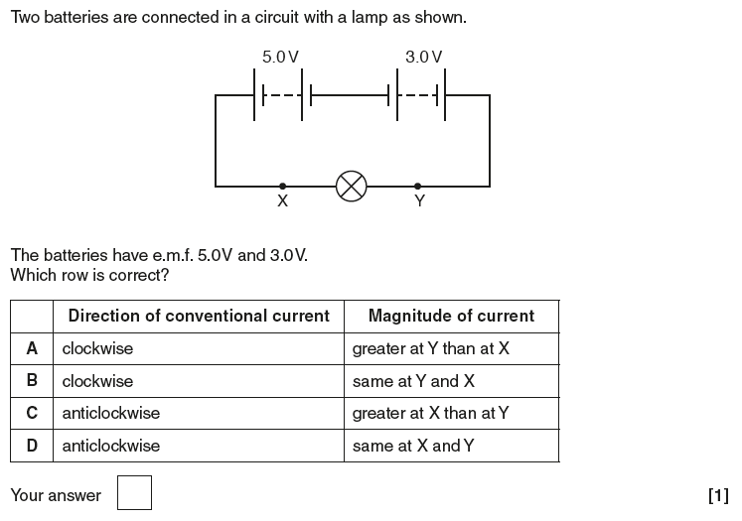

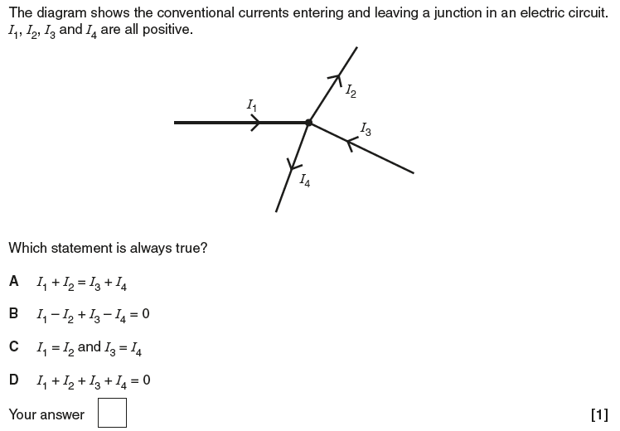

1. Calculate the drift velocity of free electrons along a copper wire of cross sectional area 5.0 × 10-7 m2 carrying a steady current of 5.0 A. [Copper contains 1.0 × 1029 electrons per m3]

[3]

1. Three different wires of the same length and cross-sectional area are connected in series as shown. Charge flows through the wire.

**A**

**B**

**C**

The densities of free electrons in the materials are:

|  |  |  |
| --- | --- | --- |
| nA | nB | nC |
| 1.0 × 10 29 m-3 | 5.0 × 10 28 m-3 | 1.0 × 10 28 m-3 |

* 1. In which wire will the electrons be moving fastest? Explain your answer.

………………………………………………………………………………………………………

………………………………………………………………………………………………………

…………………………………………………………………………………………………… [2]

* 1. Which wire would you expect to have the least resistance? Explain your answer

………………………………………………………………………………………………………

………………………………………………………………………………………………………

…………………………………………………………………………………………………… [2]

1. The cable from a car battery can be used to supply a current of 100 A. The diameter of the cable is 5.0 mm and it is made from copper (n = 1.0 × 10 29 m-3). Find the drift velocity of the electrons when the current is 100 A.

[3]

1. Two copper wires of diameter 2.00 mm and 0.50 mm respectively are joined end to end. What is the ratio of the average drift velocities in the wires when a steady current flows through them?

[2]

1. It is usually reckoned that the maximum safe current density for a piece of copper wire is 1.0 × 107 Am-2. Calculate the drift velocity of the electrons when the current reaches this value.

[3]

**Potential Difference**

|  |  |
| --- | --- |
| **Notes / Revision Preparation:** | **Completed ✓** |
| Review your GCSE work on the volt. How is a volt different to an amp and how can we calculate a volt? Reading pages 140 – 142 will help. |  |
| **Independent Study Learning Preparation task:**  Use pages 143 and 144 to research what an electron gun is. As part of your work you need to explain why they can be used to create LINAC (Linear Particle Accelerators). | **\*compulsory** |
| **Isaac Physics**  Read the concept page on Kirchhoff’s Laws; <https://isaacphysics.org/concepts/cp_kirchhoffs_laws> |  |
| **Independent Study Practice Questions:**  Complete all the questions in the spaces provided | **\*compulsory** |

1. In the spaces below, draw the commonly accepted symbol for the following components:

|  |  |  |
| --- | --- | --- |
| **Rheostat** | **LDR** | **Voltmeter** |
| **LED** | **Thermistor** | **Lamp** |

**[6]**

1. **(a)** Define potential difference.

………………………………………………………………………………………………………

…………………………………………………………………………………………………………

……………………………………………………………………………………………………...**[1]**

2.4 J of work is done in moving a total charge of 0.01 C between two points in a circuit.

**(b)** Calculate the potential difference between the two points.

…………………………………………………

**[2]**

**(c)** If the charge on one electron, e = 1.6 x 10-19 C, calculate the work done on each electron.

……………………………………………**[2]**

A total charge of 0.40 C passes through an electrical component during a current pulse for a time of 50 ms.

1. What is the current that flows?

……………………………..**[3]**

1. If the potential difference across the component is 240V, how much energy is supplied?

………………………………..**[3]**

1. Calculate the power dissipated during the pulse.

…………………………………**[3]**

1. Describe how the power dissipated might vary if the resistance of the circuit was halved. Assume everything else remains constant.

………………………………………………………………………………………………………

………………………………………………………………………………………………………

………………………………………………………………………………………………………

……………………………………………………………………………………………………..

………………………………………………………………………………………………… **[3]**

1. A car battery can supply 6 MJ to a car headlamp while delivering 500 KC of charge through the headlamp. Calculate the potential difference across the headlamp.

**[2]**

1. A car battery supplies a power of 60 W to a car headlamp using a current of 5.0 A. Calculate the potential difference across the headlamp.

**[2]**

1. If questions 1 and 2 apply to the same battery under the same conditions of use, for how long was the battery in use?

**[2]**

1. A 120 W bulb for a projector could be manufactured so that it either operates on 240 V mains or on a 20 V transformer. How much current would be supplied by each supply?

**[3]**

1. A 4600 W electric motor is to operate from a 230 V mains supply. What current will be required? Why might more than this current be needed in practice to obtain this output power?

**[2]**

1. A total charge of 5.0 C passes through a piece of equipment during a pulse of current lasting 10.0 ms.
   1. What is the average current during the pulse?

**[2]**

* 1. If the energy supplied during the pulse is 600 J estimate the p.d. applied to the piece of equipment during the pulse.

**[2]**

* 1. Calculate the average power supplied.

**[1]**

1. A power station generates 7.2 x 1012 J of electrical energy in a certain 10 hour period.
   1. What is the average power generated?

**[2]**

* 1. If the overall efficiency of the generating process is 40%, how much heat must be dissipated from the power station every hour?

**[2]**

1. It is estimated that the average quantity of electric charge transported in a   
   lightning flash is 30 C.
   1. If energy liberated is 2 x 1010 J, what is the p.d. involved?

**[1]**

* 1. In a typical thunderstorm lightning flashes strike the ground at intervals of about 3 minutes. Over the whole surface of the earth the current carried in this way between the atmosphere and the ground amounts to 1800 A. Calculate the average number of thunderstorms taking place at anyone instant all over the whole Earth.

**[3]**

**Resistance**

|  |  |
| --- | --- |
| **Notes / Revision Preparation:** | **Completed ✓** |
| Triple check your definitions for current, voltage and resistance! You must be able to recite any of these off by heart. |  |
| **Independent Study Learning Preparation task:**  Complete the quiz on the BBC bitesize link; <http://www.bbc.co.uk/schools/gcsebitesize/science/add_aqa/electricity/resistancerev1.shtml> , and write short notes on the questions which were incorrect; |  |
| **Isaac Physics**  Complete any two of the 2 or 3 star difficulty question pages on resistance. |  |
| **Independent Study Practice Questions:**  Complete all the questions in the spaces provided | **\*compulsory** |

1. Calculate the total resistance of each of the resistor combinations.

4 Ω

12 Ω

a.

4 Ω

12 Ω

b.

6 Ω

3 Ω

2 Ω

c.

**[4]**

1. Calculate the effective resistance between points A and B in the network.

A

20 Ω

20 Ω

50 Ω

100 Ω

B

**[3]**

1. A hair dryer has two identical 570 Ω heating elements, each in series with a switch. The heating elements are connected with each other and a 230 V mains supply. A 12 Ω, 230 V electric fan in the hair dryer is used to blow air over the heating elements.



Ω

Ω

* 1. When both heaters are being used, and the electric fan is on, calculate:
     1. The current passing through each heating element.

**[1]**

* + 1. The power supplied by the electricity supply.

**[1]**

* + 1. The total current passing through the hair dryer.

**[2]**

* 1. When only one heater is on, calculate:
     1. The total current passing through the heater.

**[2]**

* + 1. The power supplied by the electricity supply.

**[1]**

1. You are given three 5 kΩ resistors.
   1. Draw all the possible ways of combining them (you may use 1, 2 or 3). Then calculate the effective resistance of each combination.

**[3]**

1. (a) Assume the cell in the circuit has negligible internal resistance.

V2

R1 = 3 

R2 = 2 

R3 = 6  

V1

I1

I2

I3

V3

9V

* 1. The resistance of the parallel combination (R2 and R3).

**[1]**

* 1. The total resistance of the circuit.

**[1]**

* 1. The potential difference and current across each resistor.

**[3]**

1. The circuit diagram shows a network of four resistors.

X

Y

Z

W

6

3

6



* 1. For the network shown above, calculate the resistance between:
     1. X and Y

**[2]**

* + 1. X and Z

**[2]**

* 1. Determine the current in the 3Ω resistor if a 12V supply were connected between X and Z.

**[1]**

**I-V Characteristics I**

|  |  |
| --- | --- |
| **Notes / Revision Preparation:** | **Completed ✓** |
| Use BBC Bitesize page on Resistors, Lamps and Diodes to create an A4 summary page explaining the I-V characteristics of each of the components. <http://www.bbc.co.uk/education/guides/zqqfr82/revision>  You should seek to describe, explain **and compare**, the IV characteristics of the following components;   * A fixed resistor * A filament lamp * A LED (Light Emitting Diode) |  |
| **Independent Study Learning Preparation task:**  Complete the quiz on the BBC bitesize link above and write short notes on the questions which were incorrect. |  |
| **Isaac Physics**  Read the concept page on Ohms Law;  <https://isaacphysics.org/concepts/cp_ohms_law> |  |
| **Independent Study Practice Questions:**  Complete all the questions in the spaces provided | **\*compulsory** |

1. A set of Christmas tree lights consists of 40 identical filament lamps connected in series across a supply of 240 V.
   1. Define *resistance.*

............................................................................................................................................

...................................................................................................................................... **[1]**

1. Each lamp when lit normally carries a current of 50mA. Calculate:
   1. the potential difference *V* across a lamp

*V* = ............................................. V**[1]**

1. the resistance *R* of a lamp.

*R* = .............................................Ω**[2]**

**(c)** Figure 1.1 shows the results of an experiment to find how the current in one of the lamps varies with the potential different across it.

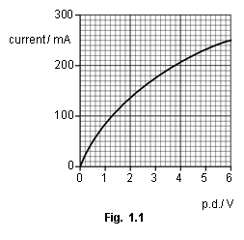

1. Draw a diagram of the circuit that you would use to perform this experiment.

**[3]**

1. The resistance of the lamp when at room temperature is 10 Ω. Using Fig. 1.1 sketch a graph on the axes of Fig. 1.2 of the variation of resistance *R* with current for the lamp.

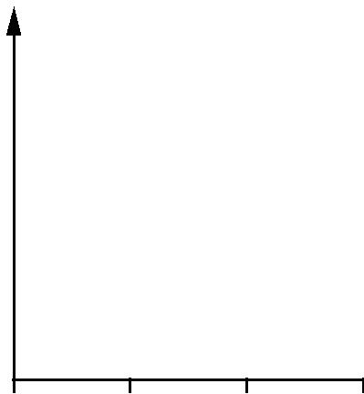

*R* / Ω

0 100 200 300 current / mA

**Fig. 1.2**

**[2]**

1. Explain why the resistance of the lamp varies as shown by the graph you have drawn on Fig. 1.2.

...........................................................................................................................................

...........................................................................................................................................

...........................................................................................................................................

........................................................................................................................................... **[2]**

1. In an alternative design for the set of Christmas tree lights, a 100 Ω resistor is connected in parallel with each lamp.
   1. Describe what happens to the brightness in each set of lamps when one lamp filament burns out.

**1** *original set*......................................................................................................................

...................................................................................................................................... **[1]**

**2** *alternative set*.................................................................................................................

...........................................................................................................................................

...................................................................................................................................... **[1]**

1. Calculate the current drawn from the supply for the alternative set of lamps with all lamps working.

current = ..................................................... A **[3]**

**2** Fig. 3.1 shows a circuit containing a battery of e.m.f. 12 V, two resistors, a light-dependent resistor (LDR), an ammeter and a switch S. The battery has negligible internal resistance.

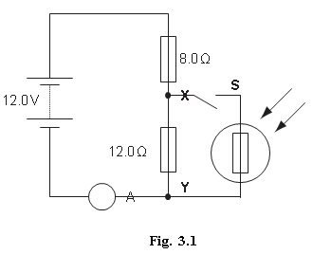

**(a)** When the switch S is open, show that the potential difference between the points X and Y is 7.2 V.

**[2]**

**(b)** The switch S is now closed. Describe and explain the change to each of the following when the intensity of light falling on the LDR is increased:

**(i)** the ammeter reading

....................................................................................................................................

....................................................................................................................................

.............................................................................................................................. **[2]**

**(ii)** the potential difference across XY.

....................................................................................................................................

....................................................................................................................................

.............................................................................................................................. **[2]**

**I-V Characteristics II**

|  |  |
| --- | --- |
| **Notes / Revision Preparation:** | **Completed ✓** |
| Use the A4 template PAG experimental sheet for the IV characteristic of the filament lamp. | **\*compulsory** |
| **Independent Study Learning Preparation task:**  Complete reading on how a diode functions. A website such as HowStuffWorks and the YouTube channel veritasium have some interesting articles. You should seek to understand how the diode can allow no current in reverse bias. |  |
| **Isaac Physics**  Read the concept page on Ohms Law;  <https://isaacphysics.org/concepts/cp_ohms_law> |  |
| **Independent Study Practice Questions:**  Complete all the questions in the spaces provided | **\*compulsory** |

1. **(a)** The following electrical quantities are often used when analysing circuits. Draw a straight linefrom each quantity on the left-hand side to its correct units on the right-hand side.

|  |  |
| --- | --- |
| potential difference | C s–1 |
| resistance | J C–1 |
| power | V A–1 |
| current | J s–1 |

**[3]**

1. Fig. 3.1 shows a battery of e.m.f. 6.0 V and negligible internal resistance connected in series with a thermistor and a 560 Ω resistor.

6.0V

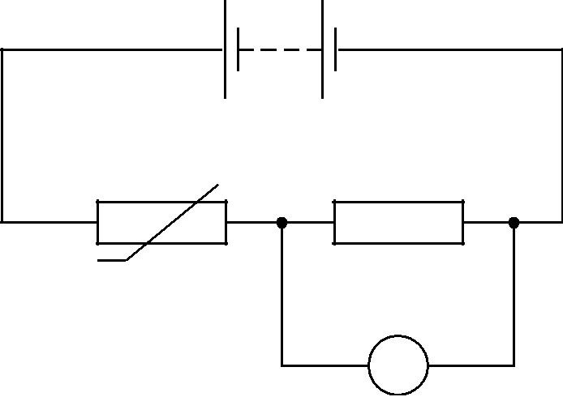

thermistor

560 Ω

V

**Fig. 3.1**

The voltmeter across the resistor has infinite resistance.

1. The reading on the voltmeter is 2.4 V. Calculate the resistance *R*T of the thermistor.

*R*T= .................................................. **[3]**

1. Calculate the current in the circuit.

current = ........................................... A **[1]**

1. The variation of resistance with temperature for this thermistor is shown in the graph of Fig. 3.

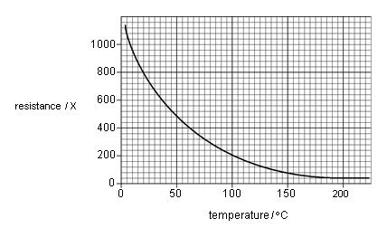

1. Use the graph to determine the temperature of the thermistor when its resistance is 800 Ohms.

temperature = ................................................... °C **[1]**

1. State and explain, without calculation, how the reading of the voltmeter in Fig. 3.1 will change as the temperature of the thermistor increases to 80 °C.

.........................................................................................................................................................

.........................................................................................................................................................

.........................................................................................................................................................

.................................................................................................................................................. **[3]**

**2 (a)** Fig. 4.1 shows the *I-V* characteristic of a light-emitting diode (LED).

4

3 *I*/10–2A

2

1

0

0.0 1.50 *V*/V

Describe the significant features of the graph in terms of current, voltage and resistance. Your answer should make clear how the features of a graph relate to the action of an LED.

……………………………………………………………………………………………………

……………………………………………………………………………………………………

……………………………………………………………………………………………………

……………………………………………………………………………………………………

……………………………………………………………………………………………………

……………………………………………………………………………………………………

……………………………………………………………………………………………………

……………………………………………………………………………………………………

……………………………………………………………………………………………….. **[5]**

**(b)** Calculate the resistance of the LED

**1** at 1.2 V

resistance = ………………. **[1]**

**2** at 1.9 V.

resistance = ….………….. **[2]**

**(c)** In order to carry out an investigation to determine the *I-V* characteristic of an LED a student connects the circuit shown in Fig. 4.2.

10Ω

**A**

6.0V

**B**

**Fig.** **4.2**

On Fig. 4.2 add an LED with a 100 Ω resistor in series, an ammeter and a voltmeter to complete the circuit between terminals **A** and **B**. **[3]**

**(d)** When designing a circuit which includes an LED, it is normal practice to connect a resistor in series with the LED, in this case 100 Ω. Suggest and explain the purpose of this resistor.

...................................................................................................................................................

...................................................................................................................................................

..............................................................................................................................................**[2]**

**MCQ**

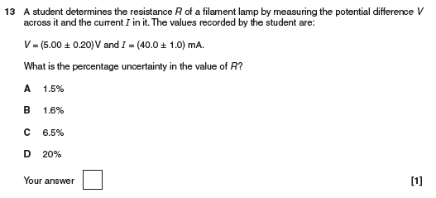

**3.** A student is investigating the resistance of a conducting putty.

1. The density of conducting putty is 5300 kg m−3. The student has a 100 g sample of this putty. Show that the volume *V* of the sample is about 1.9 × 10−5 m3.

**[1]**

1. The student rolls the putty into a cylinder shape and connects the ends of the cylinder to metal plates as shown in Fig. 5.1. The ohm-meter is used to measure the resistance *R* of the conducting putty.

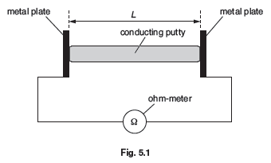

1. Suggest why the student uses large metal plates at the ends of the conducting putty.

...........................................................................................................................................

...........................................................................................................................................

..................................................................................................................................... **[1]**

1. Describe how the student can check that the diameter of the conducting putty is constant.

...........................................................................................................................................

...........................................................................................................................................

..................................................................................................................................... **[2]**

1. The student measures the resistance *R* of the conducting putty for different length *L*. The volume of the conducting putty is kept constant.

|  |  |  |  |  |  |
| --- | --- | --- | --- | --- | --- |
|  | ***L* / m** | ***R* /Ω** | ***L*2/ 10−3m2** | |  |
|  | 0.049 | 14 |  | 2.4 |  |
|  | 0.060 | 21 |  | 3.6 |  |
|  | 0.069 | 28 |  | 4.8 |  |
|  | 0.081 | 37 |  |  |  |
|  | 0.090 | 46 |  | 8.1 |  |
|  | 0.099 | 57 |  | 9.8 |  |
| **(i)** Complete the table for the missing value of*L*2. | | | | **[1]** | |

1. Each length is measured to the nearest millimetre using a ruler. Determine the percentage uncertainty in L2 for L = 0.049 m.

|  |  |
| --- | --- |
| percentage uncertainty = ..................................................... | % **[1]** |

1. Fig. 5.3 (next page) shows the graph of *R* (*y*-axis) against *L*2 (*x*-axis).

|  |  |
| --- | --- |
| **(i)** Plot the missing data point and draw the straight line of best fit. | **[2]** |

1. Determine the gradient of the line of best fit.

|  |  |
| --- | --- |
| gradient = ......................................................... | **[2]** |

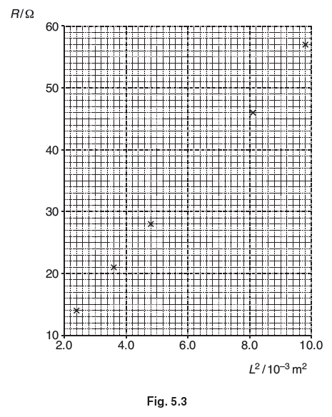

1. The relationship between *R* and *L* is

*R* = *Vρ L*2

where *ρ* is the resistivity of the conducting putty and *V* is the volume.

Use your answer to **(d)(ii)** and *V* = 1.9 × 10-5 m3 to determine a value for ρ. Include an appropriate unit.

*ρ* = ................................. unit: ................................. **[3]**