Investigating osmosis in an artificial cell STUDENT

Introduction
Water will move by osmosis from an area of high water potential to an area of low water potential across a partially permeable membrane. Using artificial cells you will investigate the principles of osmosis. You will make five artificial cells, each containing the same concentration of sucrose solution (0.4 mol dm⁻³), and then immerse these in five different concentrations of sucrose solution (ranging from 0.1 mol dm⁻³ to 1.0 mol dm⁻³).

Aim
To set up and use artificial cells to investigate osmosis.

Intended class time
- 1 – 2 hours

Chemicals
Sucrose solution | No known hazard

Equipment
- 75 cm Dialysis/ Visking tubing (provided in water)
- Ruler
- Scissors
- Clips (optional)
- Sucrose solution for filling cells: 100 cm³ 0.4 mol dm⁻³
- Sucrose solutions for immersing cells: 100 cm³ 1.0 mol dm⁻³ and 200 cm³ 0.8 mol dm⁻³
- Distilled water
- Dropping pipette
- 3 x 250 cm³ beakers for serial dilution
- 100 cm³ measuring cylinder
- Marker pen
- Stopwatch/ timer
- Balance
- Paper towel

Health and Safety
A lab coat should be worn for this activity. Be careful when using the scissors.

Procedure
- Serial Dilution: First you need to prepare these solutions: 0.4 mol dm⁻³, 0.2 mol dm⁻³ and 0.1 mol dm⁻³, by using the 0.8 mol dm⁻³ sucrose solution and distilled water. Use the following diagram to help you.
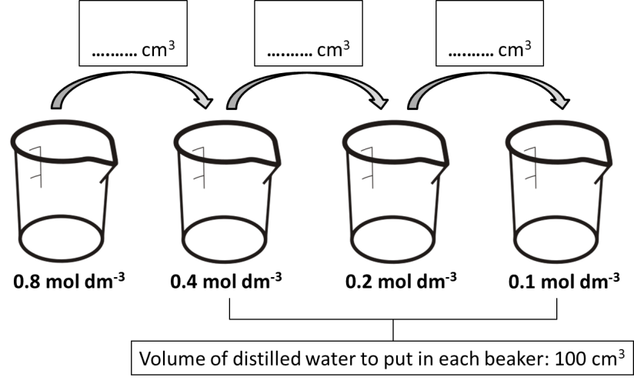
- Discard the excess solution from the 0.1 mol dm⁻³ beaker so that you have 100 cm³ in every beaker.

- Next, cut your dialysis tubing into five pieces of equal length and tie a secure knot (and/ or use a clip) at one end of each piece. Leave these in the water.
- Using the dropping pipette fill one of the dialysis tubing sections (artificial cell) to approximately one third full with 0.4 mol dm⁻³ sucrose solution. Tie a knot (and/ or use a clip) at the other end of the tubing ensuring no air is left inside the artificial cell.
- Weigh the artificial cell and record this in a suitable table.

- Place the cell in the 0.1 mol dm⁻³ sucrose solution and start the timer.

- Re-weigh the artificial cell after 20 minutes and record this in your table. You can use the paper towel to blot any excess solution on the outside of the artificial cell.
- Repeat steps 4 – 7 for the remaining four solutions: 0.2, 0.4, 0.8 and 1.0 mol dm⁻³. Record your results in your table.

- Use the starting and ending masses to calculate the percentage change in mass of each artificial cell. Record this in your table.
- Plot a graph of percentage change in mass against concentration of sucrose solution and draw a conclusion from your results.

Extension questions
- Why did you compare the percentage change in mass rather than simply the change in mass for each artificial cell?
- Are these cells comparable to the real cells of a multicellular organism in terms of osmosis and diffusion?
- Suggest an extension to this practical activity, what other solutions could be used?

To submit
For this piece of work to count towards Practical Activity Group 8 of the Practical Endorsement, you need to have evidence showing your serial dilution volumes, an appropriate and complete results table and a graph of percentage change in mass against concentration of sucrose solution. You also need to have considered the above questions as the answers will aid you in preparation for your written examinations.

