An investigation into the water potential of potato STUDENT

Introduction
Water will move by osmosis from an area of high water potential to an area of low water potential across a partially permeable membrane. Using solutions of different sucrose concentration the water potential of a potato can be determined.

Aims
- To investigate the water potential of potato.

Intended class time
- 30 minutes, then an incubation of at least 1 hour and then a further 30 minutes work

Equipment
- Potato
- Cork borer
- Ruler
- Knife
- White tile
- Sucrose solutions : 1.0 mol dm⁻³ and 0.8 mol dm⁻³
- Distilled water
- 2 x 20 cm³ syringes
- 3 x 100 cm³ beakers for serial dilution
- 6 boiling tubes
- 6 bungs to fit the boiling tubes
- Marker pen
- Forceps
- Stopwatch
- Balance
- Paper towel

Method
- Serial Dilution: First you need to prepare these solutions: 0.4 mol dm⁻³, 0.2 mol dm⁻³ and 0.1 mol dm⁻³, by using the 0.8 mol dm⁻³ sucrose solution and distilled water. Use the following diagram to help you.
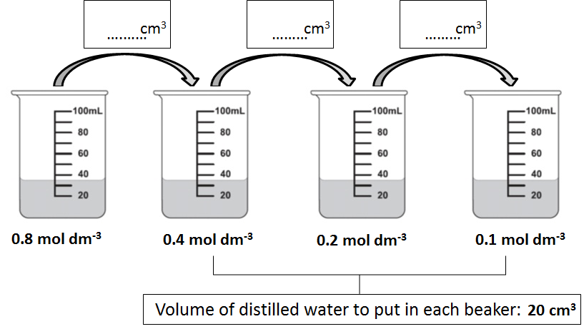
- Next, label the six boiling tubes: Water, 0.1 mol dm⁻³, 0.2 mol dm⁻³, 0.4 mol dm⁻³, 0.8 mol dm⁻³ and
1.0 mol dm⁻³ and place 20 cm³ of water, or sucrose solution into the corresponding tube using a fresh syringe.
- Construct a results table in which you will record the initial and final masses of each of 6 potato chips incubated in 6 different concentrations of sucrose solution. You will also need to record the percentage change in mass of each chip.
- Use the cork borer, knife and ruler to cut 6 potato chips that are 40 mm long. Remove the skin.
- Carefully dry the potato chips using the paper towel by rolling them 3 times for each chip.
- Use the balance to weigh a chip. Record its mass in your results table against the appropriate sucrose concentration and place it in the corresponding solution.
- Repeat for all six solutions and place the bungs in the tubes.
- Leave the tubes for at least one hour.
- In the same order that they were put into the tubes, remove the chips one at a time, roll them 3 times on the paper towel and re-weigh. Record the masses in the table.
- Use the starting and ending masses to calculate the percentage change in mass of each chip. Record in the table.
- Plot a graph of percentage change in mass against concentration of sucrose solution, show the intercept and work out the water potential of the potato using the following calibration table.

Sucrose concentration (mol dm⁻³) | Water potential (kPa)
0.05 | -120
0.10 | -250
0.15 | -380
0.20 | -520
0.25 | -650
0.30 | -790
0.35 | -920
0.40 | -1050
0.45 | -1180
0.50 | -1320
0.55 | -1460
0.60 | -1600
0.65 | -1740
0.70 | -1880
0.75 | -2020
0.80 | -2170
0.85 | -2310
0.90 | -2460
0.95 | -2610
1.00 | -2760

Extension questions to consider while carrying out practical work
- Why was it important to dry the chips and in the same way each time?
- What was the purpose of placing the bungs in the tubes?
- Why did you compare the percentage change in mass rather than simply the change in mass of each chip?
- What are the limitations of this practical activity? What improvements could be made?

To submit
For this piece of work to count towards Practical Activity Group 8 of the Practical Endorsement, you need to have evidence showing your serial dilution volumes, an appropriate and complete results table and a graph of percentage change in mass against concentration of sucrose solution. You also need to have considered the above questions as the answers will aid you in preparation for your written examinations.

