**Transformation of bacteria with plasmid encoding GFP STUDENT**

**Introduction**

Bacterial cells can be made to incorporate plasmid (small circular) DNA using a process called transformation. Plasmid DNA can encode one or more genes which can then be expressed in the bacterial cells. This technique can be used to produce large quantities of a particular protein of interest, for example it has been used to produce human insulin in bacterial cells.

In this activity you will use plasmid DNA encoding the gene for green fluorescent protein (GFP). When expressed within the bacterial cell, the fluorescence produced by this protein can be visualised using a UV lamp. This activity will allow you to gain experience of microbiological aseptic techniques, including the use of agar plates and broth.

**Aim**

To transform bacterial cells with plasmid DNA encoding green fluorescent protein (GFP).

**Intended class time**

* 3 x 30 - 60 min sessions split over several days

**Chemicals**

|  |  |
| --- | --- |
| 70% ethanol | HSE warning symbol  Highly flammable  Harmful if swallowed |
| *E.coli* | Although the strain of *E.coli* you are using is not considered pathogenic the possibility of mutation or contamination means all cultures should be treated as potentially pathogenic. Spills must be disinfected. Used cultures must be disposed of by sterilisation. |
| Antibacterial (1% Virkon®) | No known health hazard but avoid contact with skin and eyes |

**Equipment**

* Bunsen burner
* Antibacterial spray
* Antibacterial waste pot
* Bactericidal hand-wash
* Paper towels
* 1 ml culture of competent *E.coli* cells
* Sterile 10 ml Universal tubes
* Sterile nutrient agar plate for making streak plate
* Inoculating loop
* Eppendorf tube containing Plasmid DNA encoding GFP
* Sterile LB broth
* Sterile nutrient agar plate containing antibiotic for making spread plate
* Glass spreader
* Tray
* 1 ml pipette and sterile tips
* Marker pen
* 70% ethanol provided in a glass Petri dish with a lid
* Tape
* Timer/Stopwatch
* Water bath set to 42 °C
* Access to an incubator set at 37 °C

**Health and Safety**

* Ethanol is highly flammable and you have a naked flame on your bench. Great care is therefore needed to minimise the risk of fire. Have only a small volume of ethanol in your wide dish, keep it covered when not in use and well away from the Bunsen burner.
* Wear a lab coat and goggles when working with microorganisms.
* Cover any skin cuts or abrasions.
* All spills must be immediately disinfected using 1% Virkon® solution left in place for 10 minutes.

**Procedure**

*This procedure is split into three sessions so that the microorganisms you are working with have time to replicate to visible levels.*

*Note: At all times in Part 1 and Part 2 of this investigation, a roaring Bunsen flame should be burning on the bench. This is needed for sterile working. However, it is a fire hazard. Keep your dish of ethanol well away from the Bunsen burner and keep the dish covered when not in use.*

**Part 1 - Serial dilution**

1. Wipe your bench with antibacterial spray and a paper towel. Pour 1% Virkon® solution into your tray to cover the bottom with a thin layer, leave in place for 10 minutes and then wipe away.
2. Wash your hands thoroughly using anti-bacterial hand wash and dry with a paper towel.
3. Take the 1 ml culture of competent *E.coli* cells, the sterile universal tubes and the sterile distilled water.
4. Using sterile distilled water and the culture of competent *E.coli* cells, make a 1 in 10 serial dilution of the cells as follows:

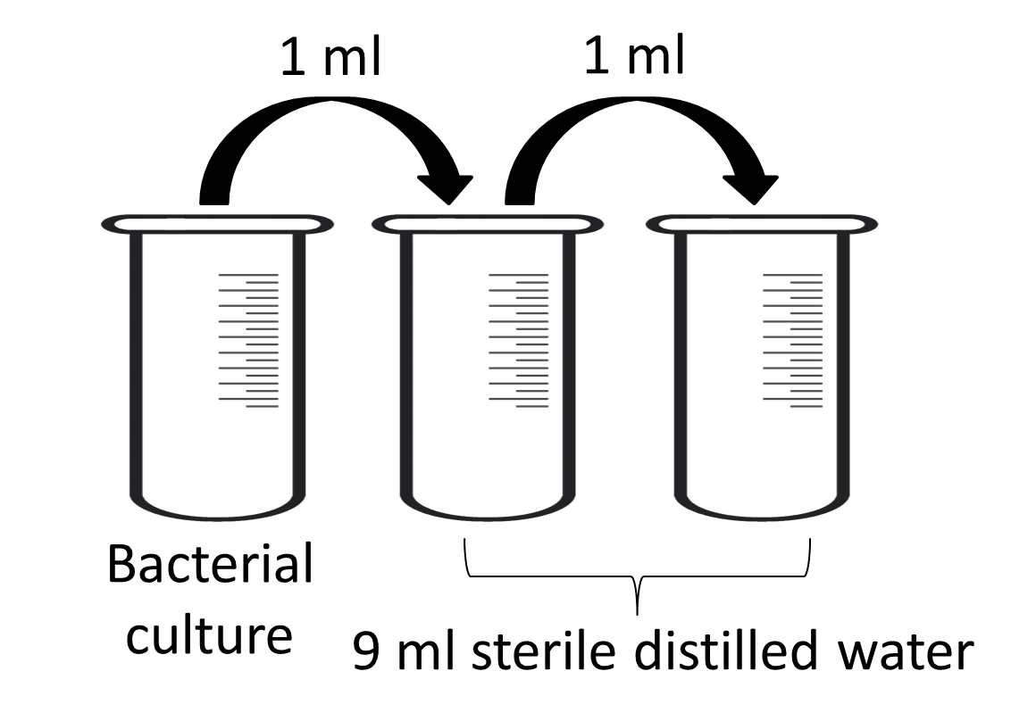

1. Take the sterile agar plate and label it ‘Streak Plate’ including the date and your name.
2. Take your inoculating loop, dip in the ethanol and flame in a blue Bunsen flame. Hold the loop close to the flame until it is cool, and then dip the sterile inoculating loop into the diluted culture, flaming the top of the culture bottle when opening and closing.
3. Lift the lid of the agar plate very slightly and streak the inoculating loop back and forth at one side of the plate, close the lid (Streak 1).

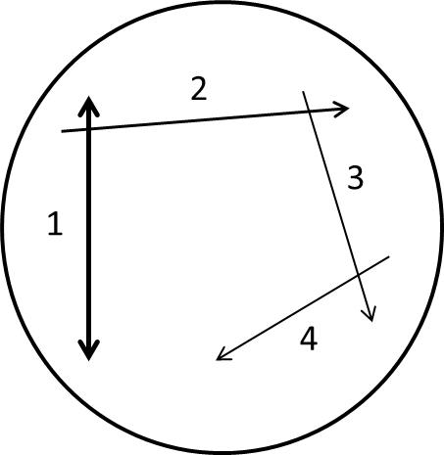

1. Dip the inoculating loop in ethanol again and hold in the flame, allow to cool. Turn the agar plate 90° and lifting the lid slightly streak the inoculating loop away from the first streak you did (Streak 2).
2. Repeat step 8 a further two times so that you have complete Streak 3 and Streak 4. Place the inoculating loop into the antibacterial waste pot.
3. Use 2-4 small pieces of sticky tape to tape the lid of the plate securely onto the base but do not seal it completely.
4. Disinfect your tray with 1% Virkon®, and wash your hands thoroughly with bactericidal hand-wash.
5. Incubate the plate overnight at 20-25°C.

**Part 2 - Transformation**

1. Collect your streak plate but do not open it. Observe and draw the bacterial colony growth on your streak plate.
2. Wipe your bench with antibacterial spray and a paper towel. Pour 1% Virkon® solution into your tray to cover the bottom with a thin layer, leave in place for 10 minutes and then wipe away.
3. Wash your hands thoroughly using anti-bacterial hand wash and dry with a paper towel.
4. Take the Eppendorf tube containing the plasmid DNA. Dip the inoculating loop in the ethanol and hold in the flame to sterilise, allow the loop to cool.
5. Carefully open your streak plate and use the sterile inoculating loop to pick one large colony from the plate, close the plate. Carefully mix the bacterial colony into the Eppendorf tube, close the lid. Place the inoculating loop into the antibacterial waste pot.
6. Cold shock – place the Eppendorf tube on ice for 15 min.
7. Heat shock – Hold the Eppendorf tube in the 42 °C water bath for 30 seconds.
8. Cold shock - Place the Eppendorf tube back on ice for a further 5 min.
9. Put a sterile tip on to your pipette and then, working near the flame, add 250 µl of LB broth to the solution. Incubate at 37 °C for 15 min.
10. Put a sterile tip on to your pipette and then, working near the flame, carefully open the Eppendorf tube and use the pipette to remove 100 µl of culture, flaming the top of the Eppendorf tube when opening and closing.
11. Take the sterile agar plate containing antibiotic. Lift the lid of the agar plate very slightly and pipette the 100 µl of culture into the centre of the plate, close the lid. Discard the pipette tip into the antibacterial waste pot.
12. Next, take the glass spreader, dip it in ethanol and flame it in a blue Bunsen flame, hold it close to the flame until it is cool, then use it to spread the culture evenly across the surface of the agar plate.
13. Disinfect your tray with 1% Virkon®, and wash your hands thoroughly with bactericidal hand-wash.
14. Incubate the plate overnight at 20-25 °C.

**Part 3 – Observing your results**

1. Collect your spread plate but do not open it. Use a UV lamp to check that the transformation has worked. Record your observations.
2. Make an annotated drawing of the bacterial colony growth on your spread plate.

**Extension questions**

1. What measures should you take when working with microorganisms?
2. What does a streak plate allow you to do and why is this useful?
3. As well as GFP, the plasmid DNA encoded a gene to give the bacteria antibiotic resistance. Why did the second agar plate contain the antibiotic?

**To submit**

For this piece of work to count towards Practical Activity Group 7 of the GCE Biology Practical Endorsement, you should have evidence of your serial dilution, annotated drawings of your streak plate and spread plate and have considered the above questions as the answers to these questions will aid you in preparation for your written examinations.