The effect of temperature on membrane permeability STUDENT

Introduction
Beetroot cells contain the purple pigment, betalain, as shown in the diagram below:
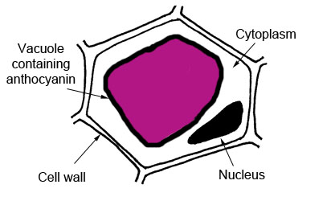
Cytoplasm
Vacuole containing betalain

Cell wall
Nucleus

This experiment investigates the effect of temperature on membrane structure by considering the leakage of betalain from the beetroot cells over a range of temperatures. The quantitative assessment of this is carried out using a colorimeter.

Aims
- To investigate the effect of temperature on membrane structure.
- To understand the use of a colorimeter.

Intended class time
- 1 hour

Equipment (per class)
- Thermostatically controlled water baths at 30°C, 40°C, 50°C and 60°C containing test tube racks

Equipment (per 4-6 students/groups)
- Colorimeter and green filter

Equipment (per student/group)
- Thermometer
- 10 beetroot cylinders, 30 mm long
- Knife / Scalpel
- Ruler
- White tile
- Paper towel
- 5 test tubes
- 5 cuvettes
- Distilled water
- 10 cm³ syringe
- Marker pen / Chinagraph pencil / OHP pen / Stickers
- Forceps
- Timer
- Test tube rack

Health and Safety
Take care with the knife when trimming the cylinders of beetroot to the correct length. The water in the water baths over 40°C will be hotter than hand-hot so be aware of this.

Procedure
- Take the 5 test tubes and label each with one of the temperatures from 20°C to 60°C.
- Add 10 cm³ distilled water to each tube using the syringe.
- Place the correctly labelled test tube in its corresponding water bath for 5 minutes to allow the water to equilibrate to the correct temperature. Record the actual temperature with the thermometer. Leave the tubes in the water baths.
- Collect 10 beetroot cylinders and trim them all to 30 mm using the knife and ruler on the white tile.
- Rinse the cylinders under a running tap and pat dry using paper towel.
- Add 2 cylinders to a tube in each temperature and leave for 15 minutes.
- Label each of the cuvettes with one of the temperatures from 20°C to 60°C.
- Remove the tubes from the water bath, carefully swirl once and use the forceps to remove the cylinders. Throw the cylinders into a waste receptacle.
- One at a time, carefully pour the remaining liquid into the cuvette with the corresponding temperature labelled on it. You should now have 5 cuvettes of showing differing intensities of pigment in the water.
- Use the colorimeter to measure the absorption for each temperature and record this information in a suitably designed table. The absorption is measured in arbitrary units (AU).
- Plot a graph of temperature against absorption and draw an appropriate line.

Extension questions
- Describe the relationship between temperature and the rate of leakage of the pigment from the beetroot cells.
- Explain your results and the shape of your graph using theory about membrane structure.
- What effect might a solvent such as ethanol have on membrane permeability? Explain your answer using ideas about membrane structure.
- State four limitations of this procedure.

To submit
For this piece of work to count towards Practical Activity Group 5 of the GCE Biology Practical Endorsement, you should have evidence of the table and graph of the data as described above and have considered the above questions as the answers to these questions will aid you in preparation for your written examinations.

