The effect of enzyme concentration on the rate of a reaction STUDENT

Introduction
Trypsin is a protease that catalyses the breakdown of other proteins. By making a serial dilution of Trypsin solution, you will observe the effect of changing enzyme concentration on the rate of a reaction.

Aim
- To investigate the effect of changing the enzyme concentration on the rate of milk protein breakdown by Trypsin.

Intended class time
- 1 hour

Equipment
- Milk powder solution
- 2 % Trypsin solution
- Distilled water
- 5 cm³ syringes
- 4 boiling tubes for the serial dilution
- 5 boiling tubes for the main practical
- Stopwatch/timer
- Marker pen
- PAG4.2 OCR Observation Sheet

Method
Note: In this activity you will measure the time taken for a reaction to reach a standardised endpoint. The rate of the reaction will be calculated as 1/time to end point.

- Serial Dilution: First you need to prepare the following concentrations of enzyme solution: 1.00%, 0.50%, 0.25% and 0.13% by using the 2.00% Trypsin solution and distilled water. Use the following diagram to help you:
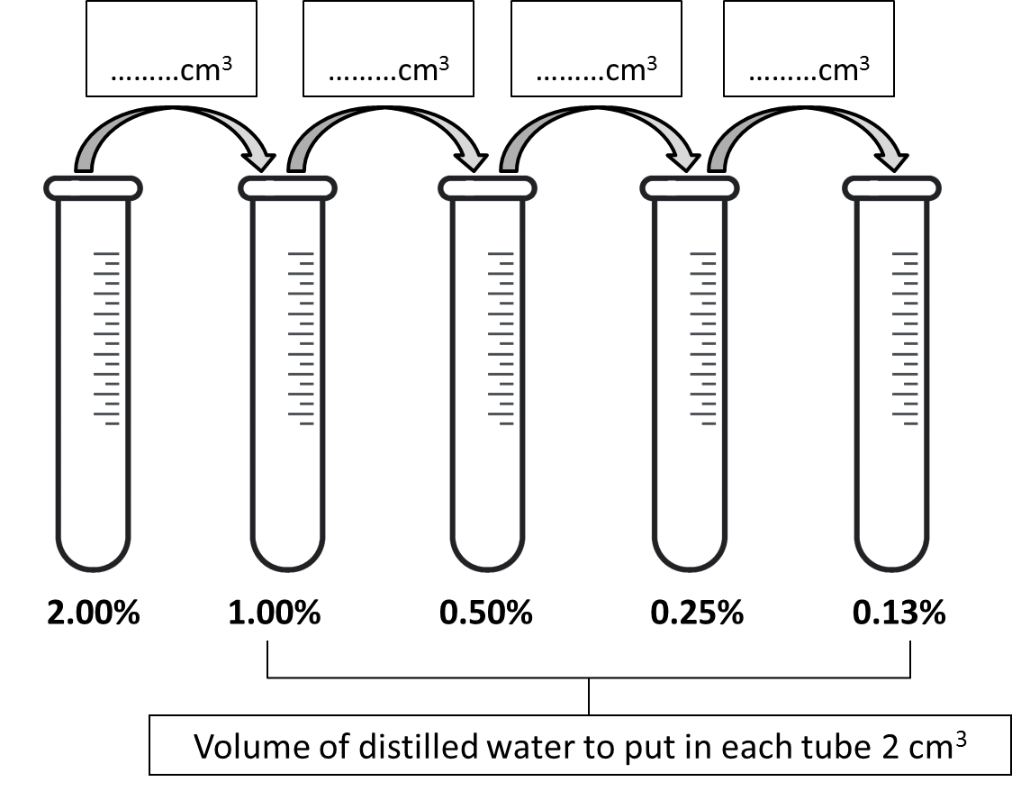

- Label five boiling tubes with the Trypsin concentrations you have prepared and place 2 cm³ milk powder solution into each.

- Hold one of the tubes up against the Observation Sheet. You should not be able to see the text through the milk solution.

- Add 2 cm³ of 2.00% Trypsin solution to the boiling tube labelled 2.00% and immediately start the stopwatch.

- Hold the tube up against the Observation Sheet and stop the timer once the writing becomes visible.

- Record your result in a suitable table. Include a column for rate of reaction.

- Repeat steps 3 - 5 for the other four concentrations, 1.00%, 0.50%, 0.25% and 0.13%.

- Plot a graph of time versus enzyme concentration.

- Finally, plot a graph of rate of reaction versus enzyme concentration.

Extension questions
- What variables were controlled in this practical activity?
- What could you have done to improve the validity of your results?
- Discuss this activity with the rest of the class. Did everybody get a similar result?
- What conclusions would you draw from this practical activity?

To submit
For this piece of work to count towards Practical Activity Group 4 of the GCE Biology Practical Endorsement, you should have evidence showing your serial dilution volumes and an appropriate and complete results table and a graph. You also need to have considered the above questions as the answers to these questions will aid you in preparation for your written examinations.

