The effect of substrate concentration on the rate of an enzyme controlled reaction STUDENT

Introduction
This is an investigation into how changing the concentration of hydrogen peroxide (the substrate) affects the rate of a reaction controlled by the enzyme catalase. Potato is used as a source of catalase.

Aim
- To investigate the effect of changing the substrate concentration on the rate of hydrogen peroxide breakdown by catalase.

Intended class time
- 1 hour

Equipment
- 20 vol. hydrogen peroxide
- Distilled water
- 50 cm³ measuring cylinder
- 250 cm³ beakers (x5)
- Eye protection
- Marker pen
- Trough to hold water
- 250 cm³ conical flask
- Delivery tube and bung to fit conical flask
- Cork borer
- Knife
- White tile
- Ruler
- Potato

Procedure
Note: hydrogen peroxide is an irritant at the maximum concentration used in this experiment so eye protection must be worn. Care needs to be taken when using sharp knives and glassware.
- Label the 250 cm³ beakers 20 vol., 16 vol., 8 vol., 4 vol. and 2 vol.
- Put 40 cm³ distilled water into the 16 vol. beaker and add 160 cm³ 20 vol. hydrogen peroxide.
- Now create a dilution series to give you 8, 4 and 2 vol. hydrogen peroxide in the corresponding beakers. Use the diagram to help you.
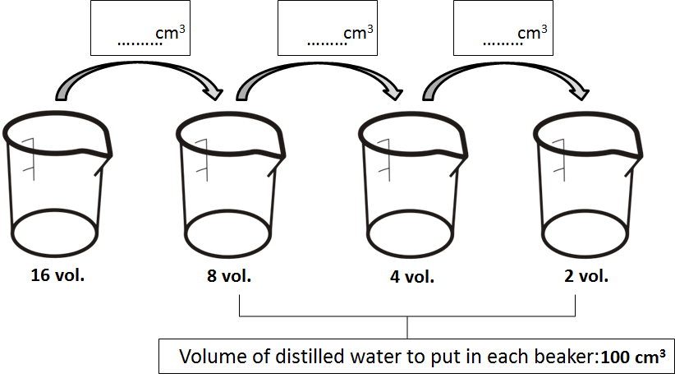
- Put 100 cm³ 20 vol. hydrogen peroxide into the 20 vol. beaker.
- Cut 5 cylinders of potato using the borer and the white tile. With care, remove any skin from the end of the potato cylinders with the knife. Use a ruler to measure them to exactly 5 cm.
- Set up the apparatus as shown in the diagram below. Fill the measuring cylinder with water from the bowl and invert it without lifting the top above the water level of the bowl.
- Record the starting position of the water in the measuring cylinder in a suitable raw data table.
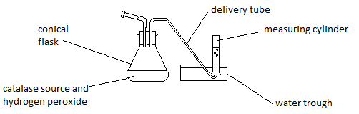
- Place one cylinder of potato into the conical flask and get the stopwatch ready.
- Pour 100 cm³ of 2 vol. concentration of hydrogen peroxide into the flask and, as soon as you can, secure the bung and start the stopwatch.
- Record the volume of gas given off every 30 seconds for 3 minutes.
- Dispose of the contents of the conical flask as directed by your teacher and rinse it under a tap.
- Fill the measuring cylinder full of water again.
- Repeat for other concentrations, moving upwards through the concentrations and using 100 cm³ each time.
- Exchange your data with other people so that you have three values for each concentration.
- Calculate the mean and the standard deviation for each concentration.
- Calculate rate of gas production in cm³ min⁻¹ for each concentration of hydrogen peroxide.
- Draw the most appropriate graphs of the processed results.

Extension questions
- What is the word equation for the reaction controlled by catalase?
- Give one reason why it was important to keep all cylinders the same size?
- Explain the shape of the graph you have drawn using biological ideas and relevant enzyme theory.
- (a) State two limitations of the experiment.
(b) State ways to overcome the limitations you have mentioned in (a).

To submit
For this piece of work to count towards Practical Activity Group 4 of the GCE Biology Practical Endorsement, you should have evidence of a table and graph of the data as described above and have considered the above questions as the answers to these questions will aid you in preparation for your written examinations.

