The calculation of species diversity STUDENT

Introduction

Aim and skill covered
- To use random sampling methods
- To calculate the species diversity index of two contrasting areas
- To determine species diversity of two contrasting areas

Intended class time
- 1 hour to collect data (mathematical processing can be carried out at a later date)

Equipment (per group)
- Quadrat
- 2 tape measures (20m long)
- Recording sheet with clear folder/plastic bag to cover it in case of rain
- Key or method of identifying species in area of study
- Method of generating random numbers e.g. calculator

Method
- Your teacher will tell you about the two areas of habitat that you are going to compare.
- Lay down the two tape measures at right angles to each other in the first area of study as directed by your teacher. The length for each ‘axis’ should be 10m.
- Randomly generate a number as an x-coordinate (read this along the horizontal tape measure) and then one as a y-coordinate (read this along the vertical tape measure).
- Carefully place the quadrat so that the left hand corner is approximately where the coordinates meet.
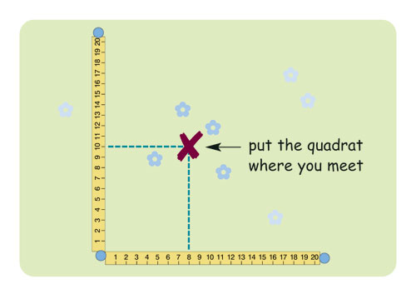

- Identify the species present in the quadrat using the key and then count the numbers present of each species. Record this information in a suitably designed table.
- Generate a new set of coordinates and repeat the process at least 9 more times.
- Repeat steps 2-6 in the contrasting area.
- Use Simpsons index of diversity to calculate the species diversity (D) for each area using the formula:

D = 1 - Σ [(n / N)²]

where N = the total number of organisms of all species and
n = the total number of organisms of a particular species.

The bigger the number calculated for species diversity, the more diverse and stable the habitat is considered to be and the more able to withstand change. It is a place where there are many species which interact together. A smaller number indicates fewer species that dominate and even a small change could potentially harm the habitat significantly and cause widespread destruction.

Questions to consider while carrying out practical work
- Draw a graph to display the data (total numbers of individual species) from the two contrasting areas.
- Why would a climax community such as oak woodland have high species diversity?
- How does farming reduce species diversity?
- If farmers plant hedges around their fields, explain what effect this might have on species diversity around their land?

To submit
For this piece of work to count towards Practical Activity Group 3 of the GCE Biology Practical Endorsement, you need to have evidence of the data collected from at least ten quadrats in each of your sampling areas and the calculations of species diversity for each area. You also need to have made some comment on the species diversity of the area sampled and considered the above questions as the answers to these questions will aid you in preparation for your written examinations.

