Investigating DNA structure using RasMol STUDENT

Introduction
The 3D structure of DNA and proteins can be viewed and investigated at the molecular level using specific software. In this activity you will observe a short section of DNA double helix using the software RasMol and produce an image of the structure.

Aims and skills covered
- To use the molecular modelling tool, RasMol, to investigate the structure of DNA.

Intended class time
- 1 hour

Equipment (per group)
- Computer with RasMol installed
- Access to the internet
- Printer

Method
- Visit the Protein Data Bank (PDB) website: http://www.rcsb.org/pdb/home/home.do

- Search for the PDB file 1BNA and download the file named ‘PDB File (text)’ from the available files on the right of the page.

- Open the file using RasMol.

- The molecule will appear in the RasMol viewing screen. You can use the cursor to move the structure around. Turn the molecule so that you can see the helix structure. Can you see the major and minor grooves?

- You can use either the RasMol command line (Note: by default the command window will be minimised when you open RasMol so maximise this to begin with) or the tab options at the top of the viewing screen to manipulate the structure of the molecule. You can use RasMol to adjust the display, colour, background and size of the molecule as well as to measure and label features of the structure. It is a useful and widely used tool in Biology.

- Zoom – Try zooming in and out. You can zoom in and out by typing ZOOM into the command line followed by a factor e.g. 50, 100, 150 etc. or by holding down shift and using your mouse.

- Colour – you can colour a whole molecule by typing COLOUR followed by a colour in the command line, for example type COLOUR RED.

- CPK – It is often useful to colour a molecule in RasMol by atom. Type COLOUR CPK. The colours are: Carbon=grey, Oxygen=red, Hydrogen=white, Nitrogen=blue, Sulfur=yellow, Phosphorus=orange. Which atoms make up the DNA structure?

- Display – now you can look at the different types of display available, type SELECT ALL, then go to the Display tab and select each option in turn. Decide on the best display for the molecule.

- Chains – to easily observe the different chains of the DNA structure, select the Colours tab, then select Chain, or type into the command line COLOUR CHAINS. How many chains can you see?
- Backbone – to observe the phosphate sugar backbone type into the command line SELECT BACKBONE, then COLOUR RED.

- Base pairs – You can now see the base pairs like a staircase running through the centre of the molecule. How many base pairs are in this structure?

- Zoom in to have a closer look at the base pairs. Have a look at the following diagram showing the hydrogen bonding between Adenine and Thymine, Cytosine and Guanine.

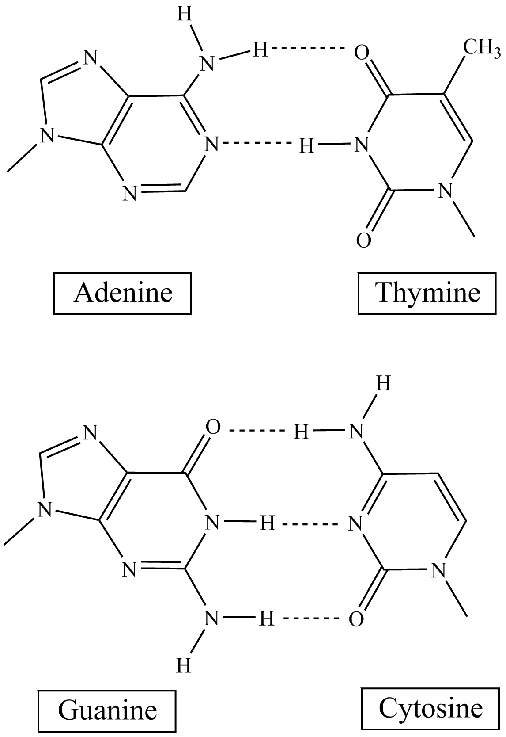

- Hydrogen bonds are between 2.5 – 3.5 Å (angstrom) in length (1 Å = 1 x 10⁻¹⁰ m). Measure the distance between a few of the base pairs, go to the Settings tab, Pick Distance, then click on the structure at either end of the bond you want to measure. Record your values in both angstrom and metres.

- Background – you can change the colour of the background by typing BACKGROUND followed by a colour, e.g. WHITE.

- Now create an image showing the features of the DNA molecule by using the commands you have used during this activity. You can create more than one image during this activity if you have time. You can export the image by going to the Export tab and selecting BMP or GIF. You can now print a colour copy of your image for your practical activity record.

Note: You can also open up PDB files using WordPad to get written information on the file.

Extension questions to consider while carrying out practical work
- How many chains does DNA have? How do these chains interact with each other? What is the orientation of the chains?
- How does this structure relate to its function?
- What method was used to work out the structure of DNA?

To submit
For this piece of work to count towards Practical Activity Group 10 of the Practical Endorsement, you need to have evidence of the molecular modelling you have done. Print at least one image to add to your lab book. You also need to consider the above questions as the answers to these questions will aid you in preparation for your written examinations.

