**Using a light microscope to study mitosis STUDENT**

**Introduction**

In this activity you will be examining the main stages of mitosis in *Allium spp*. You will also be gaining experience of observing and drawing annotated scientific diagrams from the microscope and will use a calibrated graticule to carry out a measuring activity of the chromosomes observed. You are expected to know how to use a light microscope and to have carried out some observing activities prior to this activity.

**Aims**

* To calibrate and use an eyepiece graticule
* To use a light microscope to observe and identify the stages of mitosis.
* To make annotated scientific drawings showing cells in different stages of mitosis.

**Intended class time**

* 1 hour

**Equipment**

* Light microscope with low power and high power objective lenses e.g. x 4, x10 and x40
* Eyepiece graticule
* Stage micrometer
* Permanent slides showing TS of an *Allium spp* root tip.

**Health & Safety**

You need to be sure to move the microscope stage up to almost touching the microscope slide while not looking down the microscope and then to focus DOWN. This will avoid broken cover pieces and slides.

**Procedure**

1. This activity allows you to develop your skills of the calibrating and use of a graticule by asking you to measure the length of chromosomes.
2. In order for correct symbol (µm) to be used and to take into consideration small differences between microscopes, the graticule must be calibrated prior to the activity being carried out. The technique for the calibration of the graticule is as follows:
3. This is done using a stage micrometer. These are microscope slides with an accurate scale etched on them. In the example below, 1 mm is divided into 10 parts.
4. So on this stage micrometer, each small division is equal to 0.1 mm, which is 100 micrometres (µm).





1. Insert the graticule into the eyepiece lens and line up the two scales similar to the diagram above.
2. It is then possible to count the number of divisions on the eyepiece graticule equivalent to each division on the stage micrometer and hence calculate the length that one eyepiece division is equivalent to.
3. For the example above, three divisions (shown in red) are equal to 100 µm, so each division is equal to 33.3 µm. This might be, for example, at low power.
4. The process should be repeated with each objective lens and you will then have a calibration factor for each lens. You are now ready to examine the prepared slide.
5. Place the slide showing the stages of mitosis on the microscope stage.
6. Without putting your eye to microscope but looking at the slide itself, twist the focusing dial until the microscope stage is up as far as it will go or just touching the slide.
7. Then use the coarse focusing dial to focus DOWN until you can clearly see the cells in the field of view. Make sure the cells are in the centre of the field of view (the circle of light you can see when looking down the microscope).
8. Rotate to the medium power lens and again focus until you can see the cells and the chromosomes in them clearly.
9. Then rotate to the high power lens and use the fine focusing dial only to bring the chromosomes into distinct view.
10. Take time to look carefully and identify each stage of mitosis that can be seen.
11. The eyepiece graticule can be used to measure the length of the chromosomes. Aim to do this carefully for three separate chromosomes depending on the actual slide being used.
12. Make scientific annotated drawings of the stages of mitosis that you have seen and identified. It should be possible from your drawings to know which stage has been drawn. An example of a labelled scientific drawing is shown below.

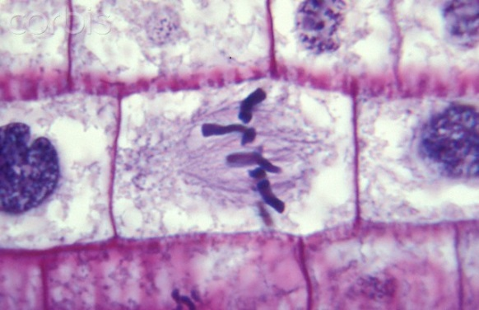

**Extension Opportunities**

1. What is the purpose of mitosis for a living organism?
2. What is a key distinguishing visible feature of each stage of mitosis?
3. Once active cell division ends, the cells will enter interphase. Explain why it is incorrect to say that these cells are “resting”.
4. Why is a sample from the roots of *Allium spp.* a good specimen for studying mitosis?
5. State which stage of the cell cycle the majority of the cells in your specimen were in and suggest why.

**To submit**

For this piece of work to count towards Practical Activity Group 1 of the GCE Biology Practical Endorsement, you should have evidence of annotated drawings of all of the main stages of mitosis, measurements of three chromosomes as described above and have considered the above questions as the answers to these questions will aid you in preparation for your written examinations.