Translocation
Specification reference
- 3.1.3 (f)
Learning outcomes
After completing the worksheet you should be able to:
- understand the process of translocation
- state all the cellular structures involved
- state all the molecules involved in the movement
- describe the processes by which each molecule moves.
Introduction
There are two transports systems in plants. Water is transported in the xylem, and sucrose and other assimilates are transported in the phloem.
The aim of this sheet is to take you through the process of the transport of sucrose as a sequence of steps, and to use the sequence to develop a memory aid in the form of a poster.
Background
There are two transport systems in plants, the transpiration stream and translocation.
Transpiration stream – this is the movement of water and solutes from the roots to the leaves. It occurs in tissues called xylem. You will have encountered process in Topic 9.3 ‘Transpiration’.
Translocation – this is the movement of assimilates, like sucrose, from the site where they are made (source) to the places where they are used or stored (sinks). This process occurs in tissues called the phloem. You will have covered in Topic 9.4 ‘Translocation’.
Translocation is a complicated topic for many reasons:
- it is difficult to recall the cells in which it occurs
- lots of different molecules or ions are involved
- you need to remember the different processes by which the molecules move.
Below is a step-by-step sequence of events for this process. Read the following statements and highlight all the keywords.
Loading at the source
- Phloem consists of two main cell types, sieve tube elements and companion cells.
- Hydrogen ions are pumped out of the companion cells into the neighbouring mesophyll cells.
- The hydrogen ions move by active transport.
- Companion cells contain many mitochondria to provide the ATP needed for the active transport of hydrogen.
- A high concentration of hydrogen ions builds up in the mesophyll cells.
- The hydrogen move back into the companion cells, down a concentration gradient using a co-transporter protein.
- Sucrose is transported with the hydrogen ions.
- These two move by facilitated diffusion.
- This results in a build-up in sucrose inside the companion cells.
- Sucrose moves by diffusion into the sieve tube elements.
- This increases the concentration inside the sieve tube element.
- The water potential inside the sieve tube now lowers.
- Water moves (from high water potential to low water potential) into the sieve tube elements by osmosis from surrounding cells such as the xylem.
- The increase in water inside the elements increases the turgor pressure inside the elements.
- This causes the movement of water and assimilates by mass flow from source to sink.
Unloading at the sink
- Water and assimilates like sucrose arrive in the sieve tube elements in the sink.
- Sucrose diffuses into the cells surrounding the sieve tube elements.
- These cells convert the sucrose into other substances like starch for storage, or glucose and fructose for respiration.
- This lowers the concentration and creates a concentration gradient, causing more sucrose to diffuse out of the sieve tube.
- The reduced sucrose in the sieve tube leads to an increase in the water potential.
- Water moves out of the sieve tube into surrounding cells by osmosis.
- This reduces the turgor pressure inside the sieve tubes.
- This maintains the mass flow inside the phloem.
Task
Use the information above to make an annotated diagram to explain translocation. Make the diagram as big as possible, (perhaps use flip chart paper or bigger) and include as much information as possible, but do not copy any statement. Try to rewrite the statements to see if you have understood each one.
Use colours to distinguish the cell types, processes, and molecules involved. You could copy this template to create your diagram.
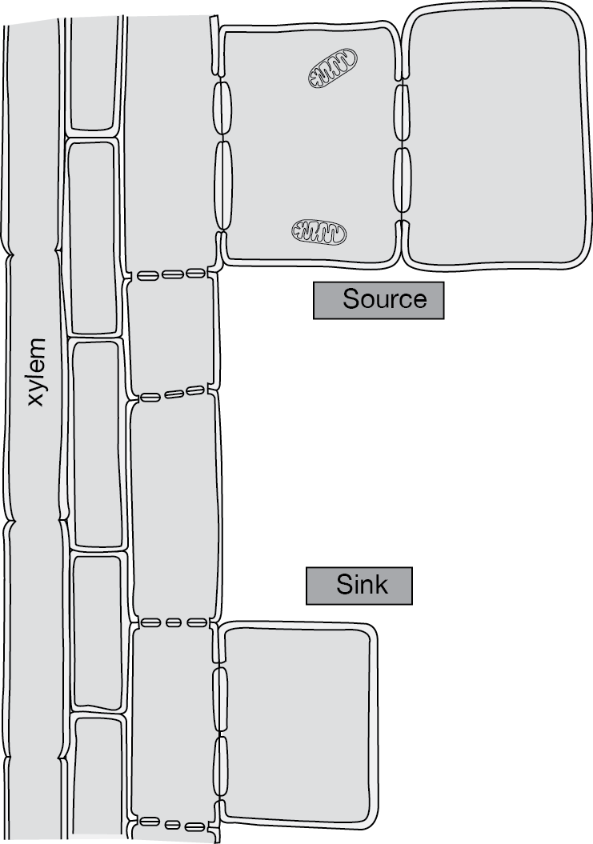
Questions
- Give one piece of evidence which shows that companion cells carry out active transport. (1 mark)
- Name the process by which:
  - Water is transported from the roots to the leaves. (1 mark)
  - Sucrose is transported from the leaves to the roots. (1 mark)
- Complete these sentences about the loading of sucrose into phloem.
Translocation is the process of transport of the products of ……………… . Sucrose
and other ……………. are loaded into the phloem at the source. ……………. ions are pumped from the companion cell into surrounding ……………. cells, by active transport. Hydrogen ions and ………… move back into the companion cells by co-transport. The sucrose concentration now builds in the companion cell, causing it to ………….. into
the sieve tube elements. This increase in sucrose in the sieve tube lowers the water potential, causing water to move in by ………... The result is that the ………….
pressure is raised causing the mass flow of the water and sucrose to the sink. (8 marks)

- Explain how the movement of sucrose out of the sieve tube element is brought about at the sink. (3 marks)

