Distance above sea level  at low tide (m) | Percentage cover %
 | Red Algae  (Catinella) | Channelled Wrack | ToothedWrack | Wireweed | Bladder Wrack | Spiral Wrack | Egg Wrack | Kelp  (Laminaria) | Sea lettuce
1 | 0 | 0 | 0 | 10 | 0 | 0 | 0 | 90 | 10
2 | 0 | 0 | 10 | 0 | 0 | 0 | 0 | 80 | 20
3 | 0 | 0 | 50 | 20 | 0 | 0 | 0 | 20 | 10
4 | 0 | 0 | 70 | 10 | 0 | 0 | 0 | 10 | 0
5 | 0 | 0 | 80 | 30 | 0 | 0 | 0 | 0 | 0
6 | 0 | 0 | 50 | 20 | 0 | 0 | 0 | 0 | 0
7 | 0 | 0 | 60 | 20 | 20 | 0 | 0 | 0 | 0
8 | 0 | 0 | 50 | 10 | 50 | 0 | 0 | 0 | 0
9 | 0 | 0 | 30 | 30 | 40 | 0 | 30 | 0 | 0
10 | 0 | 0 | 40 | 20 | 30 | 0 | 0 | 0 | 0
11 | 0 | 0 | 30 | 10 | 40 | 0 | 40 | 0 | 0
12 | 0 | 0 | 0 | 10 | 20 | 0 | 60 | 0 | 0
13 | 20 | 0 | 10 | 0 | 10 | 0 | 50 | 0 | 0
14 | 20 | 0 | 0 | 20 | 0 | 20 | 10 | 0 | 0
15 | 50 | 50 | 0 | 0 | 0 | 20 | 0 | 0 | 0
16 | 30 | 60 | 0 | 0 | 0 | 40 | 0 | 0 | 0
17 | 20 | 70 | 0 | 0 | 0 | 30 | 0 | 0 | 0
18 | 10 | 80 | 0 | 0 | 0 | 40 | 0 | 0 | 0
19 | 20 | 70 | 0 | 0 | 0 | 0 | 0 | 0 | 10
20 | 0 | 10 | 0 | 0 | 0 | 0 | 0 | 0 | 30
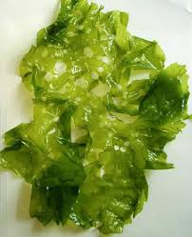
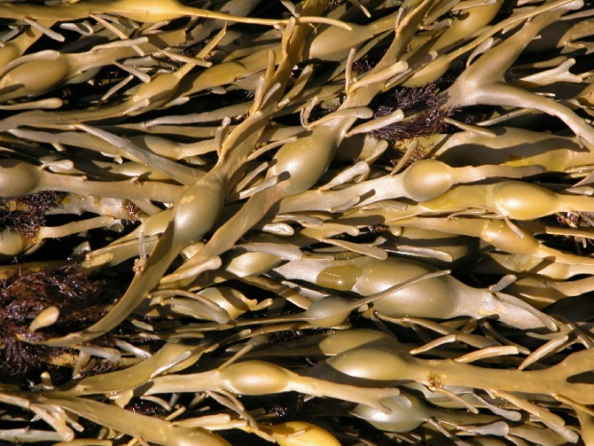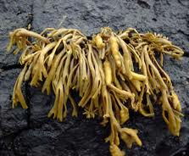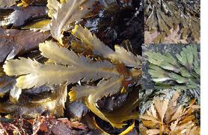
Channelled wrack
Egg wrack
Sea lettuce
Toothed wrack

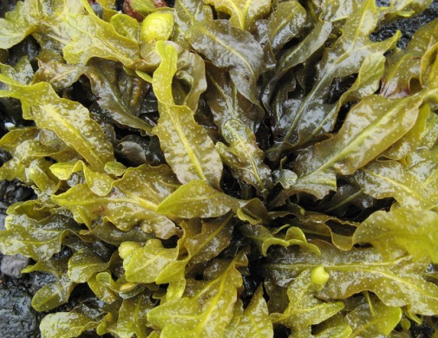
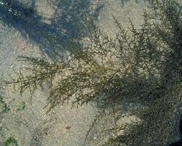
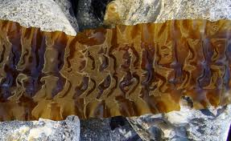
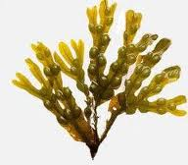
Wireweed
Bladder wrack
Kelp
Spiral wrack

