Humanistic Psychology
- Humanistic psychology emerged in the US in the 1950’s as the result of the work by Abraham Maslow and Carl Rogers. It was formed as many psychologists noted the limitations of the behaviourist and psychodynamic approaches- therefore it is often known as the ‘third’ force in psychology.
- It represents a challenge to both behaviourism and psychodynamic psychology as unlike most other approaches which are deterministic, the humanistic approach looks at free will and the individual as a whole (holism).
- It emphasises the importance of the individual striving towards personal growth and fulfilment.
- Humanistic psychology is not deterministic as it emphasises that people have full conscious control over their own destiny.
- Although it accepts that we are subject to many forces i.e. biological and societal influences, humanism believes human beings are still able to make significant personal choices within these constraints.
- Unlike many other approaches, Maslow was not concerned with what was wrong with people, but finding out what could go right with them.
- His hierarchy of needs emphasised the importance of personal growth and fulfilment.
Abraham Maslow:
Unlike many other approaches, Maslow was not concerned with what was wrong with people, but finding out what could go right with them.
His hierarchy of needs emphasised the importance of personal growth and fulfilment.
The most basic, physiological needs are represented at the bottom and the most advanced needs at the top.
Each level must be fulfilled before a person can move up to a higher need.

Self-actualisation
Every person has an innate tendency or need to want to fulfil their full potential (to become the best they could possibly be). Self- actualisation represents the uppermost level of Maslow’s hierarchy of needs. Where a person achieves their full potential and had become the best they can possibly be! All 4 other levels must be met before the individual can work towards self- actualisation- however not everyone will achieve SA. Maslow found that most people who did achieve it shared similar characteristics- they were creative, accepting of other people, independent, appreciative, happy, caring and held and accurate perception of the world around them. He defined peak moments of self-actualisation as moments of extreme inspiration and ecstasy during which a person feels able to leave behind all doubts, fears and inhibitions.
Apply your knowledge!
June is an elderly woman living in a nursing home. All her basic needs are met- she is fed, has a nice room, is in good health and feels safe. However she is not happy and has not achieved self-actualisation. When she was younger she used to love playing the piano and painting pictures.
What would you suggest the nursing home could do to help promote her self actualisation?

Evaluation:
Economic Development and the Hierarchy of Needs:
Hagerty (1999) looked at the relationship between economic growth and Maslow’s needs in 88 countries over 34 years.
- He found countries in early stages of economic development were characterised by lower levels of need (physiological needs e.g. food and safety- high murder rates)
- Only in the advanced stages of economic development did self-esteem needs (e.g. female emancipation) and self-actualisation (e.g. levels of educational enrolment) become important.
- Educational enrolment is a significant indication of the drive to self-actualise as education is seen as a way for people to better themselves.

Cultural Differences:
- In a later development to his hierarchy Maslow acknowledged that for some people, needs may appear in different orders or some may not be present at all.
- A study carried out in China by Nevis (1983) found that belongingness needs were more fundamental than physiological needs and that self-actualisation was defined more in terms of contribution to the community rather than in terms of individual development.
- Many studies have confirmed that Europeans and Americans focus more on personal identity whereas Asian cultures define self-concept more in terms of social relationships.
Explain the findings from the study above:

Carl Rogers (1951)
- Rogers believed that in order for personal growth and self-actualisation to occur, an individual must have good self-esteem.
- He suggested we had 2 ‘selves’ which need to integrate to achieve self-actualisation.
- The two selves are your self- concept and your ideal self.
Explain the two selves:

Congruence
- Definition: “in agreement or harmony”. Rogers believed that in order to achieve self- actualisation a person needs to be congruent.
- This means that their perceived self must be the same or very similar to their ideal self. This is very difficult to achieve and most people suffer from some degree of incongruence.
- To fix incongruence a person needs to develop a more healthy view of themselves or have a more achievable and realistic ideal self.
- Rogers believed that people may use defence mechanisms in order to feel less threatened by inconsistencies between who they would like to be and who they really are.
Conditions of Worth
- Conditions of worth are requirements that the individual feels they need to meet in order to be loved e.g. feeling you must get good grades for your parents to be proud of you and praise you. These can be real or perceived requirements.
- This is also called conditional positive regard (when people are only accepted by others if they do or act as they want them to).
- It is the opposite of unconditional positive regard (being loved regardless of who you are or what you do).
Research has shown that individuals who receive conditional positive regard are likely to display more ‘false self behaviour’ e.g. doing things to meet others’ expectations, even when they do not want to.
What did Harter (1996) find?

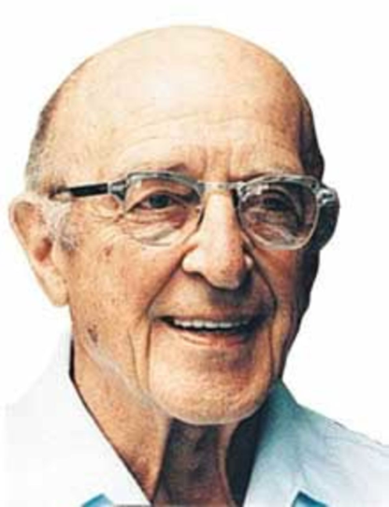
The Influence of Counselling Psychology
- Rogers claimed that an individual’s psychological problems were a direct result of their conditions of worth and the conditional positive regard they received from others.
- He believed that counselling would enable people to solve their problems in constructive ways; allowing the person to move towards self-actualisation.
During therapy:
- Client- therapist relationship was very important
- The therapist should give unconditional positive regard
- The therapist should show acceptance and understanding
- The therapist should create an environment where the patient can be honest and comfortable
- All of the above things should help to dissolve a person’s ‘conditions of worth’.
What did Elliot (2002) find about the effectiveness of counselling therapy?

The main limitations of the humanistic approach:
- Scientifically evaluating the Humanistic approach is hard as most of the evidence fails to establish cause an effect between variables.
- Studies into humanistic therapy claim that it promotes ‘personal growth’ however they do not show that therapy caused the changes. This is a fundamental requirement of scientific psychology.
- It is also very difficult to measure subjective concepts such as ‘self-worth’ and ‘congruence’
________________________________________________________________________________________________________________________________________________________________________________________________________________________________________________________________________________________________________________________________________________________________________________________________________________________________________________________________________________________________________________________________________________________________________________________________________________________________________________________________________________________________________________________

