**Chosen Speaking Topic**

You will need to decide which topic you would like to choose for the first speaking exam conversation. You may pick one topic (in bold) from the following themes:

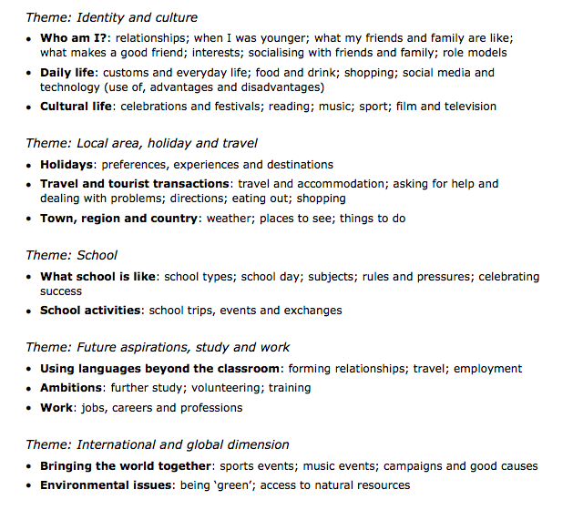

Try to include the following grammar points in your presentation:

* Present tense
* Perfect tense
* Imperfect tense
* Future tense
* Conditional tense
* Pluperfect tense
* Modals
* Subordinate clauses
* Relative clauses
* Adjective endings
* Passive voice
* Imperfect subjunctive
* Idioms