BISHOP WORDSWORTH’S SCHOOL
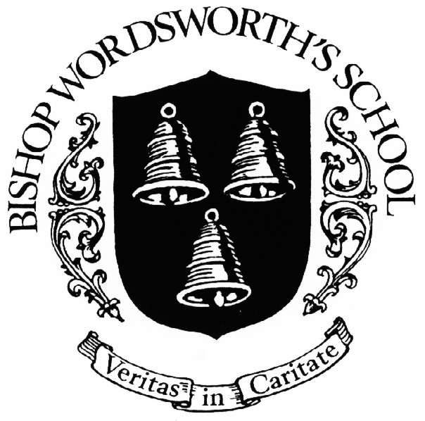
HISTORY DEPARTMENT

2nd YEAR ‘A’-LEVEL MODERN HISTORY

STUDENT GUIDE 2016-17

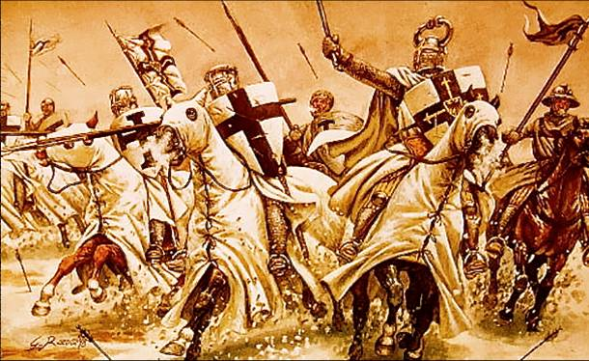
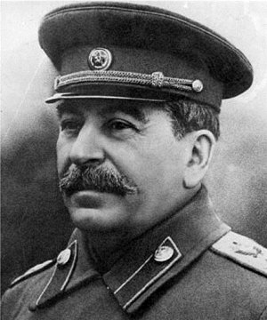
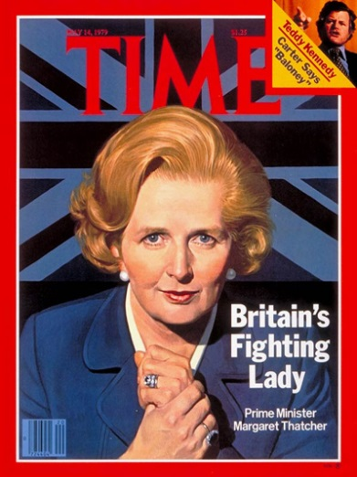

History is a dynamic subject and you will benefit from and enjoy your courses to the maximum extent if you respond with similar enthusiasm and application. As a historian you will:

- be curious about the past
- be interested in its ever-changing relationship with the present
- be eager to know more about past individuals, societies, ideas, cultures, politics and economics
- really enjoy exploring these through reading, thinking and writing

How is the course structured?

In your second year you will study two units alongside writing coursework.

1H Tsarist and Communist Russia, 1855–1964
This option allows students to study in breadth issues of change, continuity, cause and consequence in
this period through the following key questions:
• How was Russia governed and how did political authority change and develop?
• Why did opposition develop and how effective was it?
• How and with what results did the economy develop and change?
• What was the extent of social and cultural change?
• How important were ideas and ideology?
• How important was the role of individuals and groups and how were they affected by developments?

Part Two: The Soviet Union, 1917–1964
The emergence of Communist dictatorship, 1917–1941
• Political authority and government: new leaders and ideologies; Lenin's Russia, ideology and change; Stalin's rise, ideology and change
• Political authority and government: the consolidation of Bolshevik authority and development of the Stalinist dictatorship
• Economic developments: Lenin's decrees; the Stalinist economy; collectivisation and the Five Year Plans
• Social developments: effect of Leninist/Stalinist rule on class, women, young people, religion and national minorities; propaganda and cultural change
• Opposition: faction; the Red Terror and the purges
• The political, economic and social condition of the Soviet Union by 1941
The Stalinist dictatorship and reaction, 1941–1964
• Political authority, opposition and the state of Russia in wartime: the political, economic and social impact of war; effect on Stalin, government and 'the people'
• Political authority and government to 1953: High Stalinism; the revival of terror; destruction of 'supposed' opposition and cult of personality; the power vacuum on Stalin's death
• Political authority and government: Khrushchev’s rise to power; policies and ideology; de-Stalinisation; political and party change
• Economic and social developments: changes in industrial organisation from Stalin to Khrushchev; agriculture and the Virgin Lands scheme; social and cultural change from Stalin to Khrushchev
• Opposition: cultural dissidents; communist divisions; hardliners and reformers; opponents of Khrushchev and his fall from power
• The political, economic and social condition of the Soviet Union by 1964

2S The Making of Modern Britain, 1951–2007
This option provides for the study in depth of the key political, economic, social and international
changes which helped to mould Britain in the second half of the 20th century. It explores concepts such
as government and opposition, class, social division and cultural change. It encourages students to
reflect on Britain’s changing place in the world as well as the interrelationship between political policies,
economic developments and political survival.

Part Two: Modern Britain, 1979–2007
The Impact of Thatcherism, 1979–1987
• The Thatcher governments: Thatcher as leader, character and ideology; ministers; support and opposition; electoral success; internal Labour divisions and the formation of the SDP
• Thatcher's economic policies and their impact: monetarism; privatisation; deregulation; issues of
inflation, unemployment and economic realignment
• Impact of Thatcherism on society: sale of council houses; miners' strike and other industrial disputes; poll tax; extra-parliamentary opposition
• Protest and division: Northern Ireland and the troubles; attitudes to Europe, including Thatcher's policies; divisions within the Conservative Party
• Foreign Affairs: the Falklands; the 'special relationship' with USA; moves to end the Cold War; Thatcher as an international figure
Towards a new Consensus, 1987–1997
• Fall of Thatcher and her legacy; Major as leader; economic developments, including 'Black Wednesday' and its impact; political sleaze, scandals and satire; political policies; approach to Northern Ireland; Conservative divisions
• Realignment of the Labour Party under Kinnock, Smith and Blair; reasons for Labour victory in 1997
• Social issues: the extent of 'social liberalism'; anti-establishment culture; the position of women and race-relations
• Foreign affairs: relations with Europe, including the Single European Act and Maastricht Treaty ; interventions in the Balkans; contribution and attitude to the end of the Cold War
• The Labour governments: Blair as leader, character and ideology; constitutional change; domestic policies; Brown and economic policy; Northern Ireland and the Good Friday Agreement
• The Conservative Party: leaders and reason for divisions; reason for electoral failures in 2001 and 2005
• Social issues: workers, women and youth; the extent to which Britain had become a multicultural society
• Foreign affairs: attitudes to Europe; the 'special relationship' with USA; military interventions and the 'war on terror'; Britain's position in the world by 2007

You will be expected to demonstrate an understanding of key historical terms and concepts relevant to the period studied. You will be expected to be able to recall, select and deploy appropriate knowledge and communicate this clearly and effectively. You will be expected to demonstrate abilities to explain assess and analyse and to consider the relationships between key features and relationships of the periods that are studied.

For more information on the rest of the course and how it will be assessed, see the AQA website and specification booklet
http://filestore.aqa.org.uk/resources/history/specifications/AQA-7041-7042-SP-2015-V1-0.PDF

Coursework
Alongside these units, you will be completing one piece of source-based coursework in the first term. Single lessons in the first half term will be given over to teaching you the skills you will need, checking you have chosen relevant material and setting you mini-deadlines to help you structure how you work. You will be expected to keep reading logs and helpful material can be found using the Student resources button on the BWS website. Our chosen topic is The Crusades; there is plenty of reading material about, as well as television and internet programmes, and you will be given support and guidance.

How it is assessed:

3000–3500 words
40 marks
20% of A-level
marked by teachers
moderated by AQA

Students must not:

- submit work that is not their own
- lend work to other students
- allow other students access to, or use of, their own independently-sourced source material
- include work copied directly from books, the internet or other sources without acknowledgement
- submit work that is word-processed by a third person without acknowledgement
- include inappropriate, offensive or obscene material.
These actions constitute malpractice and a penalty will be given (for example, disqualification).

The historical investigation should be a single extended response, but must clearly respond to all
three Assessment Objectives.
AO1 is worth 50% of total marks and AO2 and AO3, 25% respectively.
The historical investigation should reflect this allocation of marks. Whilst a strict arithmetical
approach is not required and may, in some circumstances, disrupt the flow of the argument, the
responses to AO2 and AO3 must be substantial, reflecting the weighting that is carried by them in
the mark scheme.
In Components 1 and 2, Assessment Objectives are tested discretely in separate tasks; in
Component 3, all three are tested in the single historical investigation. However, the historical
investigation must be written in such a way that the three Assessment Objectives form part of a
single extended essay and are not treated separately.

AO1 is defined as follows in the subject criteria:
Demonstrate, organise and communicate knowledge and understanding to analyse and
evaluate the key features related to the periods studied, making substantiated judgements
and exploring concepts, as relevant, of cause, consequence, change, continuity, similarity,
difference and significance
To meet the requirements of this Assessment Objective, students should demonstrate:
• engagement with one or more of the concepts referred to in the Assessment Objective
• effective organisational and communication skills through analysis and evaluation which
consistently and relevantly focuses on the question that is set and integrates into this
evaluation, primary sources and historical interpretations
• analysis and evaluation which reflects the views and conclusions of the student
• substantiated judgements, which appear as the argument develops (assertive and
unsubstantiated or undeveloped judgements will not be placed in higher levels).

AO2 is defined as follows in the subject criteria:
Analyse and evaluate appropriate source material, primary and/or contemporary to the
period, within the historical context.
The length of primary sources to be used is not prescribed. The skills required to interrogate
primary sources to corroborate or challenge the overall response to the chosen issue may be met
through primary sources of differing lengths and ones which include visual sources.
Students are required to analyse and evaluate the value of three primary sources of at least two
different types (as exemplified in the specification), referring, as appropriate, to provenance,
content and argument and tone and emphasis.
To meet the requirements of this Assessment Objective, students should demonstrate:
• selection of sources which are directly relevant to the issue and question of the Investigation
• awareness of the value which may result from consideration of the provenance of the source,
considering, for example, who the author is, when specifically it was produced, to whom and in
what form it is addressed, the tone and style of the source and the content it contains.

AO3 is defined as follows in the subject criteria:
Analyse and evaluate, in relation to the historical context, different ways in which aspects
of the past have been interpreted.
In doing so, students must demonstrate knowledge and understanding of:
• the limitations placed on historians when they develop interpretations
• the significance of the time and/or context in which a historian writes
• comparison and evaluation of differing historical interpretations.
Whilst the issue to be investigated must be placed within the context of approximately 100 years,
the work and interpretations of the two historians which are studied in depth may:
• be interpretations which refer to the whole 100 years
• be interpretations that relate to a period of years, or a particular aspect, within the 100 years,
but cover the same period within the 100 years
• be interpretations that relate to different periods or aspects within the 100 years context.
Students must analyse and evaluate the work of two historians in depth to demonstrate the skills
and knowledge but should also show a general awareness of the range of debates related to the
issue chosen.

Your teachers will provide you with a checklist to make sure you stay on top of things, but this is really your chance to show independent learning and pursue your particular lines of interest. Enjoy!

