BISHOP WORDSWORTH’S SCHOOL
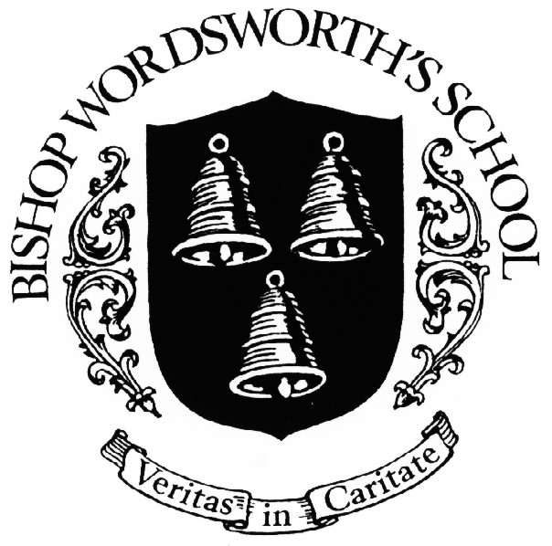
HISTORY DEPARTMENT

1st YEAR ‘A’-LEVEL MODERN HISTORY

STUDENT GUIDE 2016-17

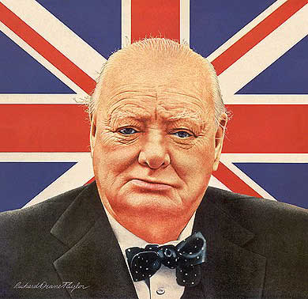 | 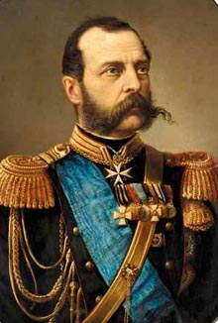
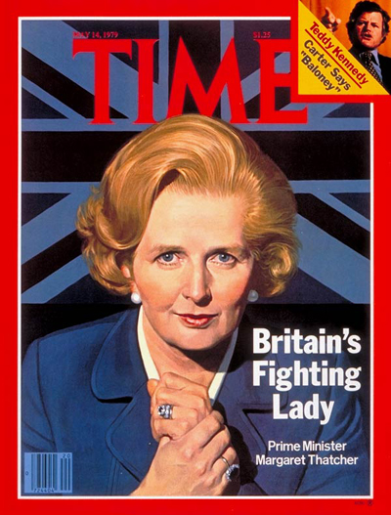 | 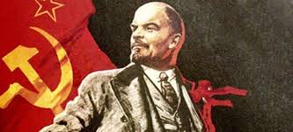

History is a dynamic subject and you will benefit from and enjoy your courses to the maximum extent if you respond with similar enthusiasm and application. As a historian you will:

- be curious about the past
- be interested in its ever-changing relationship with the present
- be eager to know more about past individuals, societies, ideas, cultures, politics and economics
- really enjoy exploring these through reading, thinking and writing

The courses enable you to study history in breadth as well as in depth, to develop expertise in various skills (general as well as historical) and to acquire and demonstrate knowledge and understanding of the periods studied.
You will study:
  - • significant events, individuals and issues;
  - • a range of historical perspectives;
  - • the diversity of society;
  - • the history of more than one country or state;
  - • a substantial element of English history;
  - • continuity and change over a period of time.
The aims of the courses are for you to:
  - • develop a coherent knowledge of the past – both within and across the topics chosen;
  - • develop and apply understanding of historical concepts – including explanation, evidence, interpretations and significance;
  - • develop the techniques of critical thinking in a historical context – and the skills necessary to analyse and solve historical problems;
  - • develop critical awareness of a range of historical dimensions – conditional and contingent, synchronic and diachronic;
  - • develop the ability to communicate historical arguments and conclusions clearly and succinctly with reference to appropriate historical terminology.
- No prior knowledge of the subject is required. The specifications build on, but do not depend on, the knowledge, understanding and skills specified for GCSE History.
The change from GCSE to AS is quite significant. You need to find ways through the reading and the work which will suit you. And be patient. Don’t expect to go from GCSE standard to AS level straight away. You need to build up the skills with time.

How is the course structured?

In your first year you will study two units:

1H Tsarist and Communist Russia, 1855–1964
This option allows students to study in breadth issues of change, continuity, cause and consequence in
this period through the following key questions:
• How was Russia governed and how did political authority change and develop?
• Why did opposition develop and how effective was it?
• How and with what results did the economy develop and change?
• What was the extent of social and cultural change?
• How important were ideas and ideology?
• How important was the role of individuals and groups and how were they affected by developments?

Part one: Autocracy, Reform and Revolution: Russia, 1855–1917
Trying to preserve autocracy, 1855–1894
• Political authority and the state of Russia: autocracy; the political, social and economic condition of
Russia in 1855 and the impact of the Crimean War
• Political authority and attempts at reform: Alexander II; emancipation of the serfs and attempts at
domestic and military reform
• Government and Tsars: Alexander II and Alexander III as rulers; attitudes to and imposition of
autocracy; key developments
• Political authority in action: Russification; treatment of ethnic minorities and Jews
• Opposition: ideas and ideologies; individuals; liberals and radical groups and the Tsarist reaction
• Economic and social developments: industrial developments and the land issue; social divisions;
nobles, landowners and position of the peasantry; the cultural influence of the Church
The collapse of autocracy, 1894–1917
• Political authority, government and Tsar; Nicholas II as ruler: political developments to 1914; 1905
Revolution; Duma government
• Economic developments to 1914: industrial and agricultural growth and change
• Social developments to 1914: change and conditions of working and living in towns and countryside;
social divisions; cultural changes
• Opposition: ideas and ideologies, liberalism, socialism; Marxism; individuals and radical groups
• Political authority, opposition and the state of Russia in wartime: the political, economic and social
problems of wartime; opposition and the collapse of autocracy; the political developments of 1917
• Political authority, opposition and government: the Bolshevik takeover and the establishment of
Bolshevik government by December 1917; opposition

2S The Making of Modern Britain, 1951–2007
This option provides for the study in depth of the key political, economic, social and international
changes which helped to mould Britain in the second half of the 20th century. It explores concepts such
as government and opposition, class, social division and cultural change. It encourages students to
reflect on Britain’s changing place in the world as well as the interrelationship between political policies,
economic developments and political survival.

Part one: building a new Britain, 1951–1979
The Affluent Society, 1951–1964
• Conservative governments and reasons for political dominance: Churchill, Eden, Macmillan and
Home as political leaders; domestic policies; internal Labour divisions; reasons for Conservatives' fall
from power
• Economic developments: post-war boom; balance of payments issues and 'stop-go' policies
• Social developments: rising living standards; the impact of affluence and consumerism; changing
social attitudes and tensions; class and 'the Establishment'; the position of women; attitudes to
immigration; racial violence; the emergence of the 'teenager' and youth culture
• Foreign relations: EFTA and attempts to join the EEC; relations with and policies towards USA
and USSR; debates over the nuclear deterrent; Korean War; Suez; the ‘Winds of Change' and
decolonisation
The Sixties, 1964–1970
• Wilson and the Labour governments: Wilson's ideology and leadership; economic policies and
problems; devaluation; industrial relations; the trade unions; other domestic policies; Labour
divisions; the beginning of the 'troubles' in Northern Ireland; the end of post-war consensus; loss of
1970 election
• Liberal reforming legislation: private members' bills and the end of capital punishment; divorce
reform; the legalisation of abortion; the legalisation of homosexual relations; educational reform
• Social and cultural change: the expansion of the mass media; growth in leisure activities; the impact
of scientific developments; the reduction in censorship; progress towards female equality; changes
in moral attitudes; youth culture and the 'permissive society'; anti-Vietnam war riots; issues of
immigration and race
• Relations with and policies towards USA, particularly issue of Vietnam; response to world affairs and
relations with Europe; decolonisation including 'withdrawal East of Suez' and Rhodesia.
The end of Post-War Consensus, 1970–1979
• Heath’s government: Heath as leader; political and economic policies; industrial relations and the
miners' strikes; the 'troubles' in Northern Ireland, including the Sunningdale Agreement
• Labour governments of Wilson and Callaghan: political, economic and industrial problems and
policies; problems of Northern Ireland
• Society in the 1970s: progress of feminism; the Sex Discrimination Act; race and immigration; youth;
environmentalism
• Britain's entry into and relations with Europe; the state of the 'special relationship' with USA;
attitudes to USSR and China

You will be expected to demonstrate an understanding of key historical terms and concepts relevant to the period studied. You will be expected to be able to recall, select and deploy appropriate knowledge and communicate this clearly and effectively. You will be expected to demonstrate abilities to explain assess and analyse and to consider the relationships between key features and relationships of the periods that are studied.

For more information on the rest of the course and how it will be assessed, see the AQA website and specification booklet
http://filestore.aqa.org.uk/resources/history/specifications/AQA-7041-7042-SP-2015-V1-0.PDF

Study skills to learn

• Be aware that you will have much more independence in organising your work than you did at GCSE and that there will be more independent study and research. It is a good idea to put aside a certain amount of time each week for AS History and divide it between the two units equally.

• Timelines are a must for getting your dates in order. Ensure you have a clear and accurate chronology of the whole period you are studying.

• Use the Key Issues for organising everything: for example use them as headings for dividers to keep your notes organised.

• Ensure you know what your notes mean; do not just copy out whole sections from textbooks. A quick check should reveal that there is more unused paper on a page than used!

• Ensure you know how to set out your notes; when using a book make sure you put down the title, author and page numbers you have used. This will help you find the pages again if you need to check up on anything.

• Ensure notes have titles, subtitles and headings; buy a multi-coloured pen so that these can be colour coded when you underline them.

• When you are taking notes, start from a basic textbook to get the basic framework of the topic. When you are using more detailed books, look for the argument the author is putting forward.

• Learn to speed read. Look at the opening sentence of a paragraph, does it relate to the topic/question on which you are working? If not, move on to the next paragraph and repeat!

• Get a list of relevant articles in sixth form History journals (such as such as Modern History Review or History Review) from your teacher; these will often give you a summary of recent research on a topic. They are quicker to read than a whole book and will be written with your needs as an A Level student in mind.

• Be willing to spend time thinking about questions before you start to write an answer.

• You will probably be given longer to do a task or essay than you were at GCSE; don’t leave it all until the last day.

• Create lots of charts that summarise key points and have arguments for and against particular issues. This will help you develop your understanding of the topic and consolidate your factual knowledge. It is also a lot more productive and interesting than staring at pages of notes!

Focus your skills effectively

• Regularly check your file to ensure your notes are in a sensible order, it is much easier to do this as you progress than have it all to do when you start revising.

• Devise charts and diagrams as summaries of topics.

• When reading, have a question or series of questions that you are trying to answer as this will keep you focused and ensure you look carefully at the text, rather than read aimlessly.

• All the Key Issues are devised as questions; ensure you can answer the Key Issue.

• Read through your friends’ essays (the good ones!) and look for ideas on how you can improve your own performance.

• When it comes to revision time, get hold of as many past and specimen questions as you can (they are on the OCR web site) and practise answering them. Use the Key Issues to think of other possible questions that could be set. This will also enable you to check that you have notes on all the Key Issues.

Stretch yourself – achieve your best

Advice
All questions set at AS and A2 are designed to test the full mark range, you do not have to attempt different questions if you want to achieve the highest marks. Instead you have to demonstrate the high level thinking skills. These are:

• An evaluation of the relative importance of the factors you have discussed.

• Evaluation throughout the essay, not just in the conclusion.

• Explain why a factor is more important; do not just assert that it is: prove it.

• Explain why other factors are less important, again, do not just assert: prove it.

• Explain and develop links between factors.

• The answer must have a clear and coherent structure.

• The ideas must be supported by a wide range of relevant evidence.

However, it is no good just having a good argument, the ideas, prioritisation and links must be supported by a wide range of factual material available. Again, read through the A grade answers and note how each student seems able to draw upon the ideal, precise fact they need to support their argument. At no stage is their argument left unsupported, but neither do they simply put facts in for the sake of it, they are chosen to support their argument.

You need to read widely. Included below in the study guide is a list of books and articles that will give you the depth of knowledge that you need.

USE OF THE HISTORY LIBRARY / STUDY CENTRE

It is expected that Sixth Form History students will undertake a number of hours of private study each week during their time in the sixth form. The History Library can be used by students as a resource centre and a place for quiet study.

Library

The History library is well stocked with core textbooks, topic books and general history books. There are in addition a number of magazines that the department subscribes to:

- History Today
- History Review
- New Perspective

These magazines provide you with a host of useful articles and it is essential that the A-Level student keeps abreast of recent academic debate. The articles should be read and noted in the library and are not to be taken out unless for photocopying purposes. They will be particularly useful when preparing for your A2 independent investigation.

At the beginning of the academic year you will be issued with a number of core textbooks and during the course of the year with a number of smaller topic books. However you are free to browse the library and borrow any relevant books. Make sure that you sign each book out on your form contained in the blue file in the History Library. It should be noted that once used books should be returned.

There are computers in the library which have access to the Internet.

Study Centre

The History Library can be used by students as a place for quiet study. There are only limited seats available for study and so only those who wish to undertake quiet study will be allowed in. The library can also be used by those who wish to seek help and advice from members of staff.

HISTORY DEPARTMENT - WORK SCHEDULE

In order to obtain the best grade in this demanding subject students are expected to undertake a considerable amount of private study.

- Students are expected to undertake at least four hours of private study outside School per week: this time should be evenly divided between the British and European courses. Private study within School is also expected of students and essential to success

- Students should expect to undertake at least two pieces of written work each two week period: one from European History and the other from British History. Not all written work will necessarily be essay form

- All written work will be given a completion date and students are required to submit work on time without fail

- Students are expected to read as widely as they can and be able to participate in class discussions knowledgeably

- Student presentations of specific topics will be required at specified times by the subject teacher

HISTORY DEPARTMENT - BRITISH & RUSSIAN BIBLIOGRAPHY

The History Library has a large number of texts and magazine articles available for student use. Some are library issue books and others are to be signed out on the appropriate form. Students should consider purchasing some additional texts..
Below is a list of texts (and other resources) available for modern British and Russian History held in the Library. Students will find that other relevant texts can be found in the library that are not on this list.

Key texts for classroom and individual study
• C Corin and T Fiehn, Communist Russia under Lenin and Stalin, Hodder, 2002
• J Laver, Triumph and Collapse: Russia and the USSR 1941-1991, Nelson Thornes, 2009
• A Todd, The Soviet Union and Eastern Europe 1924-2000, CUP, 2012
• S Waller, Imperial Russia, Revolutions and the emergence of the Soviet State 1853-1924,
CUP, 2012
• S Waller, Tsarist Russia, 1855-1917, Nelson Thornes, 2009
Useful books for students
• J Bromley, Russia 1848–1917, Heinemann, 2002
• G Darby, The Russian Revolution, Longman, 1998
• D Evans and J Jenkins, Years of Russia, the USSR and the Collapse of Soviet Communism,
Hodder Arnold (2nd edn), 2001
• J Hite, Tsarist Russia 1801–1917, Causeway Press, 2004
• J Laver, The Modernisation of Russia 1856–1985, Heinemann, 2002
• S J Lee, Russia and the USSR, Routledge, 2005
• M Lynch, Reaction and Revolutions: Russia 1881–1924, Hodder Murray (2nd new edn), 2005
• D Murphy and T Morris, Russia 1855–1964, Collins, 2008
• A Wood, The Russian Revolution, Longman (2nd edn), 1986

Visual sources and websites
• D King, Russian Revolutionary Posters, Tate Publishing, 2012
• D King, Red Star over Russia (a visual History of the Soviet Union), Tate Publishng, 2010
• P Kurth, Tsar: The Lost World of Nicholas and Alexandra, Back Bay, 1998
• B Moynahan, Russian Century: A Photographic History, Weidenfeld, 2000
• https://www.marxists.org/archive/lenin/
• http://www.hsc.csu.edu.au
• http://www.choices.edu/resources/detail.php?id=46
• http://www.tate.org.uk/whats-on/tate-modern/display/russian-revolutionary-posters

Key texts for classroom and individual study
• C Rowe, The Making of Modern Britain 1951-2007, Nelson Thornes, 2009
• M Lynch, Britain 1945-2007, Hodder, 2008
• S Waller, A Sixties Social Revolution? British Society 1959-1975, Nelson Thornes, 2008
Useful books for students
• S J Lee, Aspects of British Political History 1914-1995, Routledge, 1998
• N Lowe, Mastering Modern Britain, Palgrave, 1998
• A Marr, A History of Modern Britain, Macmillan, 2007
• A Mayer, Women in Britain 1900-2000, Hodder, 2002
• D Murphy (ed), Britain 1914-2000, Collins, 2000
• M Pearce, British Political History 1867-200: Democracy and Decline, Routledge, 2001
• C Rowe, Britain 1929-1998, Heinemann, 2004

Visual sources and websites
• Andrew Marr’s History of Modern Britain, DVD 2entertain, 2009
• http://www.news.bbc.co.uk/onthisday

Students are advised to subscribe to the Modern History Review.

