**Oil Transit chokepoints**

c. 63% of the world's oil supply moves through set maritime routes, according to the US Energy Information Administration (EIA), often aboard massive tanker ships. To minimize costs, tankers transport oil along established paths that are as short as possible. Many pass through a small handful of maritime chokepoints.

The EIA defines these as ‘narrow channels along widely used global sea routes, some so narrow that restrictions are placed on the size of vessel that can navigate through them.’ Globally, there are eight major chokepoints and a closure or disruption to any one of them could cause unpredictable price fluctuations. For example, oil prices surged in late week March 2015 after Saudi Arabia began its military operations against Yemen. 3.8 million barrels of oil a day pass through the Bab el-Mandab chokepoint on Yemen's southwestern coast.

If one of these chokepoints were disrupted, ships would need to travel additional thousands of miles to reach an alternate route. These locations are generally safe and are kept clear by the international community, whose economies and standards of living depend on these chokepoints remaining clear, though they have increasingly become targets for piracy.

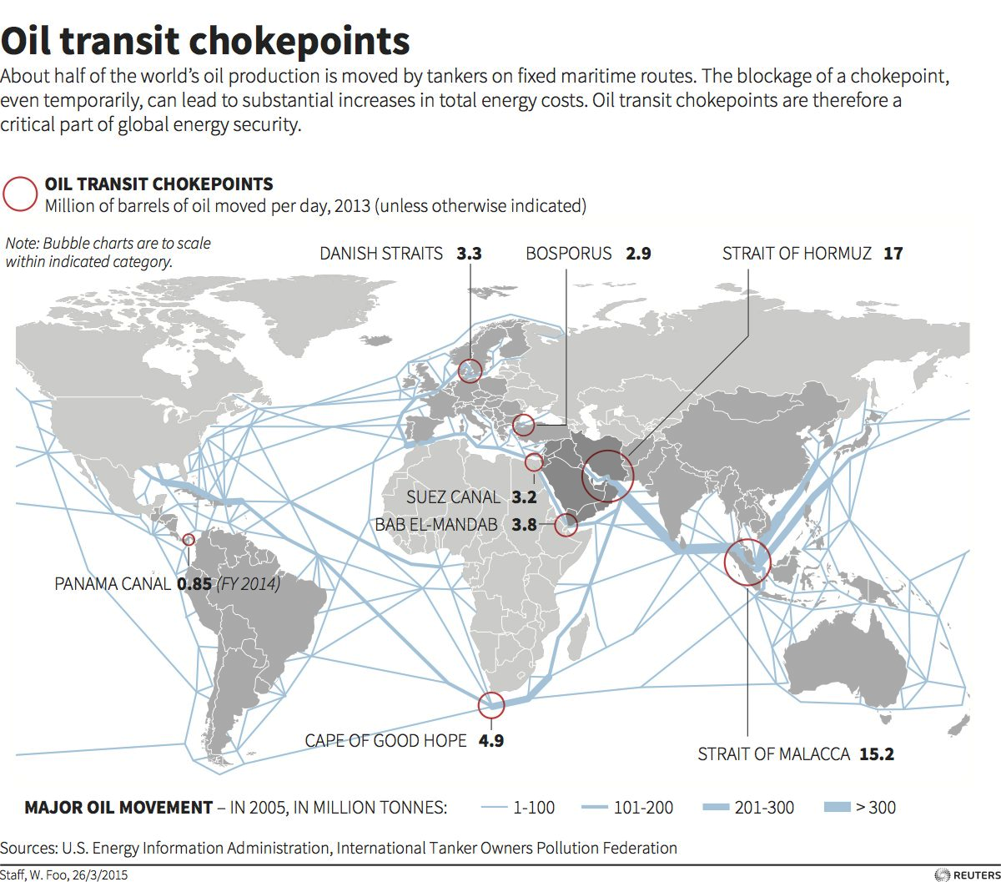

**Strait of Hormuz - 17 million barrels of oil per day**

This is the world's primary oil chokepoint, with c. 30% of all maritime-traded petroleum passing through the strait each day in 2013. Oil from Saudi Arabia, the UAE, Qatar, Iran, and Iraq all pass through the strait and head mostly towards Asia, although tankers can also head west towards the Suez Canal and the Red Sea. It is able to accommodate the largest oil tankers in the world.

Iran has indicated that it could be willing to disrupt the strait. Tehran has previously threatened to mine the waterway, and in February 2015 Iran carried out the destruction of a mock US aircraft carrier in the strait.

**Strait of Malacca - 15.2 million barrels of oil per day**

This is the shortest waterway which connects the Indian Ocean to the South China Sea and the Pacific Ocean, with fuel from the Middle East primarily heading towards Indonesia, China, and Japan.

It is also one of the most narrow chokepoints in the world, being less than 3km wide at the narrowest point, thus creating a bottleneck for shipping. The strait has become one of the newest piracy hotspots in the world.

**Cape of Good Hope - 4.9 million barrels of oil per day**

The crossing at the southernmost tip of Africa is not technically a chokepoint since it's open on one side, but the area is a critical trade route with approximately 9% of the total maritime oil trade passing it in 2013.

It also functions as the secondary route for oil if the primary chokepoints of the Suez Canal or the Bab el-Mandab were closed. But, according to the EIA, rerouting oil around the Cape would increase costs considerably as it would add c. 4,300km of transit from Saudi Arabia to the US.

**Bab el-Mandab - 3.8 million barrels of oil per day**

This is one of the most precarious oil chokepoints in the world. Only 25km wide at its narrowest point, the Bab el-Mandab connects the Red Sea to the Gulf of Aden and ultimately to the Indian Ocean. Instability or closure of the waterway could force tankers to have to travel around the southern tip of Africa. In addition, the EIA notes, the vast majority of southbound traffic through the Suez Canal must also pass through the Bab el-Mandab, so the closure of the waterway could have a cascade effect.

**Danish Straits - 3.3 million barrels of oil per day**

Formed out of a series of channels passing around Danish Islands, this chokepoint connects the Baltic Sea in the east to the North Sea in the west.

Despite rising tensions with Russia in Europe, and particularly the Baltics, shipping is unlikely to be affected by regional security issues as this is among the most secure oil chokepoints in the world. The EIA estimates that 42% of all oil shipped through the Danish Straits originated from the Russian port of Primorsk in 2013 to the West. A small amount of Norwegian and British oil also went through the straits to the Baltics, but if Russia ever blockaded the Strait, it would mostly just be blockading its own oil trade as well.

**Suez Canal - 3.2 million barrels of oil per day**

This passes through Egypt and connects the Red Sea to the Mediterranean with oil headed mostly to markets in Europe and North America. It was expanded in 2010 to allow 60% of all tankers in the world to effectively pass through.

The fall of dictator Hosni Mubarak in Egypt in 2011 and the resulting unrest did little to deter shipping through the canal, but security remains a primary concern. In September 2013, terrorists planned a failed rocket attack on cargo ships passing through the region.

**Bosporus - 2.9 million barrels of oil per day**

This narrow stretch of water divides Asia from Europe and splits Istanbul's European and Asian halves, connecting the Black Sea to the Mediterranean with petroleum coming from Russia, Azerbaijan, and Kazakhstan.

According to the EIA, Russia has slowly been shifting its exports to the Baltics while Azerbaijan and Kazakhstan have further increased shipping through the chokepoint. The Bosporus is only a half mile wide at its narrowest point, and around 48,000 vessels travel through the waterway a year.

**Panama Canal - 0.85 million barrels of oil per day**

This connects the Pacific Ocean to the Caribbean and ultimately to the Atlantic along a 77km. According to the EIA, the Panama Canal transported 1.4% of all oil and petroleum products globally in 2013.

The utility of the canal has waned in the years since it was built as the series of locks were too narrow for modern super-tankers (being only 34m wide at its narrowest point). A third, wider and deeper lane of locks was completed in 2016 which enables larger tankers (Post-Panamax) to pass through the region more easily, though these still have to be shorter, narrower and have a shallower draft than the largest ships that can pass through the other chokepoints.

<http://uk.businessinsider.com/worlds-eight-oil-chokepoints-2015-4> (28/01/18)

<https://en.wikipedia.org/wiki/Panama_Canal> (28/01/18)