‘Our City’ 20/20 Vision

Salisbury Schools Challenge 2018/9

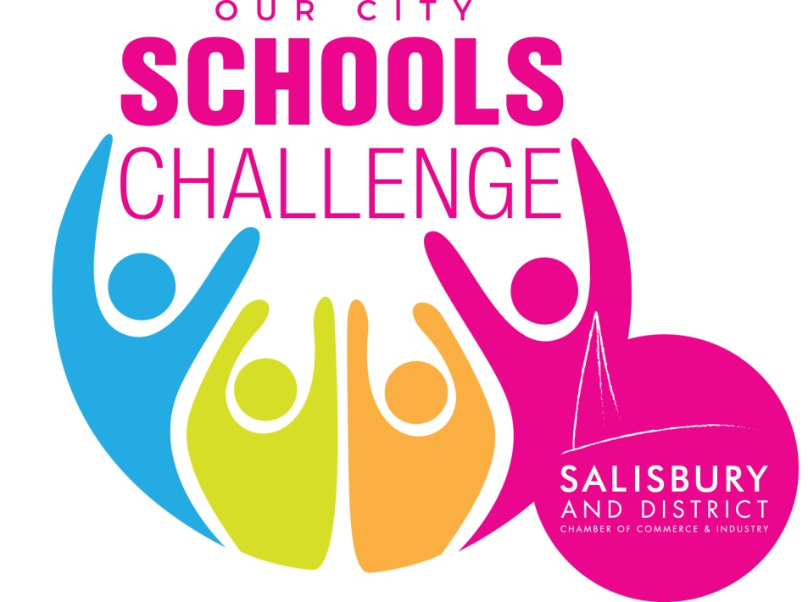

‘Our City’ - 20/20 Vision

The events of recent months have brought Salisbury greater worldwide attention and added an extra dimension to the need to plan a positive future for the city.
‘Our City’ – 20/20 Vision therefore carries on the Challenge to Salisbury students to think of ideas and ways in which the city can develop and prosper. It is and will be their city and their thoughts and ideas must help shape the future.
As before, we need their views of what is good and not so good about our city and where things can and must improve.
The Challenge
The format will be similar to this year with three categories: Key Stage 3, Key Stage 4 and Sixth Form/A level. There will be a cash prize for the winning team in each category and a prize plus the silver trophy for the overall winning school.
Through 20/20 Vision, we would like students to think of ideas and projects that can make a difference and:
- enhance Salisbury’s image across the country........and globally
- give visitors of all ages a very positive experience and
- improve life for all its residents
The suggested projects could be small or large, but should be ideas that could at least be started fairly soon and begin to make some impact towards 2020.
Timescales
There will be two terms to plan and undertake the Challenge and schools will wish to arrange this to fit with their own timetable.
Student activities could include online research, interviews with people they identify, survey work either undertaken by email or through interviews in the city centre: plus, of course, their own ‘blue skies’ ideas! We would expect a good mix of text, photographs, plans - even video - and whatever other creative ideas students might agree on.
Judging will then take place before the end of the Spring term when teams will make presentations to a panel of business people.
Presentations should aim to be of 10-15 minutes.
The student groups can be of varying sizes and can even be across Year groups - or smaller groups feeding in to one central point.
For the Finals, we will expect teams of around 4 to make the actual presentation and they may be doing this behalf of a larger group who could have contributed to the previous work - surveys, research, interviews etc.
Supporting the Students
Part of the task will be for students to decide where they go for information and a list of useful websites that they may wish to access will be made available - including many of the city’s civil society organisations. Students may also approach the Chamber of Commerce and supporting organisations with specific queries or for information and advice. A list of business experts and contact details will also be made available.
Whatever ideas the students have, they should look at how achievable they are in
the shorter term (ie 2020) and over a longer period. Wherever possible, they should
aim to cost the ideas, however approximately. They should look at possible sources
of funding and any possible barriers to success

The potential areas to look at are included in the pie chart below, but it’s up to the students and we’ve also added some extra thoughts.

‘Our City’ - 20/20 Vision
Salisbury Schools Challenge 2018/19
We want your views about what is good and, maybe not so good about Salisbury. Your ideas can make a difference and help shape the city’s future.
It’s important that your voices are heard.

There are trophies and prizes for both the winning schools and winning teams. This year’s teams got certificates and shopping vouchers as well as the prizes for the winners. There is also a planned visit to London and the House of Commons to meet Salisbury MP, John Glen for some of this year’s teams

Also, some of this year’s ideas are already being taken forward and we will aim to support your best ideas to really make them happen!

Some areas to consider.....................................

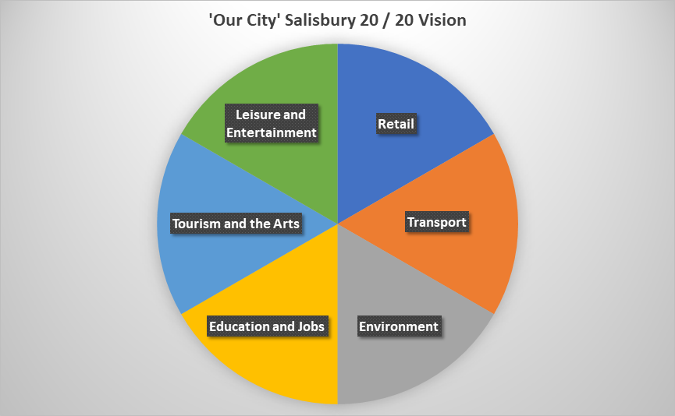
The areas such as transport, tourism, retail and the environment - as well as leisure and entertainment, education and jobs - are all going to be important: and so is all the culture, history and heritage that is so much part of Salisbury.

But, you may have more ideas!

It’s your city. What would you do?
How can Students’ be heard?
Can there be a coordinated student voice across the city?
Does Salisbury need a makeover?
Can we market Salisbury better?
Can we use social media to help?
Is there an App – or more than one – that could be developed?

Over to you!!
-------------------------------------------------------------

