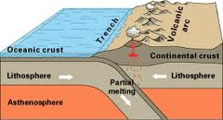
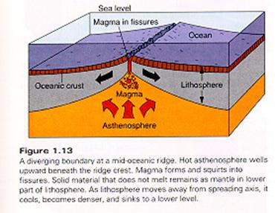
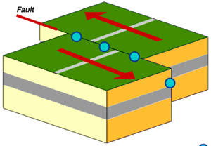

Collison Zone | Conservative Plate Boundary | Constructive Plate Boundary | Destructive Plate Boundary
Convection currents in the mantle cause the plates to move together. | If these shield volcanoes are big enough to be seen above sea level they create volcanic islands, such as Iceland. | Convection currents in the mantle cause the plates to move apart. | Convection currents in the mantle cause the plates to move together.
As the plates pull away, cracks and fractures form between the plates where there is no solid crust. | Magma forces its way upwards and into the cracks, building the new plate. | If the two plates moving towards each other are both continental then subduction cannot occur. | Therefore, oceanic plate sinks beneath the continental plate.
It is this sudden release of pressure that causes earthquakes. | Convection currents in the mantle can cause the plates to move past one another. | The two plates will buckle upwards and downwards. | Oceanic crust is denser than continental crust.
This process is called subduction. | This is called a collision boundary and is how the Himalayas are formed. | This magma may build up to form volcanoes, known as shield volcanoes. | Eventually the pressure is too great, the pressure is released and the plates will move.
They can be moving in the same direction, at different speeds, or in opposite directions. | The sliding motion is not smooth and the plates get stuck due to the friction. | The magma may rise up through cracks and faults within the continental plate causing volcanic eruptions. | The resultant features are composite volcanoes.
The lighter continental plate will buckle as the oceanic plate blocks its path, resulting in fold mountains forming. | A deep oceanic trench is also formed. | So much magma is poured out of these cracks and fractures that ridges are built up from the sea bed, like the Mid-Atlantic Ridge. | An example is the San Andreas fault line, as the North American plate moves past the Pacific plate.
Due to the considerable heat and pressure from the subduction, the rock melts to form magma. | There is considerable friction caused by the subduction and severe earthquakes are common occurrences.

