Nunton Dairy Farm – Farming as a Business
Objectives
- Know the systems of the dairy farm
- Identify the range of jobs carried out at varies times in the year
- Describe and explain how Nunton Farm has changed in order to maximise its potential as a business

You should be able to answer these questions following the farm visit:
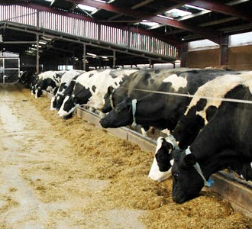
- What are the inputs, processes and outputs?
- Which crops are grown on the farm? Why?

- How has the farm changed over time?
- Why have these changes occurred?

- What machinery is used on the farm?
- How has this changed over time?

- Who buys the milk produced on Nunton Farm?

- Are all dairy farms the same?
Key words
Rotary parlour Hay Slurry
Silage Ruminant Cud
Artificial insemination (AI) Colostrum
Partnership Fertiliser Pesticides
Mastitis Dry cow Heifer
Lactation Calf
Pasteurisation Crop rotation
Stewardship
TASK:
Present your findings on one side of A4.
You must include the following:
The Inputs, processes and outputs of a Dairy Farm
What makes Nunton Farm business different from other dairy farms?
What do you think has contributed to the the success on Nunton Farm?
Any other relevant information/ pictures/diagrams

