Title: Migrating to Australia
Objective: To find out why many UK citizens move to Australia
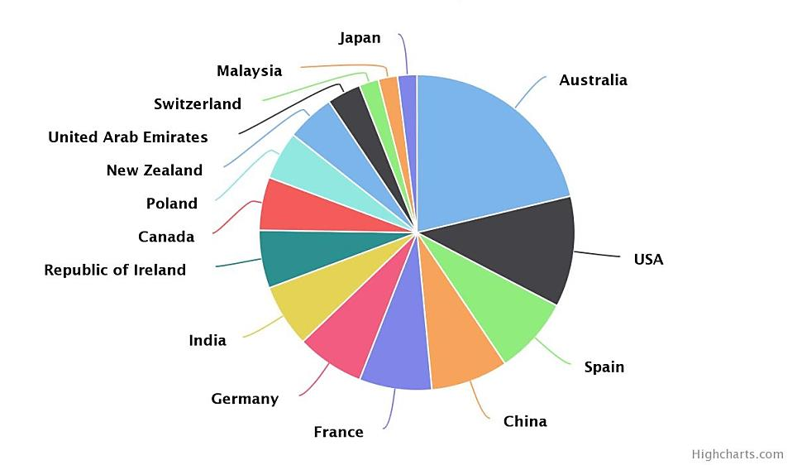
This pie chart shows where people from the UK emigrated to in 2013. As you can see, Australia is a very popular destination for UK citizens. Why is this? What are the push and pull factors operating – and are there any obstacles to migrants wanting to live permanently in Australia?
Your task is to produce a document explaining why Australia is such a popular destination for people who want to move from the UK. You can present your work in Word or Publisher – but it must not be longer than 2 sides of A4. Include relevant pictures, maps and photos – making sure to refer to them in your text. Make sure to research each section thoroughly: don’t just go on what you think you know about either Australia or the UK! Organise your work in these sections:
- Where is Australia? Referring to an appropriate map, briefly describe where it is in relation to other countries, oceans, and lines of latitude/longitude. Include stats about its size, number of states, etc., and how it compares in size to the UK.
- How does Australia’s landscape compare to the UK’s? Research the different types of physical (i.e. natural) landscapes to be found in Australia (e.g. tropical rainforests, deserts, coastlines, mountains). How different are these to what can be found in the UK? What are the possible push and pull factors operating?
- How does Australia’s weather and climate compare to the UK’s? Find specific details about the different climates that can be found in Australia. How different are these from what the UK experiences? What are the possible push and pull factors operating?
- How is life in Australia different to life in the UK? Research the following to find out push and pull factors might be operating: how does life in towns and cities compare? How do standards of living and quality of life compare? [Try and find out information relating to such aspects as: health, education, wages, housing, employment and leisure opportunities, air quality…]
- What types of UK citizen migrate to Australia? [This is about obstacles to migration] Can anyone from the UK migrate to Australia? What system is used to decide if UK citizens can migrate to Australia? Are all the people migrating to Australia from the UK economic migrants?
- A concluding paragraph: Summarise the main points you have identified from the above sections that you think makes Australia such a popular destination for UK migrants.

