Title: Migrating to Australia
Objective: To find out why many UK citizens move to Australia
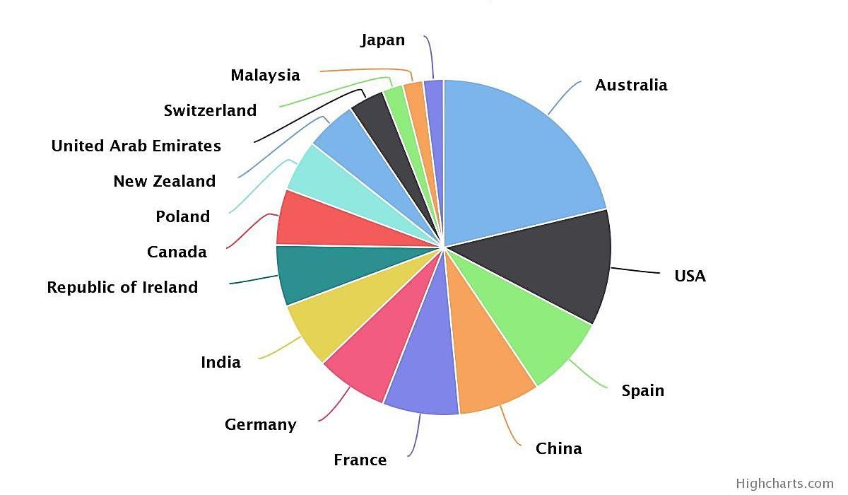
This pie chart shows where people from the UK emigrated to in 2013. As you can see, Australia is a very popular destination for UK citizens. Why is this?
Your task is to produce a document explaining why Australia is such a popular destination for people who want to move from the UK. You can present your work in Word or Publisher – but it must not be longer than 2 sides of A4. You may include any relevant pictures, maps (including ones you have drawn yourself) and photos. For each of the following sections, include relevant information that helps to explain the attraction:
- Where is Australia? Include a map of the world showing the location of Australia and a description of where it is in relation to other countries, the oceans and lines of latitude and, of course, you should mention that it is in the Southern Hemisphere! You can also add in any stats here about its size/states and how it compares in size to other countries around the world.
- Diverse landscape: Here you need to include information about the physical geography of Australia, such as: tropical rainforests, rivers, beaches and deserts, and other important features including the two world heritage sites, Uluru and The Great Barrier Reef. Relevant information about the wildlife could be useful in this section, too.
- Weather and Climate: Why does Australia have the climate that is does? How does it vary? Think about its location and proximity to the equator. What extreme weather does Australia experience? You could find out about tropical cyclones and droughts (which can lead to bush fires).
- The human geography of Australia: What are the towns and cities like to live in? What types of jobs might be available to migrants? What are the standard of living and quality of life like?
- How is migration to Australia managed? How do they make decisions about who will be able to migrate to Australia? The website: www.emigrate-to-australia.co.uk is one place you can look. Who do you know who might be eligible to migrate to Australia?
- A concluding paragraph: Summarise the main points that you think makes Australia such a popular destination for UK migrants.

