Title: Migrating to Australia
Objective: To find out why many UK citizens move to Australia
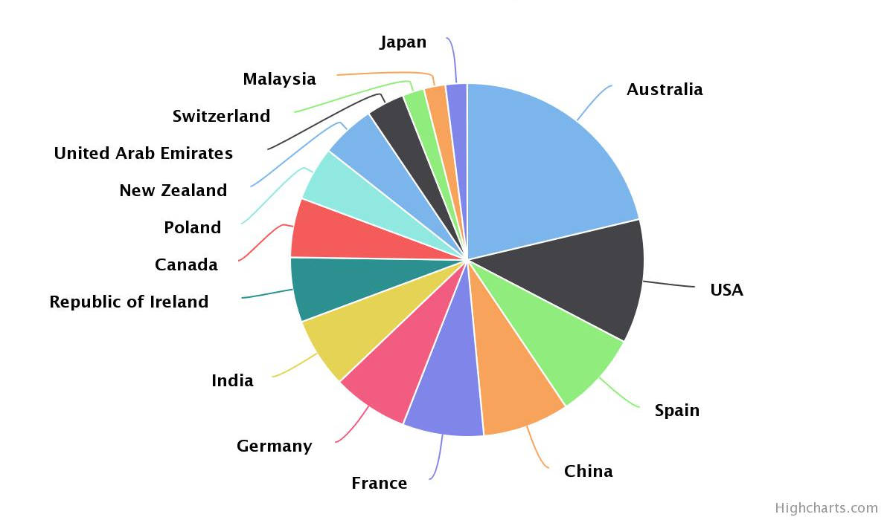
This Pie chart show where people from the UK emigrate to (2013). As you can see, Australia is a very popular destination for UK citizens. Why is this?
Your task is to produce a document explaining why Australia is such a popular destination for people who want to move from the UK. You can present your work in word or publisher. You may include any relevant pictures, maps (including ones you have drawn yourself) and photos.
- Where is Australia? You will need to include a map of the world showing the location of Australia and a description of the location of Australia – in relation to other countries, the oceans and lines of latitude and of course, you should mention that it is in the Southern Hemisphere! You can also add in any stats here about its size/states and how it compares in size to other countries around the world.
- Diverse landscape. Here you need to include information about the physical qualities that make up Australia. Tropical rainforests, rivers, beaches and deserts and other important features including the 2 world heritage sites: Uluru and The Great Barrier Reef. Think about the wildlife in this section too.
- Weather and Climate – Why does Australia have the climate that is does? How does it vary? Think about its location and proximity to the equator. Extreme weather – you could find out about tropical cyclones and drought – which can lead to bush fires.
- Australian Cities – how is Australia managed and governed ? How do they make decisions about people migrating to Australia. The website: www.emigrate-to-australia.co.uk is one place you can look. Who do you know who might be eligible to migrate to Australia?
- Finally, a concluding paragraph – what do you think makes Australia such a popular destination for UK migrants?

