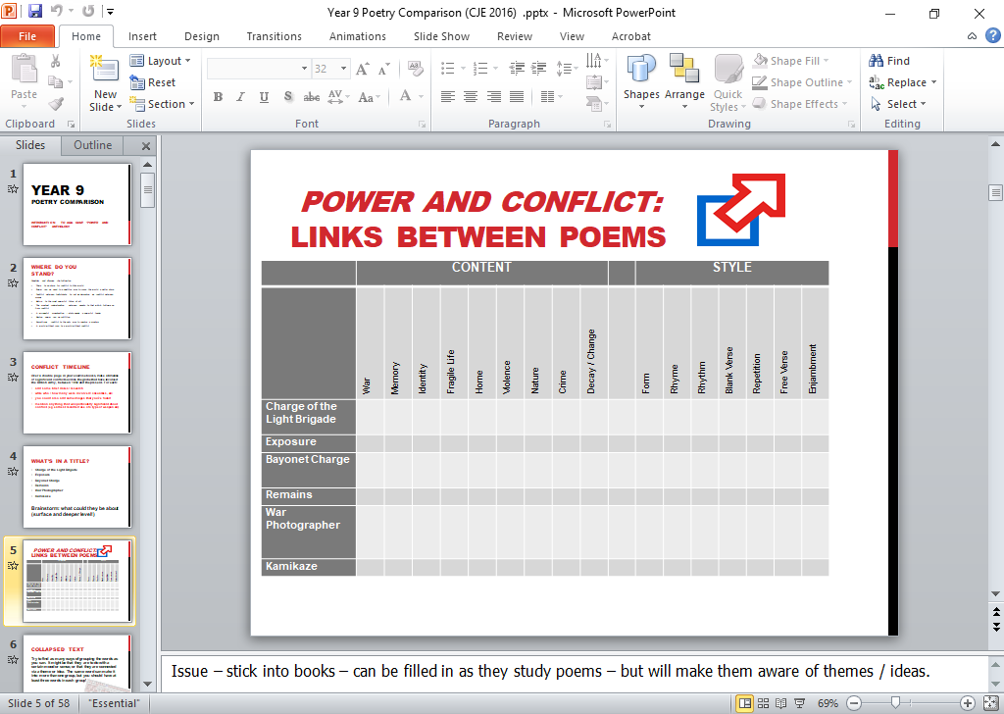



Listed below are all of the words from the poem that you are about to study – but they have been re-arranged into alphabetical order! This is called a **collapsed text**. You can work on a collapsed text in a number of ways:

* **Thematically:** Try to find as many different ways of grouping the words as you can. It might be that they are to do with a certain mood or sense; or that you associate them all with a certain theme or idea. The same word can make it into more than one group, but you should make sure that there are at least three words to each group!
* **Contextually:** By looking at individual words, try to make guesses as to what your poem is about, who it might have been written by, and when it could have been written. What do the individual words tell us?
* **Grammatically:** Group the words according to parts of speech – verbs, adverbs etc. Make some conclusions from your findings.
* **Creatively:** Try using just the words of the collapsed text to write a poem or story of your own!

a a a a air all all all all all an and and and and and and and and and army as at at back back bare battery-smoke behind blundered boldly brigade brigade brigade broke but but came can cannon cannon cannon cannon cannon cannon charge charge charge charging cossack death death death death death die dismayed do fade fell flashed flashed for forward forward fought from from front glory gunners guns had had half half half he hell hell hero honour honour horse hundred hundred hundred hundred hundred hundred hundred in in in in into into into into jaws jaws knew league league league left left left left light light light line made made make man mouth mouth noble not not not not not o of of of of of of of of of of of of of of onward plunged reason reeled reply right right right rode rode rode rode rode rode russian sabre sabres sabring said shattered shell shell shot shot six six six six six six six so soldier someone stormed stormed stroke sundered that that the the the the the the the the the the the the the the the the the the the the the the the the the their their theirs theirs theirs them them them them them them them then there there they they they they they they they though through through thundered thundered to to to to to to to turned valley valley valley volleyed volleyed was was well well when while while why wild with with wondered wondered world world

***collapsed* TEXTS**

**Tennyson *The Charge of the Light Brigade***

**The Charge of the Light Brigade**

ALFRED TENNYSON

1.

Half a league, half a league,

Half a league onward,

All in the valley of Death

Rode the six hundred.

‘Forward, the Light Brigade!

Charge for the guns!’ he said:

Into the valley of Death

Rode the six hundred.

2.

‘Forward, the Light Brigade!’

Was there a man dismay’d?

Not tho’ the soldier knew

Some one had blunder’d:

Theirs not to make reply,

Theirs not to reason why,

Theirs but to do and die:

Into the valley of Death

Rode the six hundred.

3.

Cannon to right of them,

Cannon to left of them,

Cannon in front of them

Volley’d and thunder’d;

Storm’d at with shot and shell,

Boldly they rode and well,

Into the jaws of Death,

Into the mouth of Hell

Rode the six hundred.

4.

Flash’d all their sabres bare,

Flash’d as they turn’d in air

Sabring the gunners there,

Charging an army, while

All the world wonder’d:

Plunged in the battery-smoke

Right thro’ the line they broke;

Cossack and Russian

Reel’d from the sabre-stroke

Shatter’d and sunder’d.

Then they rode back, but not

Not the six hundred.

5.

Cannon to right of them,

Cannon to left of them,

Cannon behind them

Volley’d and thunder’d;

Storm’d at with shot and shell,

While horse and hero fell,

They that had fought so well

Came thro’ the jaws of Death

Back from the mouth of Hell,

All that was left of them

Left of six hundred.

6.

When can their glory fade?

O the wild charge they made!

All the world wonder’d.

Honour the charge they made!

Honour the Light Brigade,

Noble six hundred!

**The Charge of the Light Brigade**

ALFRED TENNYSON

1.

Half a league, half a league,

Half a league onward,

All in the valley of Death

Rode the six hundred.

‘Forward, the Light Brigade!

Charge for the guns!’ he said:

Into the valley of Death

Rode the six hundred.

2.

‘Forward, the Light Brigade!’

Was there a man dismay’d?

Not tho’ the soldier knew

Some one had blunder’d:

Theirs not to make reply,

Theirs not to reason why,

Theirs but to do and die:

Into the valley of Death

Rode the six hundred.

3.

Cannon to right of them,

Cannon to left of them,

Cannon in front of them

Volley’d and thunder’d;

Storm’d at with shot and shell,

Boldly they rode and well,

Into the jaws of Death,

Into the mouth of Hell

Rode the six hundred.

4.

Flash’d all their sabres bare,

Flash’d as they turn’d in air

Sabring the gunners there,

Charging an army, while

All the world wonder’d:

Plunged in the battery-smoke

Right thro’ the line they broke;

Cossack and Russian

Reel’d from the sabre-stroke

Shatter’d and sunder’d.

Then they rode back, but not

Not the six hundred.

5.

Cannon to right of them,

Cannon to left of them,

Cannon behind them

Volley’d and thunder’d;

Storm’d at with shot and shell,

While horse and hero fell,

They that had fought so well

Came thro’ the jaws of Death

Back from the mouth of Hell,

All that was left of them

Left of six hundred.

6.

When can their glory fade?

O the wild charge they made!

All the world wonder’d.

Honour the charge they made!

Honour the Light Brigade,

Noble six hundred!



***exam* TIPS AO:1and 4**

**the ‘SMILER’ technique**

The *SMILER* technique is a really useful way of remembering how to structure your response to the exam question. It basically breaks your answer down into six main parts – one for each letter in ‘SMILER’. Within each of these sections, you compare the two poems that you are working with for that particular section. What is especially useful is that the ‘S’ (for ‘subject’) section at the start, doubles up as a good introduction to your essay, while ‘R’ (for ‘response’) acts as your conclusion! The bullet points will give you a guide to the sorts of things that you should be comparing / including – not all of them may be relevant to the poem you are looking at, and you might even think of other things to include! **It is useful, though, to try to learn this structure off by heart and apply it to any essay you write about the Anthology!**

**‘S’ for ‘Subject’**

* What are the poems about, and what is their main link to the area of focus on the title?
* Who is the narrator of each poem?
* Who are the characters in the poem?
* Why were the poems written?
* Are there any overall points or messages to the poems?

**‘M’ for ‘Movement of Ideas’**

* Whether they are split into stanzas, and how regular these are
* Whether there is a specific pattern to stanzas / line-lengths / rhythm / rhyme (and why!)
* Ideas that are contained in each stanza, and how these are sequenced, leading to the end

**‘I’ for ‘Imagery’**

* Literal images – ones that are described as they are, with no comparison
* Metaphors and similes, that use comparison for striking effect
* Symbolism – where an object or image represents something deeper or more significant

**‘L’ for ‘Language’\***

* Particularly effective parts of speech (i.e. verbs, adjectives, adverbs)
* Sounds of words used for effect – through techniques like alliteration, assonance, onomatopoeia
* Words which are used together for effect, such as hyperbole, repetition, oxymoron, etc.

**‘E’ for ‘Emotions’**

* The emotions of the whoever is narrating the poems
* The emotions of other characters in the poems
* How emotions and moods change through the poems

**‘R’ for ‘Response’**

* What YOU think of each poem overall
* What you believe the significant similarities and differences between the poems are
* Your lasting impression of each poem (in the light of the area of focus in the question)

***exam* TIPS AOs: 1 2 and 3**

**the ‘SMILER’ technique-*task!***



Now that you know how the SMILER technique works, consider the following task: Using *Charge of the Light Brigade* and your SMILER sheet, make bullet points notes on the poem under the SMILER headings.

|  |  |
| --- | --- |
| SUBJECT |  |
| MOVT,. OF IDEAS |  |
| IMAGERY |  |
| LANGAUGE |  |
| EMOTIONS |  |
| REPOSNSE |  |

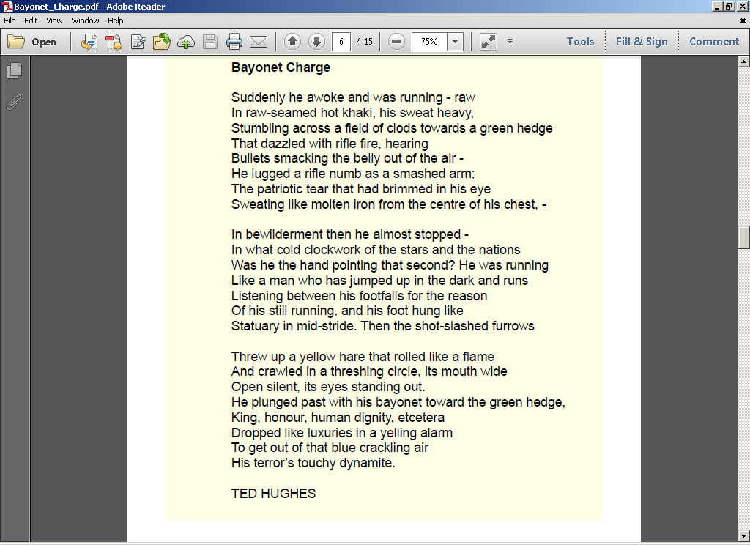



Kamikaze

Her father embarked at sunrise  
with a flask of water, a samurai sword  
in the cockpit, a shaven head  
full of powerful incantations  
and enough fuel for a one-way  
journey into history

but half way there, she thought,  
recounting it later to her children,  
he must have looked far down  
at the little fishing boats  
strung out like bunting  
on a green-blue translucent sea

and beneath them, arcing in swathes  
like a huge flag waved first one way  
then the other in a figure of eight,  
the dark shoals of fishes  
flashing silver as their bellies  
swivelled towards the sun

and remembered how he  
and his brothers waiting on the shore  
built cairns of pearl-grey pebbles  
to see whose withstood longest  
the turbulent inrush of breakers  
bringing their father’s boat safe

– *yes, grandfather’s boat* – safe  
to the shore, salt-sodden, awash  
with cloud-marked mackerel,  
black crabs, feathery prawns,  
the loose silver of whitebait and once  
a tuna, the dark prince, muscular, dangerous.

*And though he came back  
my mother never spoke again  
in his presence, nor did she meet his eyes  
and the neighbours too, they treated him  
as though he no longer existed,  
only we children still chattered and laughed*

*till gradually we too learned  
to be silent, to live as though  
he had never returned, that this  
was no longer the father we loved.*  
And sometimes, she said, he must have wondered  
which had been the better way to die.

Beatrice Garland

Kamikaze

Her father embarked at sunrise  
with a flask of water, a samurai sword  
in the cockpit, a shaven head  
full of powerful incantations  
and enough fuel for a one-way  
journey into history

but half way there, she thought,  
recounting it later to her children,  
he must have looked far down  
at the little fishing boats  
strung out like bunting  
on a green-blue translucent sea

and beneath them, arcing in swathes  
like a huge flag waved first one way  
then the other in a figure of eight,  
the dark shoals of fishes  
flashing silver as their bellies  
swivelled towards the sun

and remembered how he  
and his brothers waiting on the shore  
built cairns of pearl-grey pebbles  
to see whose withstood longest  
the turbulent inrush of breakers  
bringing their father’s boat safe

– *yes, grandfather’s boat* – safe  
to the shore, salt-sodden, awash  
with cloud-marked mackerel,  
black crabs, feathery prawns,  
the loose silver of whitebait and once  
a tuna, the dark prince, muscular, dangerous.

*And though he came back  
my mother never spoke again  
in his presence, nor did she meet his eyes  
and the neighbours too, they treated him  
as though he no longer existed,  
only we children still chattered and laughed*

*till gradually we too learned  
to be silent, to live as though  
he had never returned, that this  
was no longer the father we loved.*  
And sometimes, she said, he must have wondered  
which had been the better way to die.

Beatrice Garland



**Japan and the United States were involved in much military conflict during the Second World War which had far-reaching consequences. As well as using kamikaze pilots, Japan famously bombed the US naval base at Pearl harbour, destroying 4 ships and 188 aircraft, and killing 2403 Americans. The United States eventually retaliated by dropping two atomic bombs, one on the city of Hiroshima, the other on Nagasaki. These resulted in the deaths of almost 130,000 Japanese, mostly civilians. Six days after this event, Japan surrendered, effectively ending the Second World War.**

**In *Kamikaze,* Beatrice Garland explores the point of view of the daughter of a Japanese pilot. Much of the imagery in the poem focuses on the beauty of the Japanese coastline in stanzas 2 to 5; but if you look carefully at the poet’s use of similes and metaphors, you might find hidden references that foreshadow the dangers and violence in the wider world at war, beyond the exquisite colours of the sea.**

**In the box below, write down three images (in the form of short quotations) in the poem which strike you as very visually powerful or beautiful. Write down the technique used (metaphor, simile, personification, etc.), and the two things that are being compared.**

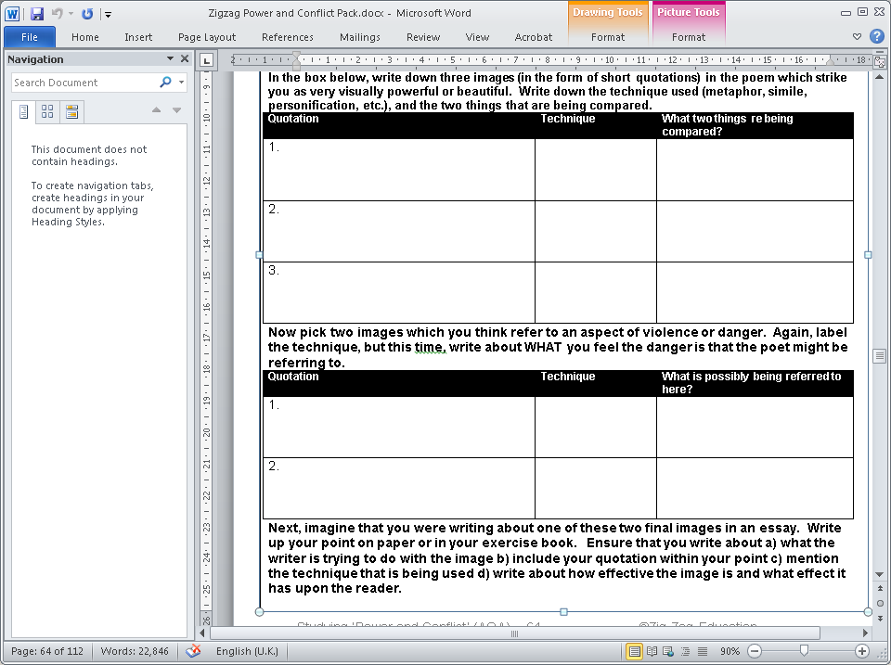

***technique* FOCUS** (AOs 1,2,3)

**Imagery: *Kamikaze***



***exam* TIPS**)

**Essay writing: getting tone and style right**

When you write your essay, it’s really important to get your tone and style right. This means that you are writing clearly, in the correct register, and in a way that engages the interest of your reader. This relates to parts of two of the Assessment Objectives for this question:

**AO1: maintain a critical style and develop an informed personal response**

**AO2: using relevant subject terminology where appropriate**

**AO4: Use a range of vocabulary and sentence structures for clarity, purpose and effect, with accurate spelling and punctuation**

In the table below is a list of things examiners like and dislike about essay style:

|  |  |
| --- | --- |
| ***Examiners Like…*** | ***Examiner’s Don’t Like…*** |
| 1. The use of standard, formal English 2. Use of evaluative words (words that show an appreciation of the poet’s qualities) 3. A mostly *impersonal* style (one that doesn’t often use the first person pronouns, ‘I’ or ‘me’) 4. Ambitious but relevant vocabulary 5. Use of specialist terminology (poetic and linguistic terms) | 1. Non-standard / slang / colloquial language (except when quoting from the poem) 2. Slang evaluative words, negative words (as in putting the poem down) or no evaluative words 3. Too much use of personal pronouns (‘I think that…’ etc) 4. Over-simplified or wrong choice of words 5. Incorrect or no use of terminology |

TASK: The five extracts below (from essays about the poem *Kamikaze*) all use features that could rub up the examiner the wrong way! Using the letter codes (f) to (j), identify the fault next to each. Then, use the letter codes (a) to (e) to write a new, improved version for each.

1. ***Kamikaze* is a really cool poem. I like the way it refers to nature and stuff in the bit about his dad being a fisherman.**
2. **‘Cloud-marked mackerel’ is a very effective simile, as the audience can picture the reflection of the clouds in the fish’s scale…’**
3. ***Kamikaze* is OK but there are bits of it I don’t understand. Like the bit about the feathery prawns, I mean, what’s that all about?**
4. **The third paragraph is really good. You can really picture the fishes swimming in shoals in the sea. ‘Flashing silver’ is a metaphor.**
5. **In the sixth verse, it switches from the poet telling the story to the pilot’s daughter telling it. This works well.**

**EXTENSION:** Go back to a recent Literature essay you have written. Try to identify where you may have written something in a tone or style that might not please the examiner. Identify the reason why this might be, then write a new, improved version in your book.

**Remember these rules for good, critical writing when you next write an essay!**

## *Remains*

by **Simon Armitage**

On another occasion, we got sent out

to tackle looters raiding a bank.

And one of them legs it up the road,

probably armed, possibly not.

Well myself and somebody else and somebody else

are all of the same mind,

so all three of us open fire.

Three of a kind all letting fly, and I swear

I see every round as it rips through his life –

I see broad daylight on the other side.

So we’ve hit this looter a dozen times

and he’s there on the ground, sort of inside out,

pain itself, the image of agony.

One of my mates goes by

and tosses his guts back into his body.

Then he’s carted off in the back of a lorry.

End of story, except not really.

His blood-shadow stays on the street, and out on patrol

I walk right over it week after week.

Then I’m home on leave. But I blink

and he bursts again through the doors of the bank.

Sleep, and he’s probably armed, and possibly not.

Dream, and he’s torn apart by a dozen rounds.

And the drink and the drugs won’t flush him out –

he’s here in my head when I close my eyes,

dug in behind enemy lines,

not left for dead in some distant, sun-stunned, sand-smothered land

or six-feet-under in desert sand,

but near to the knuckle, here and now,

his bloody life in my bloody hands.

War Photographer – **Carol Ann Duffy**

In his dark room he is finally alone

with spools of suffering set out in ordered rows.

The only light is red and softly glows,

as though this were a church and he

a priest preparing to intone a Mass.

Belfast. Beirut. Phnom Penh. All flesh is grass.

He has a job to do. Solutions slop in trays

beneath his hands, which did not tremble then

though seem to now. Rural England. Home again

to ordinary pain which simple weather can dispel,

to fields which don’t explode beneath the feet

of running children in a nightmare heat.

Something is happening. A stranger’s features

faintly start to twist before his eyes,

a half-formed ghost. He remembers the cries

of this man’s wife, how he sought approval

without words to do what someone must

and how the blood stained into foreign dust.

A hundred agonies in black and white

from which his editor will pick out five or six

for Sunday’s supplement. The reader’s eyeballs prick

with tears between the bath and pre-lunch beers.

From the aeroplane he stares impassively at where

he earns his living and they do not care.

War Photographer – **Carol Ann Duffy**

In his dark room he is finally alone

with spools of suffering set out in ordered rows.

The only light is red and softly glows,

as though this were a church and he

a priest preparing to intone a Mass.

Belfast. Beirut. Phnom Penh. All flesh is grass.

He has a job to do. Solutions slop in trays

beneath his hands, which did not tremble then

though seem to now. Rural England. Home again

to ordinary pain which simple weather can dispel,

to fields which don’t explode beneath the feet

of running children in a nightmare heat.

Something is happening. A stranger’s features

faintly start to twist before his eyes,

a half-formed ghost. He remembers the cries

of this man’s wife, how he sought approval

without words to do what someone must

and how the blood stained into foreign dust.

A hundred agonies in black and white

from which his editor will pick out five or six

for Sunday’s supplement. The reader’s eyeballs prick

with tears between the bath and pre-lunch beers.

From the aeroplane he stares impassively at where

he earns his living and they do not care.

War Photographer – **Carol Ann Duffy**

In his dark room he is finally alone

with spools of suffering set out in ordered rows.

The only light is red and softly glows,

as though this were a church and he

a priest preparing to intone a Mass.

Belfast. Beirut. Phnom Penh. All flesh is grass.

He has a job to do. Solutions slop in trays

beneath his hands, which did not tremble then

though seem to now. Rural England. Home again

to ordinary pain which simple weather can dispel,

to fields which don’t explode beneath the feet

of running children in a nightmare heat.

Something is happening. A stranger’s features

faintly start to twist before his eyes,

a half-formed ghost. He remembers the cries

of this man’s wife, how he sought approval

without words to do what someone must

and how the blood stained into foreign dust.

A hundred agonies in black and white

from which his editor will pick out five or six

for Sunday’s supplement. The reader’s eyeballs prick

with tears between the bath and pre-lunch beers.

From the aeroplane he stares impassively at where

he earns his living and they do not care.

War Photographer – **Carol Ann Duffy**

In his dark room he is finally alone

with spools of suffering set out in ordered rows.

The only light is red and softly glows,

as though this were a church and he

a priest preparing to intone a Mass.

Belfast. Beirut. Phnom Penh. All flesh is grass.

He has a job to do. Solutions slop in trays

beneath his hands, which did not tremble then

though seem to now. Rural England. Home again

to ordinary pain which simple weather can dispel,

to fields which don’t explode beneath the feet

of running children in a nightmare heat.

Something is happening. A stranger’s features

faintly start to twist before his eyes,

a half-formed ghost. He remembers the cries

of this man’s wife, how he sought approval

without words to do what someone must

and how the blood stained into foreign dust.

A hundred agonies in black and white

from which his editor will pick out five or six

for Sunday’s supplement. The reader’s eyeballs prick

with tears between the bath and pre-lunch beers.

From the aeroplane he stares impassively at where

he earns his living and they do not care.