**Year 9 Assessment : Poetry Comparison**

Compare the ways in which the poets present attitudes to war in ‘Bayonet Charge’ by Ted Hughes and one other poem from the six we have studied.

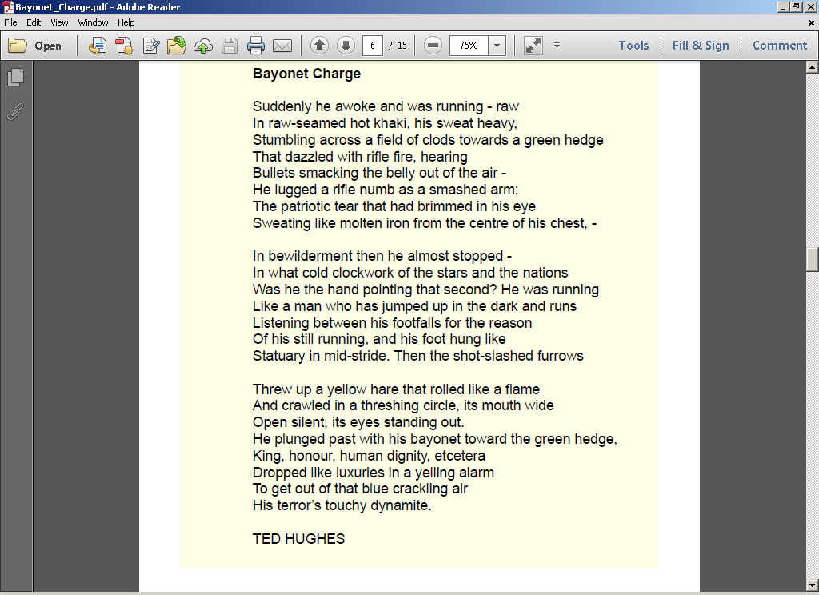

(30 marks + 10 marks for accuracy of spelling, punctuation and grammar)