
technique FOCUS
Rhythm in The Charge of the Light Brigade AO: 2

RHYTHM is created in poetry by combinations of stressed and unstressed syllables. This works much the same way as creating a BEAT in music.
- Charge of the Light Brigade begins with the phrase ‘Half a league’. Working in pairs, have one person repeat the phrase over and over, trying to create a rhythm. The other person should repeat ‘One-two-three’ over and over at the same time. You should find that you are creating a rhythmic effect – the repeating of one stressed syllable, followed by two unstressed syllables over and over again.
- A pattern of stressed syllables – such as this one – is called a FOOT. This particular type (stressed / unstressed / unstressed) is called a DACTYLIC foot and it creates the sense of galloping – like the horses of the cavalrymen charging through the ‘valley of death’!
- On way to work out and record the rhythm in a poem like this, is to mark the stressed and unstressed syllables above the words of the poem. You make the mark of a forward slash ( / ) above stressed syllables; and the mark of a U-shape above unstressed syllables. Therefore, your annotations for the first stanza might look something like this:
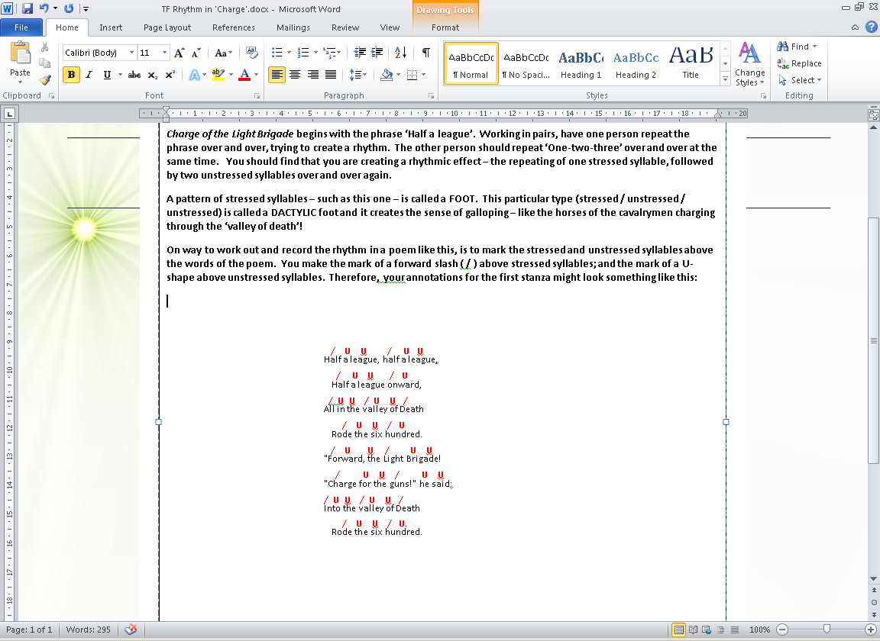
- From the above, you can see that it’s not quite regular – but that the same pattern does dominate this stanza, and indeed the poem as a whole. We can also comment on the number of times a pattern (or FOOT) can be repeated over a line. This is called the METER. In the first and sixth line, we can see that it’s repeated twice – this is called a DIMETRE.
TASK: Try working out the rhythm for Exposure and consider what effect it has upon the tone of the poet. How does that fit in with what he is trying to get across?
You could also find out about other types of rhythmic FEET (look up the very important IAMBIC, as well as TROCHAIC and ANAPAESTIC). Also, look at different types of meter: the MONOMETRE, TETRAMETRE, and the very important PETRAMETRE!) In your research, you should find out quite a lot about the IAMBIC PETRAMETRE and who uses it!

