Remains by Simon Armitage AOs: 1 2 and 3
Groups: | War, Memory, Violence, Crime, Decay / Change
Good poems to link with: | Exposure, Kamikaze, Poppies, War Photographer
Bio and Context: Armitage (b.1963) is a well-known and popular modern poet who has had many collections published, and was awarded the CBE in 2010. Remains appears in a collection called The Not-Dead. Ahead of writing the book, Armitage interviewed many veterans of modern conflicts, and used their words, thoughts and feelings to pen a series of poems about modern warfare and the effects of conflict on the individual. Remains tells the story, forst-hand, of a retired soldier whole conscience is haunted by an episode from the near-past whilst fighting aborad.

Summary:  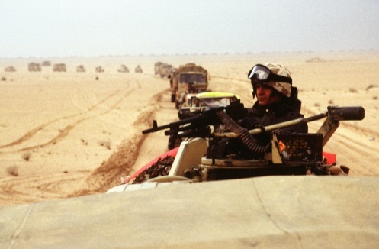 | The opening stanza suggests that the narrator is telling this as one of series of episodes. The use of present tense suggests he is re-living it as he tells us: he and his fellow soldiers are patrolling in an unspecified country and are tasked with dealing with civilian looters who have looted a local bank, presumably after the area has been bombed. They don’t know whether the looters are armed. The next two stanzas describe, quite graphically, how the soldiers quickly decide to shoot until the looter lies on the ground, his guts ‘inside out’. The fourth stanza sees the remains of the looter being piled back into the lorry. The next three stanzas describe how, going home on leave, the soldier tries to come to terms with what he has done. He relives the moment when asleep and awake, and the ‘drink and drugs’ won’t clear his mind. In the chilling final lines, he seems to realise that he, and he alone, is responsible for taking the other man’s life.
Interesting Features:
- Colloquial / simple language
- Regular four-lined stanzas (apart from the final two lines)
- Enjambment
- Graphic imagery
In a Nutshell: This is one of a number of poems where Armitage captures the effects of modern war on an individual (see also the very powerful Manhunt). The endless flashbacks recreate the horrific effects of Post-Traumatic-Stress-Disorder, or what the veterans of the First World War used to call ‘shell shock’. Armitage’s neat, contained stanzas replicate the soldiers attempt to justify and contain what he has done, whilst the violent imagery, and enjambment show how emotions and reality start to spill out of him to the point where he can no longer contain or justify past events.

