War Photographer by Carol Ann Duffy
Groups: | War, Memory, Fragile Life, Home
Good poems to link with: | Bayonet Charge, Remains, Poppies, Kamikaze, Tissues
Bio and Context: Carol Ann Duffy (born 1955) is one of Britain’s best-known poets. As ‘Poet Laureate’ it is her job to write poems for important state occasions, and she is the first Scot, woman and lesbian to have been given this position. Duffy was friends with two war photographers, Don McCullin and Philip Jones; and she was fascinated by the idea of how they felt in their role –taking still photographs of people suffering but not taking any direct role in the conflict or their lives.
Summary:  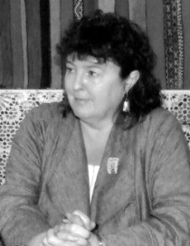 | In the first of four six-line stanzas, Duffy describes the war photographer preparing his materials in his ‘dark room’, getting ready to develop photographs of war zones he has visited. He sets out his equipment as a priest does his. As he prepares to develop the images, he becomes aware of the differences between the land of his home life and the war-torn places he has visited in his job. His photographs start to deveklop before him in the third stanza – harsh images of war that take him back to the awful things he has seen and heard. In the final stanza, Duffy tells of how the photographer will ick just a few of the many images to appear in a Sunday newspaper. She imagines a typical bloke looking over the images, feeling bad for a moment, and then moving on with his normal Sunday routine. The final ambiguous lines of the poem ask whether the war photographer feels the same as he is caught between his home life and the place of his work.
Interesting Features:
- Neat, regular six line stanzas
- Regular rhyme scheme, but obscured by irregular rhythms, caesura and enjambment
In a Nutshell: Duffy is careful to portray the photographer as an outside might see him. She lets us have glimpses into how he might feel about taking these pictures; but shows us that, even though he chooses to distance himself from the suffering of others, it is he who brings us the pictures. We, the observers, are even more distant.

