Bayonet Charge by Ted Hughes AOs: 1 2 and 3
Groups: | War, Fragile Life, Violence, Power
Good poems to link with: | Exposure, Remains, Charge of the Light Brigade, Poppies, Kamikaze
Bio and Context: Like Tennyson, Ted Hughes (1930-1998) was Poet Laureate from 1988 until he died, and is considered one of the best poets of his generation. Earlier in life, Hughes had served National Service, following in the footsteps of his father, who had fought at Ypres in the First World War. Hughes was also a great fan of the poet Wilfred Owen, whom he said inspired him to write Bayonet Charge, the story of a lone soldier caught unawares in battle during World War One.
Summary:  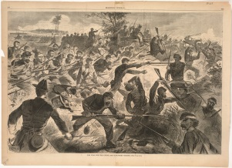 | The opening suggests that the soldier is caught by surprise at having to engage action suddenly – Hughes uses words which give a sense of his sweating clumsiness as weapons fire off around him. His own rifle feels useless. The final two lines of stanza 1 suggest any pride he might have felt in fighting for his country is falling away in the heat and reality of battle. In stanza 2, the soldier stops to check himself, and questions there at all. Hughes uses abstract imagery and language to describe him as almost frozen in time at this point. Stanza 2 runs straight into stanza 3 (enjambment), as, suddenly, a nearby explosion throws up a ‘yellow hare’ out of the nearby trenches. The description of the animal is unsympathetic and horrific – as if describing casualties of war in a similar style to the war poet Wilfred Owen. The solder runs blindly on – presumably towards his enemy, as everything he has stood for falls away around him. The final words of the poem suggest he is charging towards an explosion and probably his own death.
Interesting Features:
- Free verse
- Abstract imagery
In a Nutshell: Bayonet Charge is a complex picture of a soldier who is caught up in battle, and left feeling that he doesn’t really know or care what he is fighting for. Hughes captures what many soldiers must have felt when faced with the horrific reality of trench warfare on a day-to-day basis. Ultimately, they are fighting for their own survival, rather than any noble beliefs, which have long-since gone.

