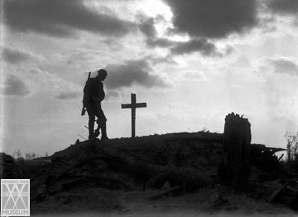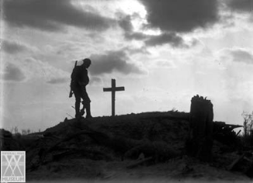

### Play Overview

**Act One *Evening - Monday, 18th March, 1918***

**pp 1-9 Osborne and Hardy Discussing Stanhope**

**pp 9-17 Osborne and Raleigh Raleigh's introduction to trench life**

**pp17-23 Joined by Stanhope, Trotter,**

**Mason Stanhope and Raleigh meet**

**pp23-31 Stanhope and Osborne Discussing Raleigh and the war**

**Act Two, Scene 1 *Tuesday morning***

**pp 32-37 Osborne, Trotter, Mason Discussing food**

**pp37-40 Osborne, Raleigh Discussing life back in England**

**pp40-45 Stanhope, Osborne Censorship**

**p46 Stanhope, Raleigh, Osborne Stanhope seizes Raleigh's letter**

**p47 Stanhope, Osborne Osborne reads the letter aloud**

**Act Two, Scene 2 *Tuesday afternoon***

**pp48-50 Stanhope, S-Major Discussing tactics**

**pp51-53 Stanhope, Colonel Discussing 'going over the top'**

**pp54-58 Stanhope, Hibbert Hibbert tries to escape war**

**pp59-60 Stanhope, Osborne Discussing forthcoming raid**

**pp61-65 All Food - discussion of raid**

**Act Three, Scene 1 *Wednesday afternoon***

**pp66-70 Colonel, Osborne, Stanhope Last preparation for the raid**

**pp71-76 Osborne, Raleigh Taking their minds off the raid**

**- *The Raid -***

**pp76-80 Stanhope, Col, S-M, German Getting information from the soldier**

**Act Three, Scene 2 *Wednesday evening***

**pp81-86 Stanhope, Trotter, Hibbert,**

**Mason Celebrations and blow-ups**

**pp87-91 Stanhope, Raleigh Stanhope confronts Raleigh**

**Act Three, Scene Three *Thursday, towards dawn***

**pp91-96 Stanhope, Mason, Trotter, S-M Discussion of positions**

**pp96-101 Stanhope, S-M, Hibbert News from above**

**pp101-103 Stanhope, Raleigh Reconciliation**

# ‘Journey’s End’ by R.C.Sherriff