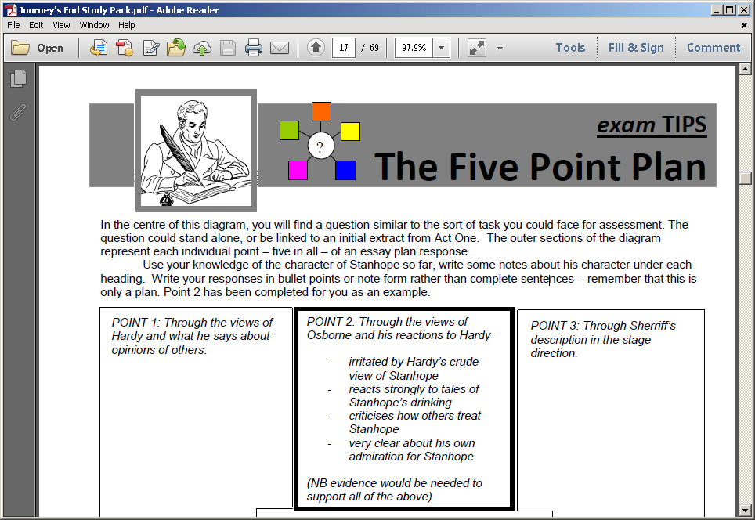

m

|  |  |  |
| --- | --- | --- |
| Ranks (in order) appearing in the play: | Different Social Classes in the play | |
|  | Middle / Upper Class | Working Class |

Find dialogue where you can contrast Trotter’s speech with Stanhope’s