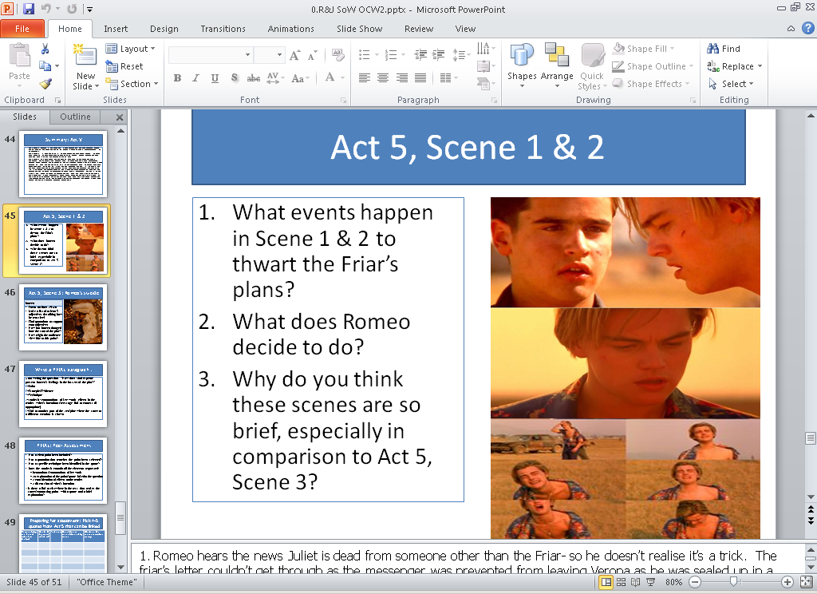 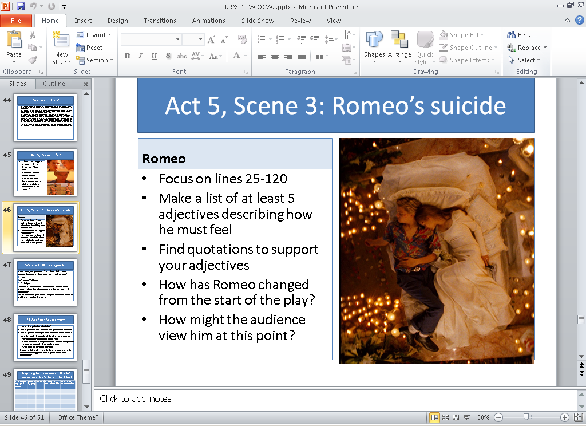

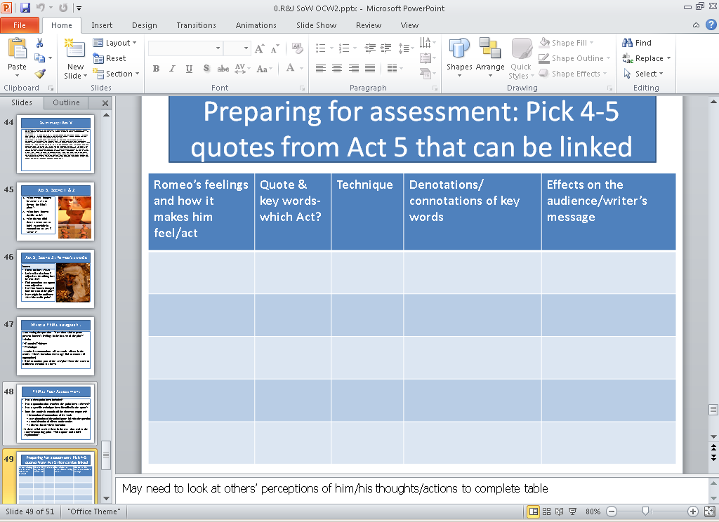 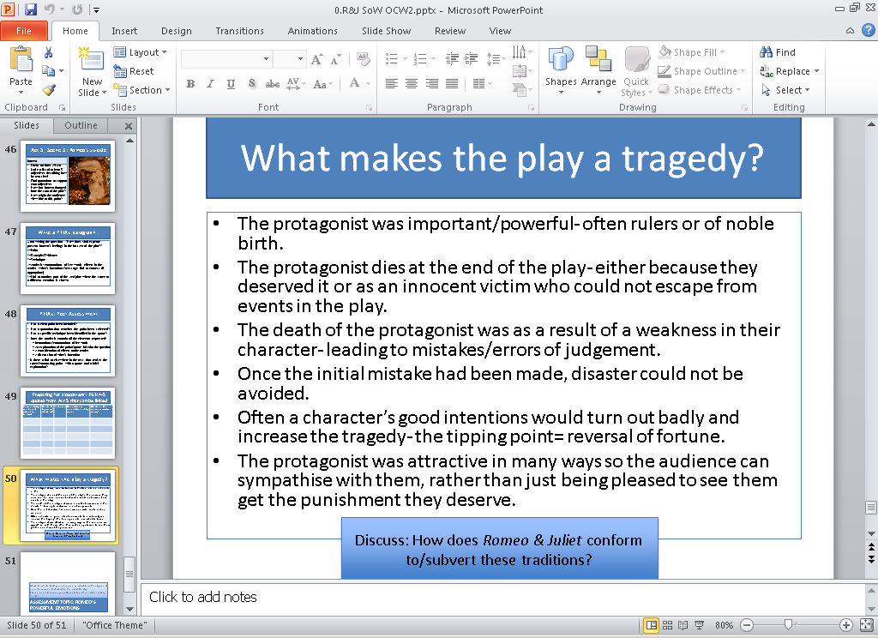

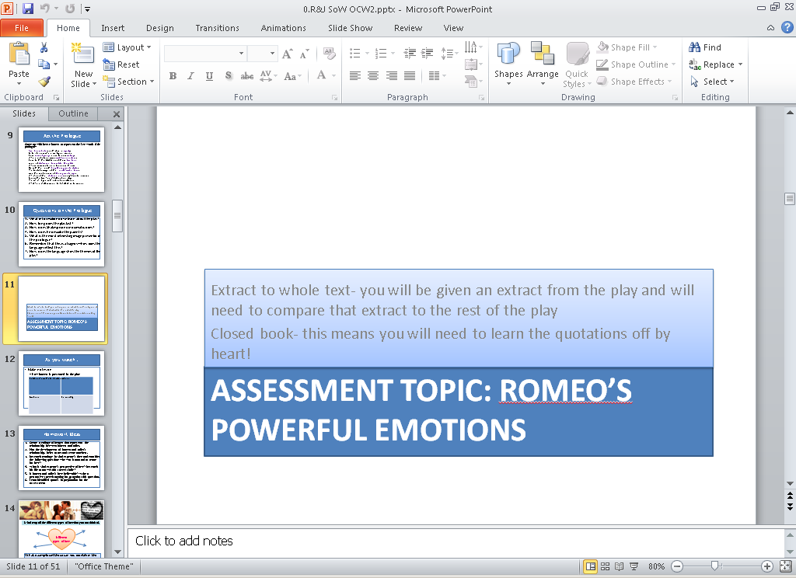

Revision:

* Look over your Act Summaries, and learn the major events in each Act
* Pick out the parts of each act that are relevant to the question and re-read them
* Pick out around ten key quotations to memorise for your response