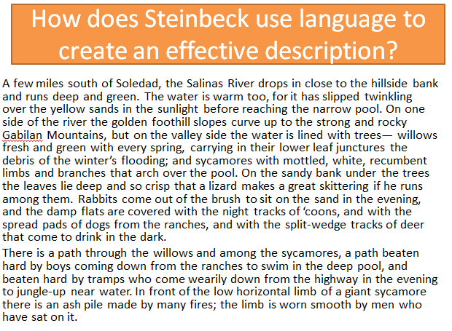

|  |  |  |
| --- | --- | --- |
| Onomatopoeic words |  | To describe the fluent nature of the landscape |
| Gentle verbs | To signify the influence of man on a natural environment |
| Adjectives relating to strength | To evoke the sounds of the valley |
| Naturalistic adjectives | To capture the slow pace of life give a feel of laziness within the valley |
| Semantic field of animals | To highlight the richness and diversity of life in the valley |
| Semantic field of man-made references / effects | To create a sense of flow between sentences and how objects relate to each other |
| Prepositions | To show how various elements of nature relate to each other |
| Long sentences | To evoke the power of Nature |
| Semantic field of paths / journeys | To foreshadow a sense of the characters going on a journey over the course of the novel |
| (Adverbial) subordinate clause to open sentence | To capture the freshness of the valley |

* Cut out and stick the passage in the centre of a page
* Match the terminology on the left hand side to the effect on the right, then copy the labels across to your diagram – you can use a key here if you like, but ensure to include them all.
* Write each of them up as a point as it might appear in the essay – including the example as a quotation integrated into your point

**Eg: *Through making many references to water, such as in describing the Salinas river ‘reaching the pool’, and describing the ‘Winter’s flooding’, Steinbeck uses a semantic field of water to suggest that life is always fluid and moving on.***