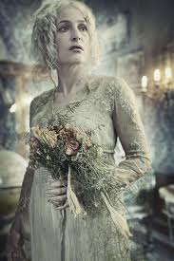**Description of Miss Havisham from *Great Expectations***

She was dressed in rich materials - satins, and lace, and silks - all of white. Her shoes were white. And she had a long white veil dependent from her hair, and she had bridal flowers in her hair, but her hair was white. Some bright jewels sparkled on her neck and on her hands, and some other jewels lay sparkling on the table. Dresses, less splendid than the dress she wore, and half-packed trunks, were scattered about. She had not quite finished dressing, for she had but one shoe on - the other was on the table near her hand - her veil was but half arranged, her watch and chain were not put on, and some lace for her bosom lay with those trinkets, and with her handkerchief, and gloves, and some flowers, and a prayer-book, all confusedly heaped about the looking-glass.

It was not in the first few moments that I saw all these things, though I saw more of them in the first moments than might be supposed. But, I saw that everything within my view which ought to be white, had been white long ago, and had lost its lustre, and was faded and yellow. I saw that the bride within the bridal dress had withered like the dress, and like the flowers, and had no brightness left but the brightness of her sunken eyes. I saw that the dress had been put upon the rounded figure of a young woman, and that the figure upon which it now hung loose, had shrunk to skin and bone. Once, I had been taken to see some ghastly waxwork at the Fair, representing I know not what impossible personage lying in state. Once, I had been taken to one of our old marsh churches to see a skeleton in the ashes of a rich dress, that had been dug out of a vault under the church pavement. Now, waxwork and skeleton seemed to have dark eyes that moved and looked at me. I should have cried out, if I could.