[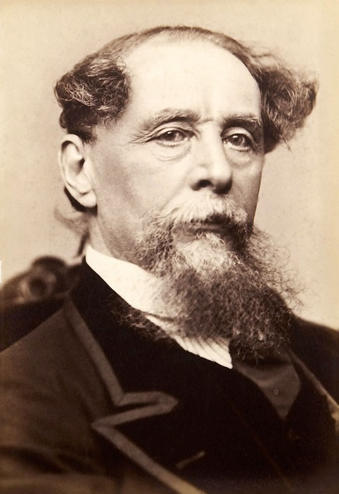](https://www.google.co.uk/url?sa=i&rct=j&q=&esrc=s&source=images&cd=&cad=rja&uact=8&ved=0ahUKEwjwrK_XgrnNAhWDJMAKHcKxAvkQjRwIBw&url=https://en.wikipedia.org/wiki/Charles_Dickens&bvm=bv.125221236,d.ZGg&psig=AFQjCNEH6Bltwd6jvdPdHh5IPTEIv2xOAQ&ust=1466595102529278)**Homework – Charles Dickens research task**

*Research facts about Charles Dickens.*

Born: ________________

Died: ______________

Father’s name and occupation: __________________________________

Mother’s name: ______________________________

What was Dickens interested in portraying in his novels?

___________________________________________________________________

___________________________________________________________________

.Research Charles Dickens’ childhood.

______________________________________________________________________________________________________________________________________

___________________________________________________________________

Do you think Dickens’ childhood experiences have any impact on the plot and/or characters of the Dickens extracts we are studying? Explain your answer

__________________________________________________________________________________________________________________________________________________________________________________________________________________________________________

Dickens’ stories were often serialised. Explain what this means and why it was a good way of getting his stories into the public.

______________________________________________________________________________________________________________________________________

___________________________________________________________________

Describe what life was like in London at the time Dickens was writing ___________________________________________________________________

___________________________________________________________________