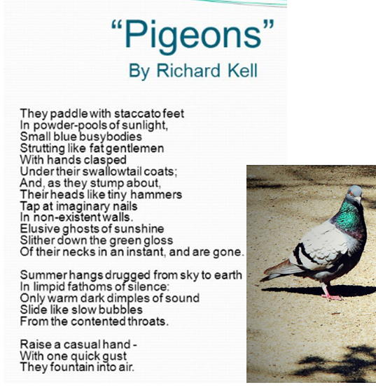

**Question**

**Read the poem *Pigeons* by Richard Kell.**

**How does the poet create a vivid image of the birds in this poem?**

**You should write about:**

* **Your impressions of the pigeons**
* **How the writer creates those impressions**