**Animal Farm** Year 8 Assessment Task : *1 hour*

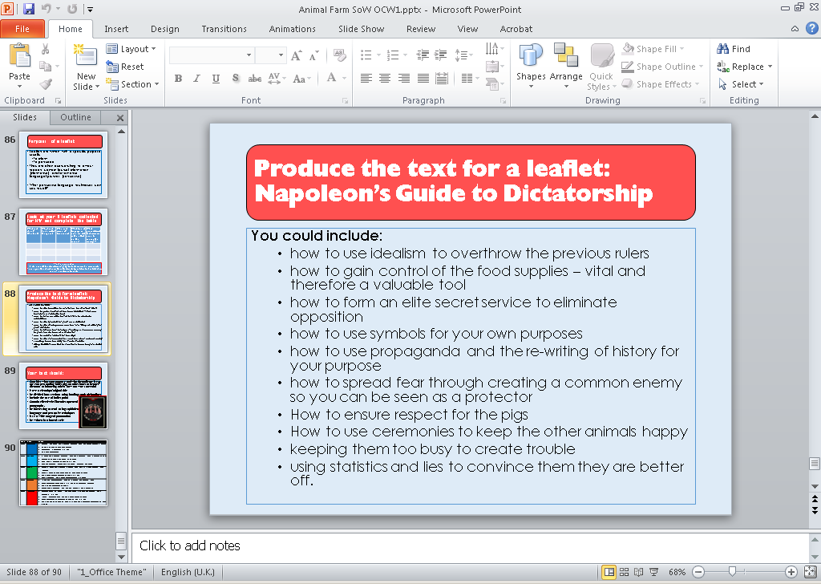 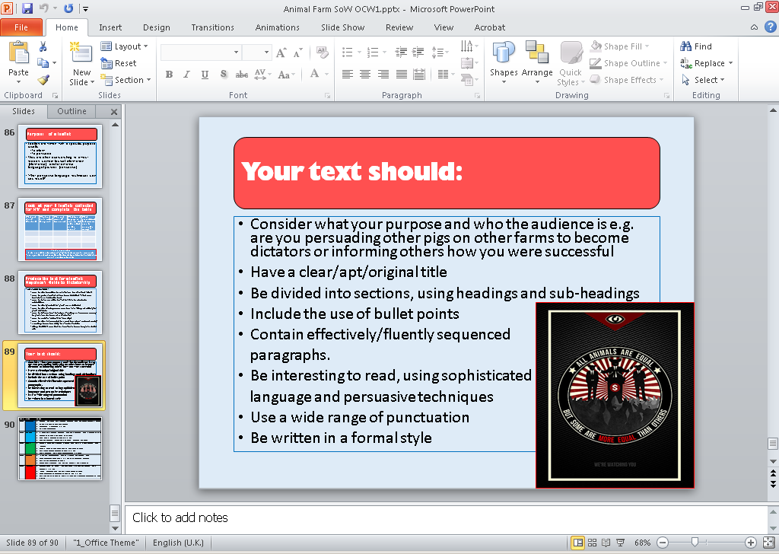

**Planning your task**

* Decide on between six and ten main points that will become the sections of your leaflet
* Decide on an appropriate order for these (think about the chronology of the novel)
* For *at least half* of these, link them to specific events that Napoleon orchestrated or was involved in

**Writing the text** (NB there is no need to consider the presentation – no marks will be awarded for this)

* Decide on your AUDIENCE and PURPOSE before writing (see above)
* Write a brief introduction, setting out the aims and purpose of your leaflet
* For each main point you make: a) state the point in a sentence b) go on to explain why it matters c) give examples of how it worked for you
* Ensure that your next point links / flows from your last
* Consider a brief but suitable conclusion at the end – what can the reader gain from having read the leaflet?

**Finally**

* Leave at least five minutes before the end of the assessment to a) improve your writing b) check for errors – spelling, punctuation and grammar. Attempt to use commas / colons / semi-colons to enhance meaning.

Your leaflet should be:

**Devices to use:**

* **Rhetorical questions**
* **Imperative statements**
* **Direct address**
* **Personal pronouns**
* **Metaphors / figures of speech**
* **Tricolon / rule of three**
* **Repetition**
* **Persuasive adverbs**
* **Powerful verbs**
* **Short, blunt statements for effect**

Entertaining!

Informative!

Persuasive!

Well-structured!

Well-written!

Accurate!