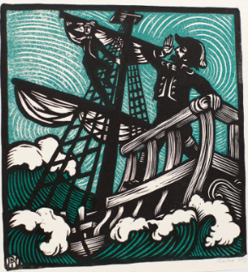

**The Gresford Disaster  
from A.L. Lloyd’s “Come all ye bold miners”.  
  
You’ve heard of the Gresford disaster,  
The terrible price that was paid;  
Two hundred and forty-two colliers were lost  
And three men of the rescue brigade.  
  
It occurred in the month of September,  
At three in the morning that pit  
Was racked by a violent explosion  
In the Dennis where dust lay so thick.  
  
The gas in the Dennis deep section  
Was packed like snow in a drift,  
And many a man had to leave the coal-face  
Before he had worked out his shift.  
  
A fortnight before the explosion  
To the shot-firer Tomlinson cried;  
“If you fire that shot we’ll all be blown to hell!”  
And no one can say that he lied.  
  
The fireman’s reports they are missing,  
The records of forty-two days;  
The colliery manager had them destroyed  
To cover his criminal ways.  
  
Down here in the dark they are lying,  
They dies for nine shillings a day;  
They’ve worked out their shift and it’s now they must lie  
In the darkness until Judgement Day.  
  
  
  
The Lord Mayor of London’s collecting  
To help both the children and wives;  
The owners have sent some white lilies  
To pay for the colliers’ lives.  
  
Farewell our dear wives and our children,  
Farewell our dear comrades as well;  
Don’t send your sons in the dark dreary mine,  
They’ll be damned like the sinners in hell.**



**The Gresford Disaster  
from A.L. Lloyd’s “Come all ye bold miners”.  
  
You’ve heard of the Gresford disaster,  
The terrible price that was paid;  
Two hundred and forty-two colliers were lost  
And three men of the rescue brigade.  
  
It occurred in the month of September,  
At three in the morning that pit  
Was racked by a violent explosion  
In the Dennis where dust lay so thick.  
  
The gas in the Dennis deep section  
Was packed like snow in a drift,  
And many a man had to leave the coal-face  
Before he had worked out his shift.  
  
A fortnight before the explosion  
To the shot-firer Tomlinson cried;  
“If you fire that shot we’ll all be blown to hell!”  
And no one can say that he lied.  
  
The fireman’s reports they are missing,  
The records of forty-two days;  
The colliery manager had them destroyed  
To cover his criminal ways.  
  
Down here in the dark they are lying,  
They dies for nine shillings a day;  
They’ve worked out their shift and it’s now they must lie  
In the darkness until Judgement Day.  
  
  
  
The Lord Mayor of London’s collecting  
To help both the children and wives;  
The owners have sent some white lilies  
To pay for the colliers’ lives.  
  
Farewell our dear wives and our children,  
Farewell our dear comrades as well;  
Don’t send your sons in the dark dreary mine,  
They’ll be damned like the sinners in hell.**