**What does Scrooge look like?**

**Where does Scrooge live? What is his office like?**

**INSIDE the body, write down his emotions…**

[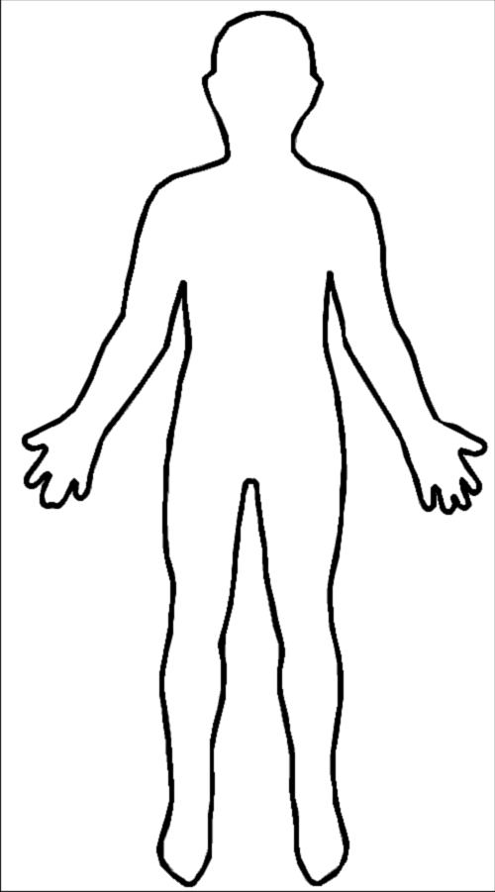](http://www.google.co.uk/url?sa=i&rct=j&q=&esrc=s&frm=1&source=images&cd=&cad=rja&docid=1oJBFmLHBtfyhM&tbnid=QddO1A5jMggyaM:&ved=0CAUQjRw&url=http://en.wikipedia.org/wiki/File:Outline-body.png&ei=EJGxUfG5DMLI0AXI4YGYAw&bvm=bv.47534661,d.ZG4&psig=AFQjCNH73qWJUWbuw8CZNpI3UcHSIdZwPg&ust=1370677901263655)

**What does Scrooge learn from the Spirits?**

**How does Scrooge treat people?**

**How is Scrooge treated by others?**

**As Scrooge is visited by the Spirits do you feel any sympathy towards him?**

**How does Scrooge make you feel at the end of the novella?**