**Webarticle from BBC news**

**Deadly tornadoes hit US Midwest states**

**Powerful tornadoes have swept through the US Midwest, destroying buildings and overturning vehicles in the states of Illinois, Indiana and Kentucky.**

At least eight people were killed and it is feared that several hundred people may have been injured in the fast-moving storms.

A number of people are feared trapped inside buildings.

Forecasters said people in 10 states had been at risk. Hailstones the size of tennis balls were reported.

The storm was so fast-moving - with winds of up to 111km/h (68mph) - that forecasters warned people not to wait until they saw the weather change.

It is continuing its way east.

## 'War zone'

About 80 reports of tornadoes had come in by late Sunday, said the National Weather Service - though a spokesman cautioned that multiple reporting meant the actual number might be about 30 or 40.

Six fatalities were reported in Illinois, the hardest hit state.

Three people died in southern Massac County, and one person died in the town of Washington, the Illinois Emergency Management Agency said. Between 250 and 500 homes were either damaged or destroyed in the town.

An 80-year-old man and his 78-year-old sister were killed when a tornado struck their farmhouse in the rural southern Illinois village of New Minden.

Two others were killed in Michigan - a 21-year-old man whose vehicle was crushed by a fallen free, and a 59-year-old man found entangled in high-voltage power lines.

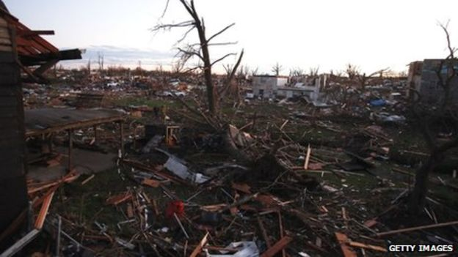

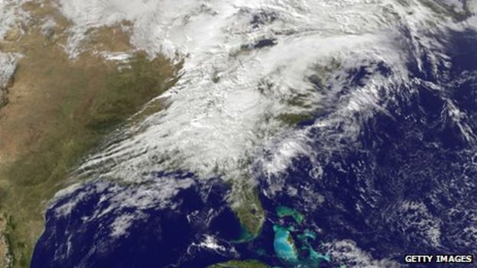

Eyewitnesses described how large parts of Washington had been levelled by the tornadoes.

"The whole neighbourhood's gone. The wall of my fireplace is all that is left of my house," Michael Perdun told news agency Associated Press by mobile phone from Washington, where he said his neighbourhood was wiped out in seconds.

"I stepped outside and I heard it coming," he said. "My daughter was already in the basement, so I ran downstairs and grabbed her, crouched in the laundry room and all of a sudden I could see daylight up the stairway and my house was gone."

Another resident returned from a trip to find her home completely blown away by the tornado.

"A lot of people have a pile of rubble still," Michelle Cumrine told the AFP news agency. "I don't have anything. It's gone. I don't know where it went."

Illinois officials are describing the situation as "dangerous and volatile". State trooper Dustin Pierce told agencies there had been reports of looting in Washington and a dusk-till-dawn curfew had been imposed.

Karen Harris, a food truck operator in Washington, told the BBC she saw a "car completely mangled, the houses gone".

"Telephone wires [are] down everywhere, live wires are still down. I'm pretty traumatised from what I saw.

"I actually saw a vehicle in the middle of the road, their left signal light turned on, like they were getting ready to turn, all the windows were out of it, blood was in the back seat.

Media captionHomes have become "piles of rubble", says Pastor Dave Jane who had been giving a service

"Pandemonium. It looks like a war zone," Ms Harris added.

Illinois police say they fear residents may be trapped in their basements under debris.

In nearby Peoria, dozens of patients are being treated - some for serious injuries.

Tens of thousands of residents were without power in Michigan, Indiana and Kentucky, utility companies said. Parts of Wisconsin and Ohio were also hit by the storm.

American football fans were evacuated from a stadium in the centre of Chicago as one tornado moved through the city suburbs.

The White House said President Barack Obama was being regularly updated on the situation.

Laura Nightengale, a reporter with the Journal Star newspaper in Peoria, Illinois, witnessed the approach of a tornado from inside a house in the town.

"From the window I saw this huge tornado, tonnes of debris flying through the air.

"I took shelter in the basement. The area that was hit, it's just absolutely devastated - entire blocks where homes stood this morning right now are just rubble," Ms Nightengale told the BBC.

[**The National Weather Service**](http://www.weather.gov/) warned that showers, thunderstorms and windy conditions were likely for much of the north-eastern US on Monday morning.

Some storms "could contain strong winds, hail and even an isolated tornado", it said.