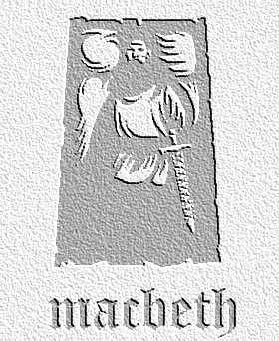


Summary Cards
overview

These cards constitute a summary of the play. Pupils should be givena shuffled version and put events into the right order

